For Reading Books online we are using a resource called Raintree Online. Below is how to access it:

- Google ‘Raintree Online’

- Put in the username and password:
Username: DEAEH5
Password: pupil

- When inside you will see this screen:
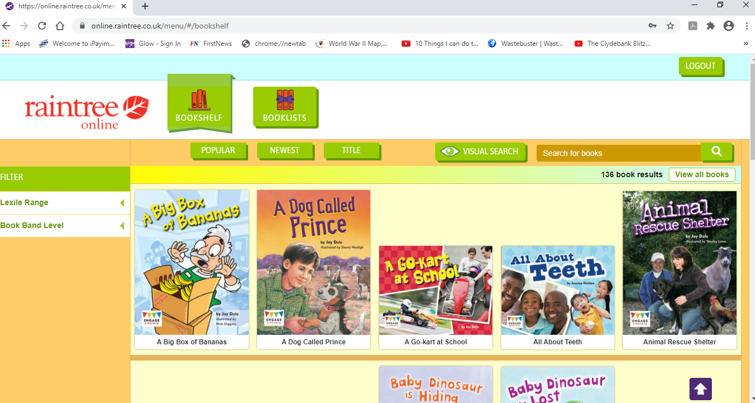
- Click the ‘Booklists’ button at the top:

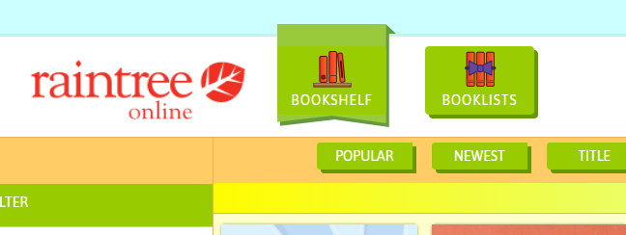

- It will then take you to our class booklists. There is one for each of our groups we have in class: Red Group, Orange Group, Green Group, Blue Group and the Purple Group. You all know which group you are in.

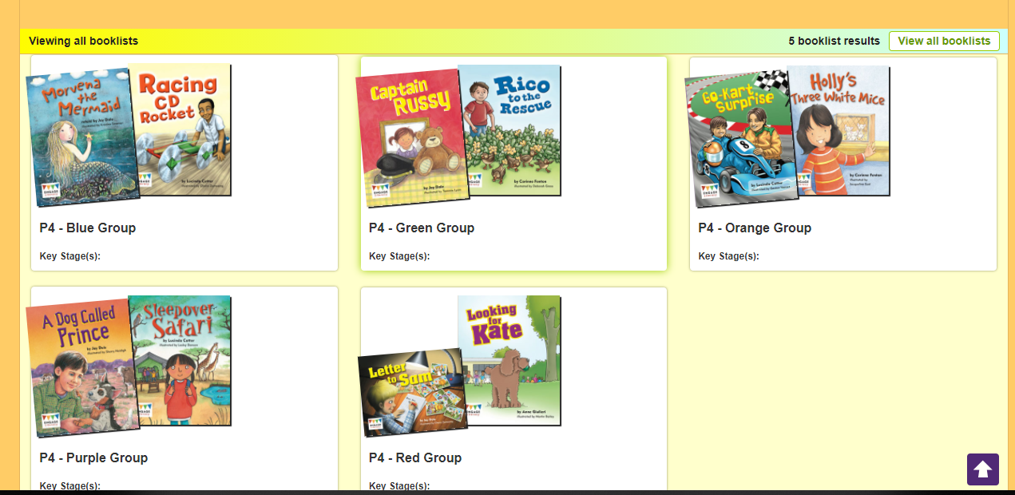

- Select your group and it will look something like this:
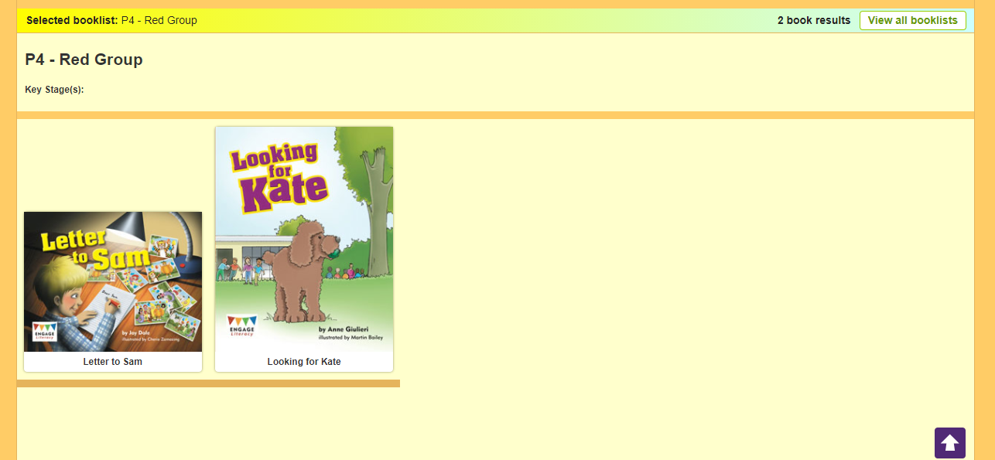

- Pick the first book on the list and you can see information on the book like a summary of it for example.

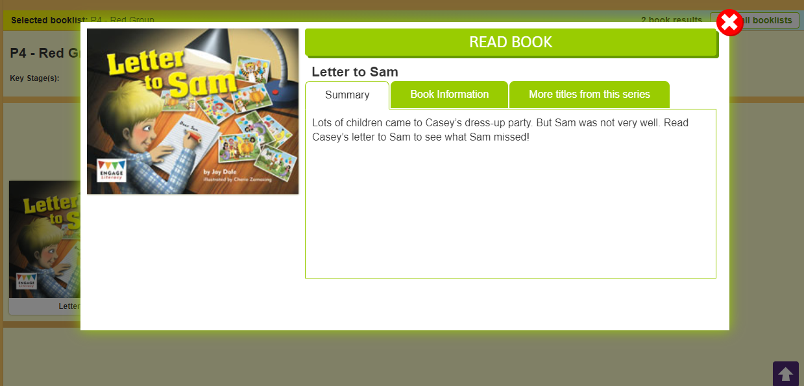

- Click the ‘Read Book’ bar at the top and then press start when you get to the next page that will look like this:

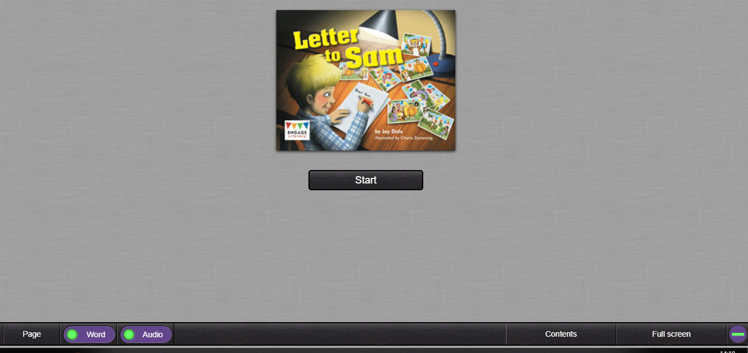

- You can either have the audio on where someone reads the book along with you, or you can click the audio button at the bottom left hand side of the screen to turn this off.
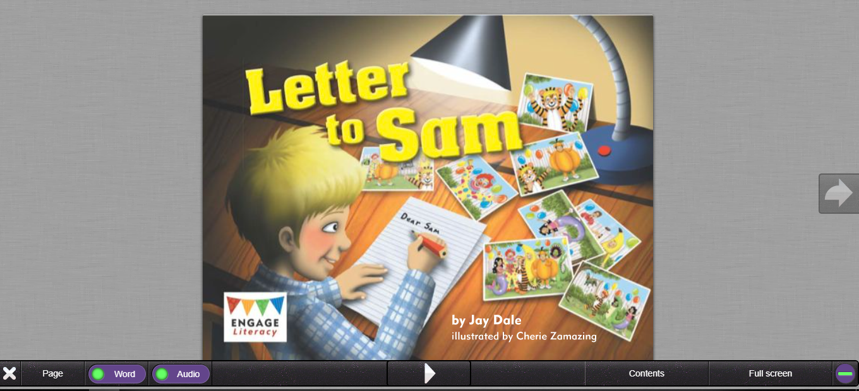
On or off

- Use the arrows to work your way through the story. You can pause the book if you want to and come back to it.

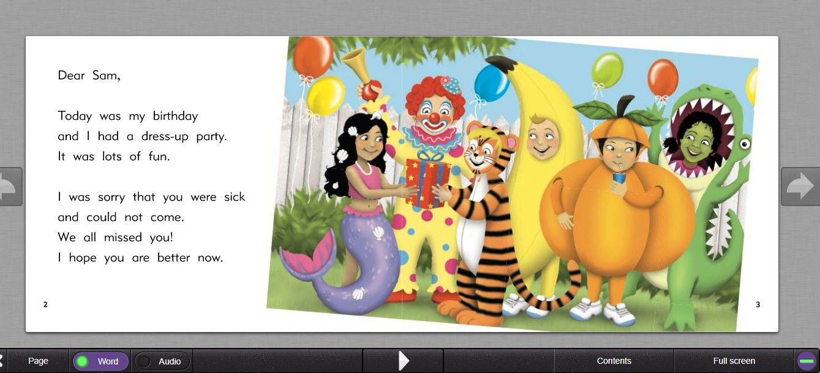
I have added 2 books in each group booklist so far and I will add more next week.

Hope you have fun reading the texts I have chosen for you!!

