F

R

1. Complete these divisions
a) £31.80 ÷ 3 = b) £26.40 ÷ 4 =
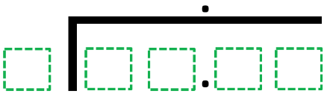

c) £28.50 ÷ 5 = d) £14.40 ÷ 8 =

e) £95.40 ÷ 9 = f) £52.80 ÷ 8 =

g) £14.40 ÷ 16 = h) £85.50 ÷ 15 =

2. Winston knows that £4.60 × 9 = £41.40
He uses this fact to work out the value of £41.40 ÷ 9
Find Winston’s solution.
Explain your reasoning.
_________________________________________________________________________________________________________________________________________________________

Use a calculator to check your answers are correct.

