
Primary 2 - Term April - June
Home Learning Choice Board
Use the choices below to decide what home learning tasks you would like your child to take part in. It is up to families as to how many activities they complete.
My interdisciplinary context for learning is
Sealife

My weekly reading homework is to read for enjoyment three times a week

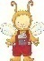
Across Learning
Health & Wellbeing
Numeracy
Literacy

Task 1  At home, if you are having pizza or cake, cut it into halves then quarters. How many pieces do you have after you half then quarter? | Task 4  Using different household items (rice, pasta, cereal) add punctuation to different sentences. This could be using pieces of rice as commas in a list, macaroni for speech marks or cheerios for full stops! Post pictures on Seesaw to show the class. | Task 7  Look at nutritional information and traffic lights on different food labels. Design a healthy eating menu for a week. | Task 10  Blue Planet - Live Lesson - BBC Teach  Watch this video,  Can you draw the food web and fill it in ?  Activity-Sheets-1-V11-FINAL.pdf
Task 2  Division Challenge: Find the answer to these calculations by making equal groups of items you can find around the house. Remember to take a picture.  8÷2=  15 ÷3=  20 ÷5=  18 ÷2=  24 ÷3= | Task 5  Write a list or take pictures of as many items/words you can find which use your sight words for the week. | Task 8  Go on a walk with an adult or look in your garden, can you see any flowers or plants?  Can you identify the different parts of them? Use the picture below to help.  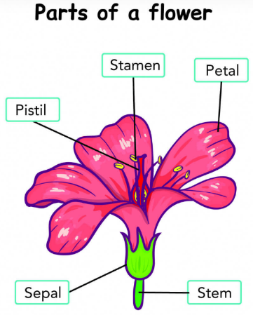 | Task 11  Using a football or basket ball, practise dribbling, passing and catching.  Challenge:  - How long can you pass the ball without dropping it?  - Can you dribble a ball in and out of obstacles without losing control?  - Can you bounce a ball while standing still/walking/jogging?
Task 3  Scan the QR codes below and explore the games.  | Task 6  Get your adult to ask you questions about your reading for enjoyment book. | Task 9  On a piece of paper or on Seesaw, draw a picture of 3 people in your life who are important to you.  Record or write down why they are important.     | Task 12  Have a go at drawing a coral reef or sealife creature, click on the videos below:  https://youtu.be/kX2g3AMmjHw?si=mtI8d90ig5yDKMoT  https://www.youtube.com/watch?v=ou7NitF6gkU&list=PLnoO3k54vcBS0l0MUyEElG6J6H3bVNDiX
Sharing your task:
Option 1:
- Take a photo of your learning/ make a video/ create a document.
- Login to your Seesaw account.
- To see activities from your teacher, tap the Activities tab and look for the Term 1 Home Learning Choice Board (on the right side under class name).
- Click ‘Add Response’ to respond and add your learning.
- Always press the green check to save work to your journal.

Option 2:
- Take some paper home from your clan to record your home learning.
- Bring it into school, use a device to take a photo and one of the champions or your child can use the clan QR code to upload it to Seesaw.

1. What was the best thing that happened at school today?
2. Tell me something that made you laugh today.
3. Tell me a new word that you heard today.
4. If I called your champion tonight, what would they tell me about you?
5. How did you help somebody today or how did you help someone?
6. Tell me one thing that you learned today.

Ask me

