
Home Learning Choice Board- Primary 6 Term 3
The tasks in blue must be completed. The other tasks are optional.
You will share all of your learning at our home learning highlights!
My interdisciplinary context for learning is – John Muir and Health & Wellbeing.

My weekly reading homework is to read for enjoyment three times a week. You can record your thoughts and ideas in your reading passport. Bring your passport in and share this at our home learning highlights!

Task 1  - Create a character profile for one of the main characters in Divided City. Include emotions, motivations, relationships, and key events. | Task 2  Write an information report on a theme from our topic (e.g. sectarianism, stereotypes, discrimination, empathy). Include subheadings and factual language. | Task 3  Create a poster promoting kindness, inclusion and understanding within communities. Use slogans and visuals. | Task 4  Design a PE skills exercise programme developing tennis skills (movement, control, rallying). Show progression steps and try your programme out with someone at home.
Task 5  Create a fact file about an issue raised in Divided City (identity, friendship, belonging). Add images or drawings.  - Sectarianism  - Friendship  - Discrimination  - Kindness  - Belonging | Task 6  Write a poem using Scottish language, rhythm and features. Practise reciting it aloud. | Task 7  Create a shape and angles investigation in your home. Identify different angles and classify shapes. Record findings.  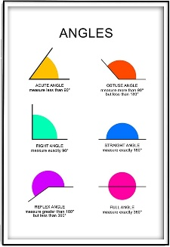 | Task 8  Create a word‑problem booklet using all four operations (multiplication, division, addition, subtraction). Include real‑life contexts and solutions.
Task 9-Sumdog  Complete the challenge on Sumdog:  Shape and Angles |  | Task 10-Languagenut  Complete the challenge on Languagenut:  Sentence Builder: Use vocabulary to describe yourself and family

Sharing your learning:

- All home learning should be put in your class notebook in your home learning jotter on Teams.

- You can add videos, upload photographs, insert Sway/PPT links or type directly onto your jotter. You can use a device in school to help you do this.

- You can share your learning with your clan home learning highlights.

Ask me!

1. What was the best thing that happened at school today?
2. Tell me something that made you laugh today.
3. Tell me a new word that you heard today.
4. If I called your champion tonight, what would they tell me about you?
5. How did you help somebody today or how did you help someone?
6. Tell me one thing that you learned today.

