Calderwood Nursery
I will be out of my bubble
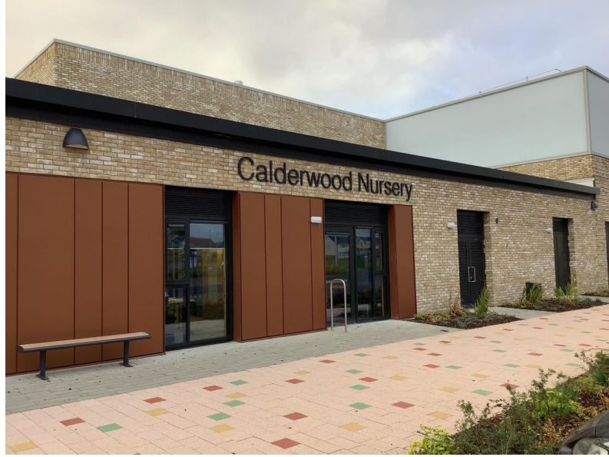

I will see my usual and new nursery teachers

When I come to nursery, I will put my bag and my jacket in the cloakroom, on my peg
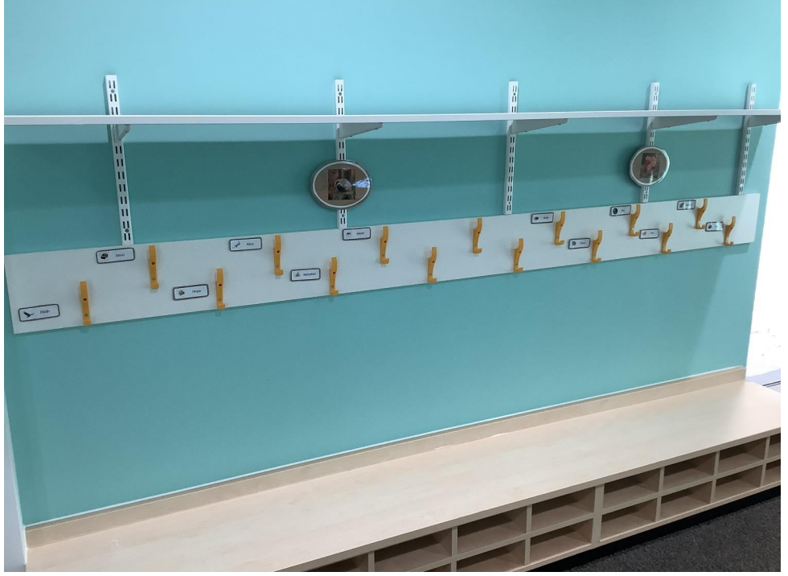

I will be able to play and explore every area inside the nursery
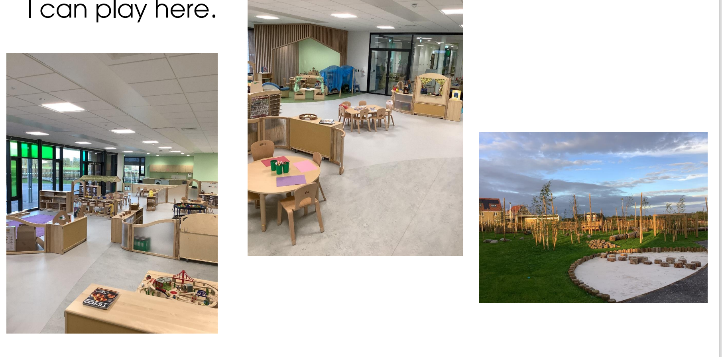

I will be able to play with all my friends inside the nursery
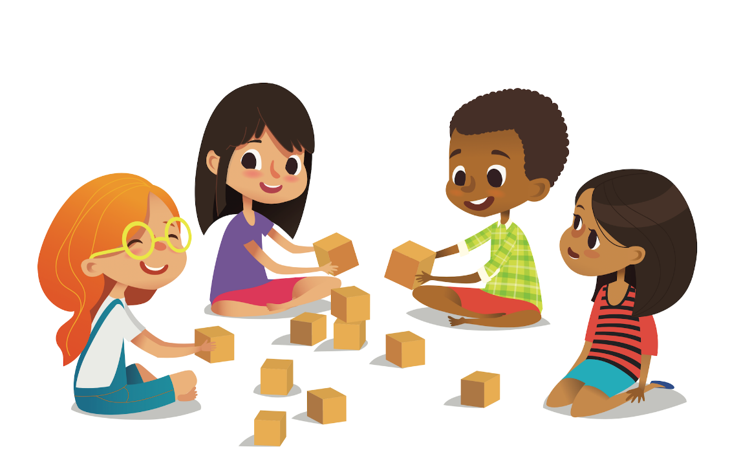

I can continue to learn lots of things
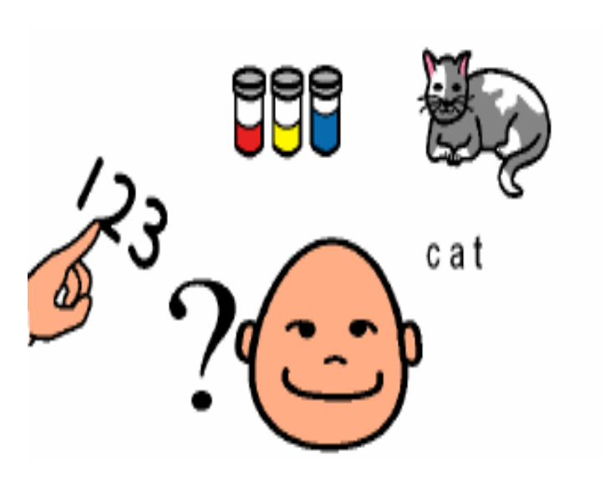

This is going to be fun!

