 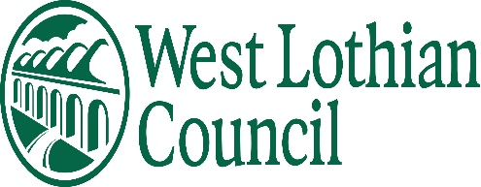 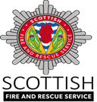

Dear Parents/Guardians,

In the run up to bonfire night, Police Scotland, West Lothian Council and Scottish Fire & Rescue are keen to keep everyone safe. In previous years we have seen firework-related anti-social behaviour (ASB) and disorder in this area, and we are asking for your help to prevent this occurring again. This year, we are also facing the added challenge of preventing the spread of COVID 19 within our communities. As a result organised fireworks displays and bonfires are unlikely to be permitted.

The Scottish Government is continually reviewing its COVID guidance and up to date information on what is and isn’t permissible can be found here<https://www.gov.scot/coronavirus-covid-19/>

We are offering the following advice to stay safe this fireworks night:

* Unless supervised by an adult, please do not allow your children or young people to handle, purchase or set off fireworks.
* Do not allow your children or young people to be involved in or accompany anyone who is involved in ASB or disorder.
* Please report any ASB or disorder you are aware of or hear of.
* Dispose of your rubbish appropriately leading up to bonfire weekend.
* Please report any known unauthorised bonfires or firework displays by calling:
  + West Lothian Council, 01506 280000
  + Police Scotland, 101
  + Crimestoppers, 0800 555 111
* You can report unauthorised fireworks sellers to Trading Standards anonymously by clicking the following link:

<https://www.westlothian.gov.uk/article/49071/Report-a-Trading-Standards-Issue-Anonymously>

Unauthorised bonfires and firework displays have resulted in serious harm and injury in the past. Further bonfire safety advice can be found here <https://www.firescotland.gov.uk/your-safety/bonfire-safety.aspx>

**Legislation**

* No person under the age of 18 can possess an adult* firework in a public place
* It is an offence to supply adult* fireworks to persons under 18
* It is an offence to supply *any* fireworks to persons under 16
* It is an offence to throw fireworks on a road or other public place

***\*Adult firework*** *is any firework except for caps, cracker snaps, indoor fireworks, novelty matches, party poppers, serpents and throw downs.*

Those who choose to get involved in antisocial behaviour or disorder on or around the 5 November 2021 will be dealt with robustly and may also be subject to prosecution.

Please help us make sure that everyone has a safe and enjoyable bonfire night.

Thank you in advance for your understanding and assistance.

Kind regards,

**Police Scotland, West Lothian Council & Scottish Fire & Rescue Service**