Online Learner’s Journals
This year the school are trialling ‘Learning Journals Online’ after their successful use in the nursery last year. Thank you to all the parents who have already sent in their email address and have accessed their child’s journal already.
If you need a login, please send your email address to Miss Mitchell in Primary 4.

How to Login:
https://blackridge.yourlearningjournals.co.uk/Login.aspx
Enter your user name and password on the first screen, followed by your 4 digit code on the next page.
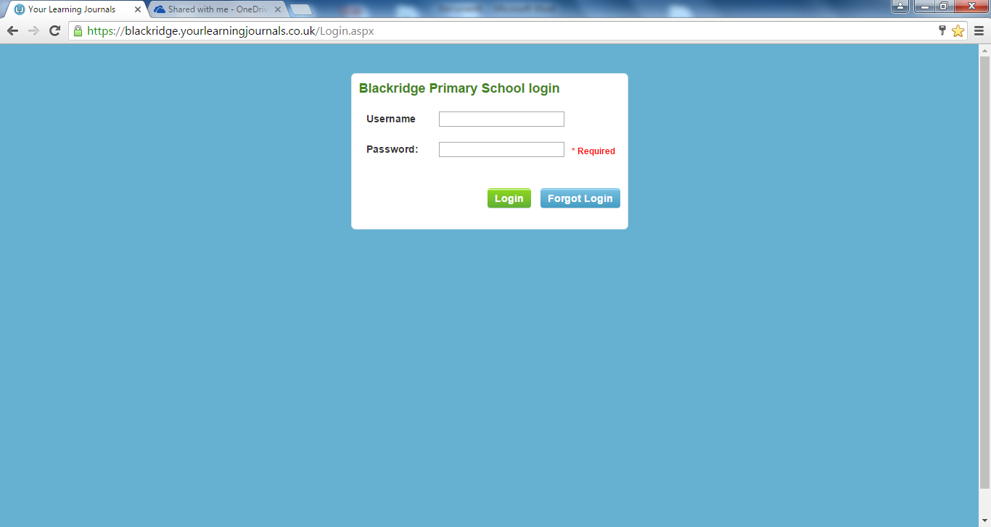
This should take you directly to your own child’s profile. If you have more than one child in N-p6 then you will have an options tab to choose which child you wish to look at.
What will you see?
The areas of the curriculum
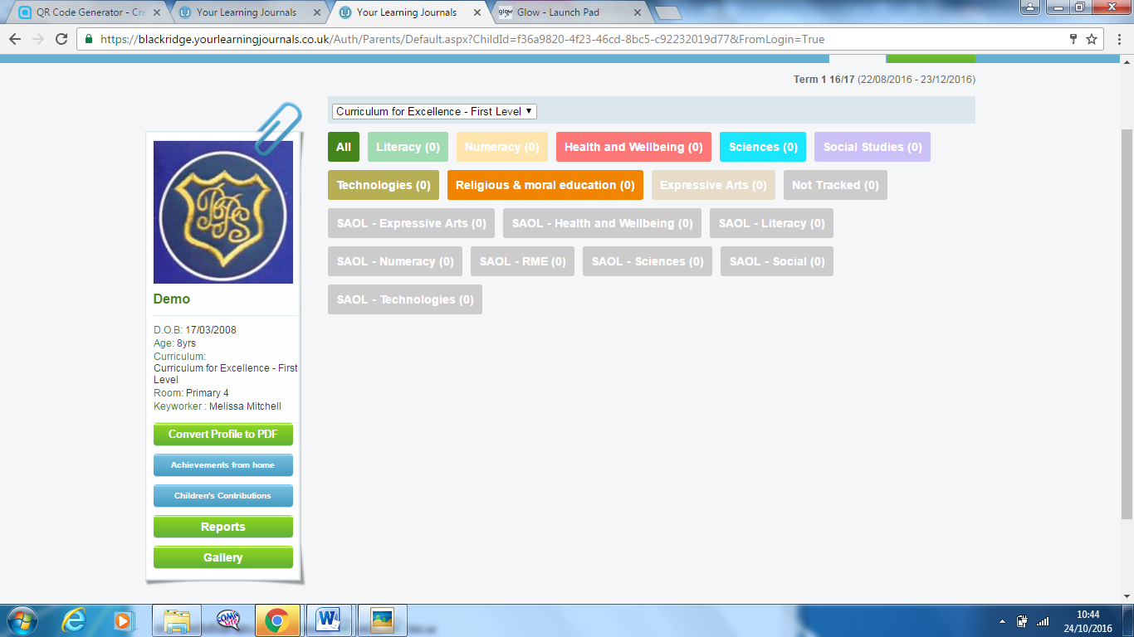
View all of the pictures of your child in an easy view gallery.
An option to upload ‘Achievements from Home’
An option to convert your journal into a pdf for easy printing at home.
Your child’s details including information about who their key worker or teacher is.

What an observation will look like:
Your observation may include 1 or more picture. If there is no picture the school badge will appear here.
Copies of the pictures will appear in the gallery.
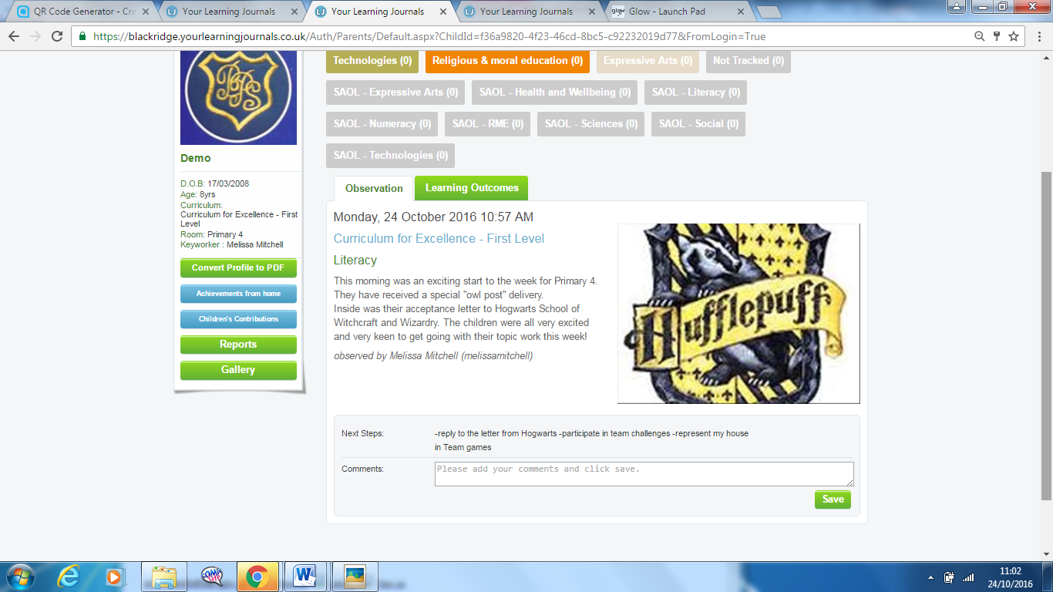
Any problems or questions, feel free to contact Miss Mitchell in Primary 4
Upload a photograph of your child’s achievement.
Add a title
Write a description of what is happening in the picture
Click Submit
This will only be able to be viewed by yourself and school staff.
Click on the ‘Achievement from Home’ Tab
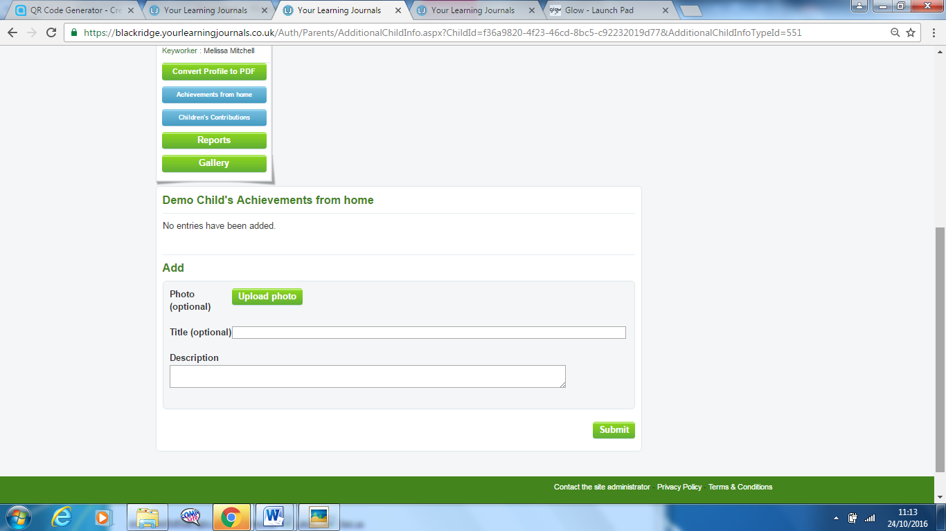
How can you add an achievement?
In the main body of the text there will be a quality observation of learning that has happened in your child’s classroom. This could be a group, class or individual observation. Underneath it will tell you which teacher wrote the observation.
Learning Outcomes-
If you click this tab it will show you the areas of the curriculum that this observation relates to.
In the shaded box is your child’s ‘Next Steps’ which will tell you their next step in learning.
In the white box there is a space for you to leave a positive and encouraging message for your child.

