Brian came and spoke to p6 again. We asked him some more questions and he answered all of them. He said that the link corridor had taken a long time as it needed underpinned. It would be open by the 18th of April 2016 so hot dinners will return again.
He also told us that the perimeter of the build is 19.6m + 13.7+ 19.6+13.7.
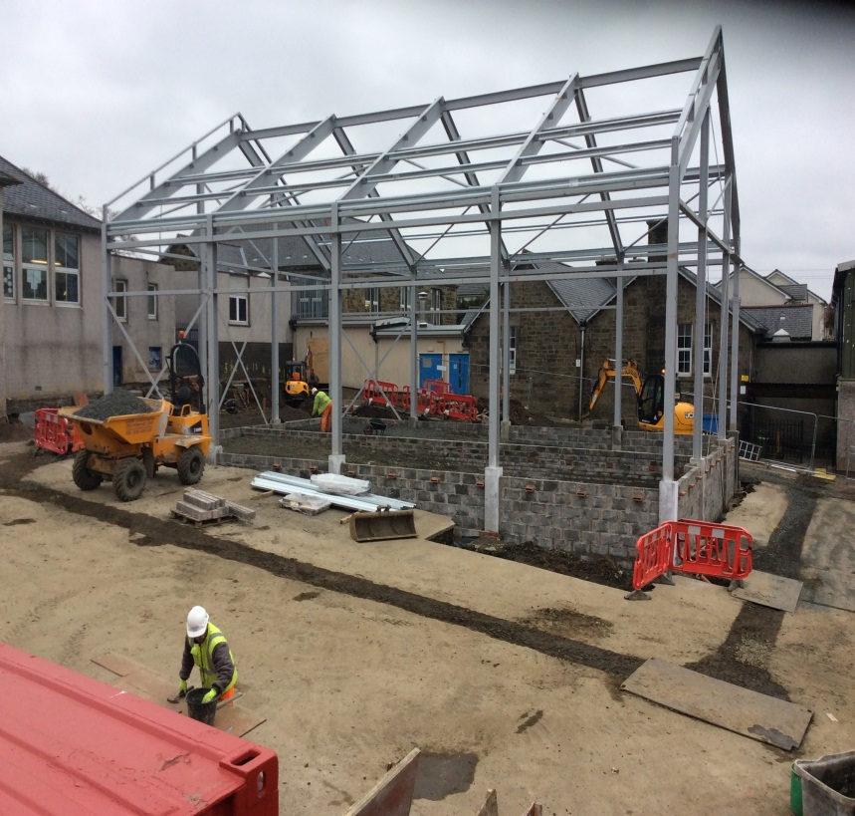
Brian says they can only do 3 brick layers a day as any more would not be safe. He is pleased with the way the build is progressing.
Brian, when he came in January, asked us to solve a real life problem. He said, how many men would I need to lay 25000 bricks in 22 days? The answer- Brian needs 3 men to lay those bricks in 22 days by laying 1200 per day.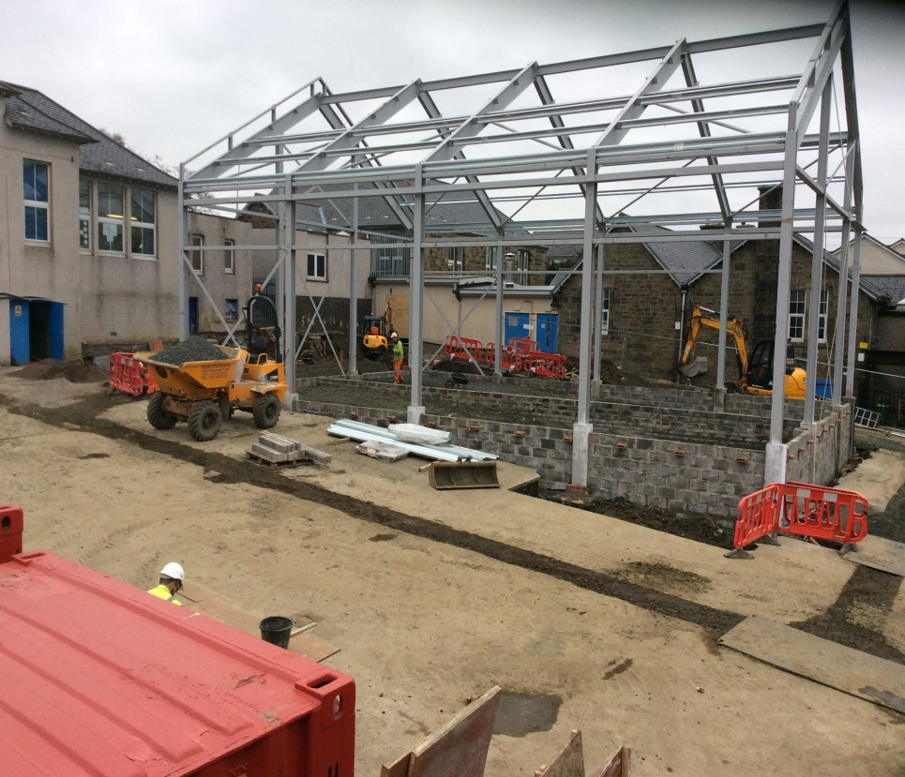
There will be no more digging in the process of this build. The frame is up! It is taking shape.

