Named Person - The Children and Young People (Scotland) Act 2014
The Act requires the promotion, support and safeguarding of wellbeing, as a common approach across all services engaging with children and families. It relates to the Getting it right for every child (GIRFEC) approach to improving outcomes through the delivery of services to support the wellbeing of children and young people. GIRFEC will help realise the shared ambition of making Scotland the best place in the world to grow up.
The GIRFEC approach recognises that at different stages of their life each child will have specific needs. Services need to be responsive to how these needs differ between children, how they change as they get older and whether they can be met with the universal support available to all children. Some children and young people may have temporary difficulties, such as illness, bereavement or moving school and some may live with challenges such as the effects of disability or long-term conditions. While most will get all the help and support they need from their parents, wider family and community, sometimes they and their families may seek extra support.
The Act becomes law on 1 Aug 2016 and West Lothian Council is working towards ensuring that all the requirements are met by this date.
This is the Wellbeing wheel and guides the work of staff in schools who help your child meet all 8 of the indicators show

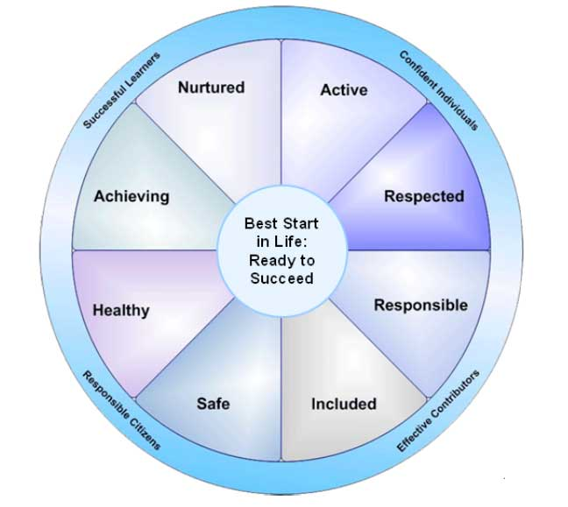
Safe
Healthy
Achieving
Nurtured
Active
Responsible
Respected
Included

What will it mean for your son/daughter?
A Named Person is one point of contact that your son/daughter, or yourself, can go to for advice or support if required.
West Lothian schools already have a system in place to ensure that your child is supported and to communicate any information to you. Staff use a range of practices to ensure that all 8 indicators are considered when planning any additional support for your child. This may involve requesting input from other services. This will continue for your son/daughter.
Who will be the Named Person for your son/daughter?
The Named person will be your Health Visitor in Nursery provision and prior to school entry.

Named person at school entry transfers to Education services.

Primary school Head teacher
Secondary school Head teacher who will delegate responsibility to House/Year Head
Special school Member of school management team

Some groups will be offered the Named Person service through West Lothian council, rather than Education services. These include Home Educated children and young people and young people who leave school prior to age 18.

What will the Named Person do?
The Named Person will endeavour to ensure support within the school is tailored to support your child.
At times, help is needed from out with the school and, as is currently routine practice, the Named person will apply for support from other agencies, eg. Social Work, Educational Psychology, Health and Police

The Named Person:
• Is the point of contact for the child, the parent/carer, the professional and community
• Will be familiar with a child’s progress within Curriculum for Excellence
• Will ensure that children and families are involved and informed of what is happening
• Will take action to help the child or arrange for someone else to do so
• Must work with universal services
• Co-ordinates support and liaises with other agencies if required
• Updates core information and keeps chronology of events

What happens is my child leaves school before age 18?
They will be given a card which will show them who to contact if they require help or support in the future. Staff working with young people post-school will be able to direct them to the person, employed by the Council, who will carry out the Named Person role.

West Lothian Council is committed to ensure the requirements of the Act are met and implemented by 1 Aug 2016.

Further information can be found on Scottish Government website
www.gov.scot/Topics/People/Young-People/gettingitright/named-person

For West Lothian Council information on Named person contact XXXXXXXX

