P6 spoke to Brian the site manager about the building project.
Brian said that the finishing date would be the 24th of August 2016. Their working times are 8:00 AM to 4:30 PM. The architect sent the builders the coordinates to get the right measurements.
They have been digging a trench that is 2m deep to make the solid floor of the extension. They need to dodge the pipes running underground.
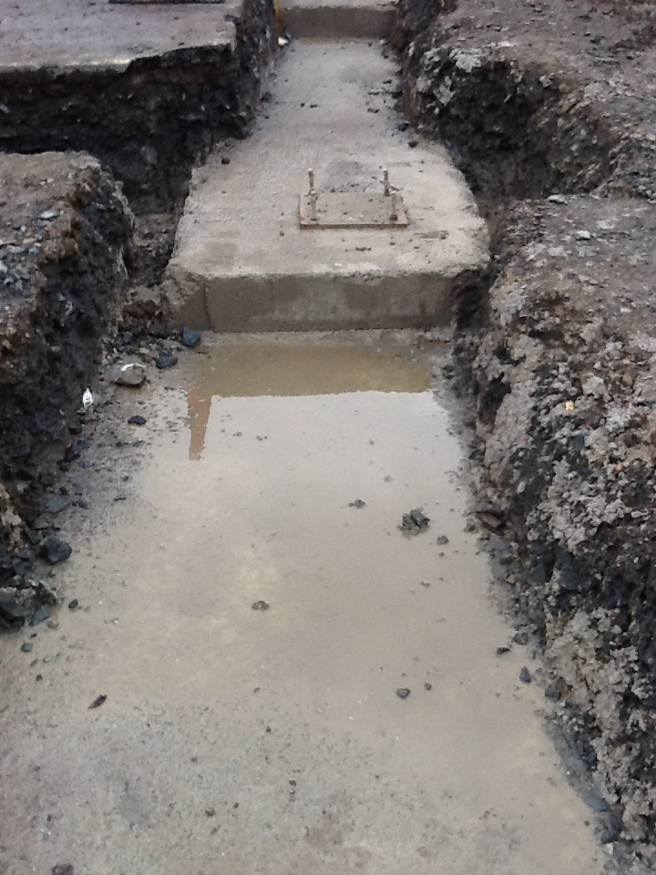
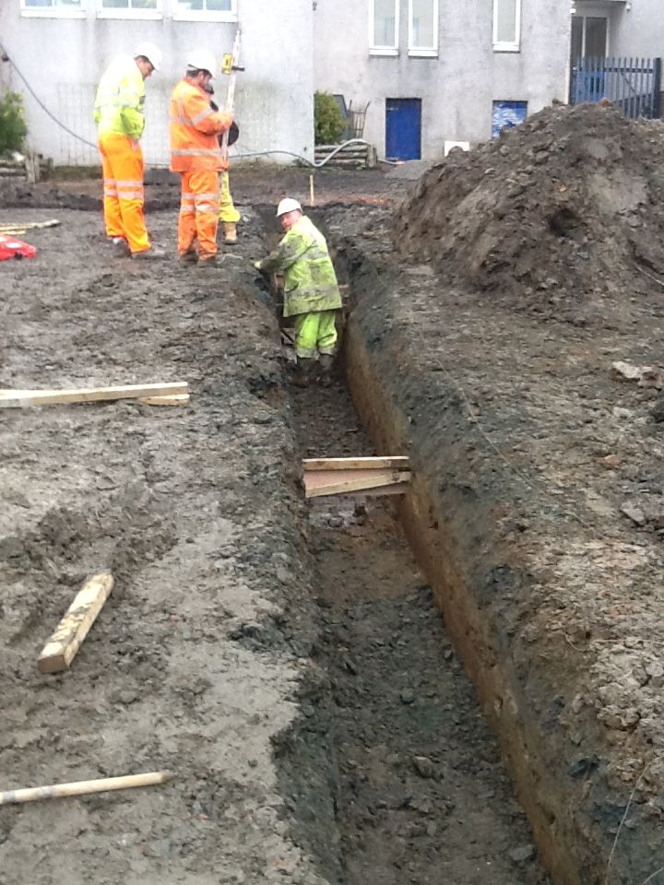

They are putting in a disabled lift in the link corridor. 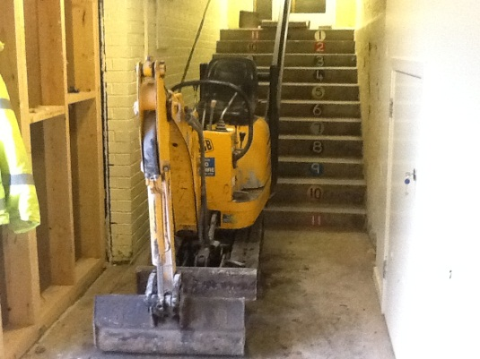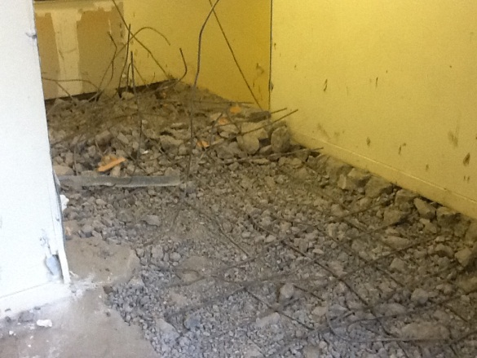
On site there are about 8 people right now. Soon there will be brick layers and steel fitters and then there will be about 20 people. There is no limit to how many diggers they can have on site, they have 3 diggers on site at the moment. To build the main structure they will need to use 25,800 bricks. Here is the view from Brian’s office.
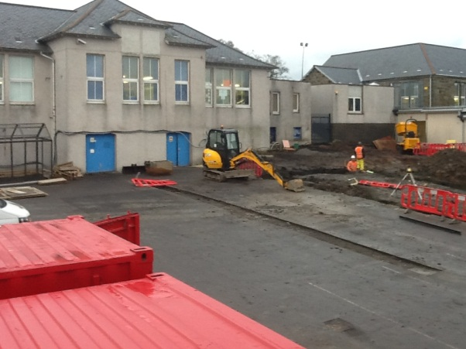
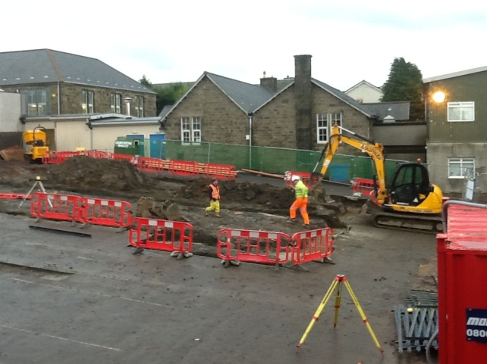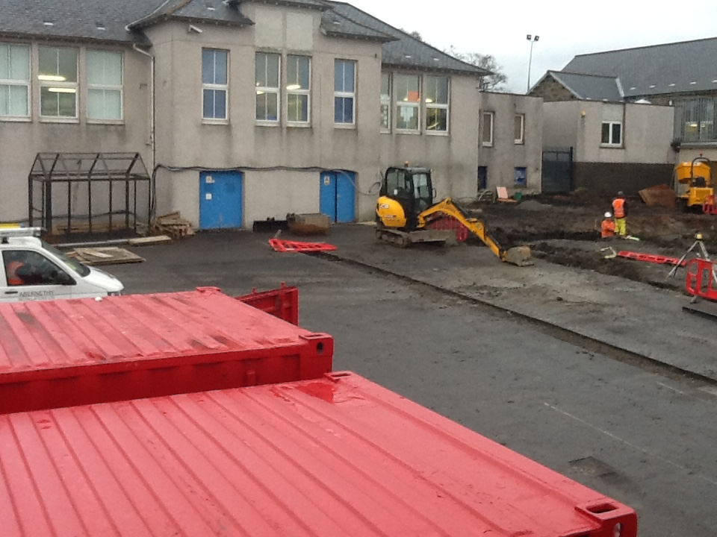
Here is Brian’s office. 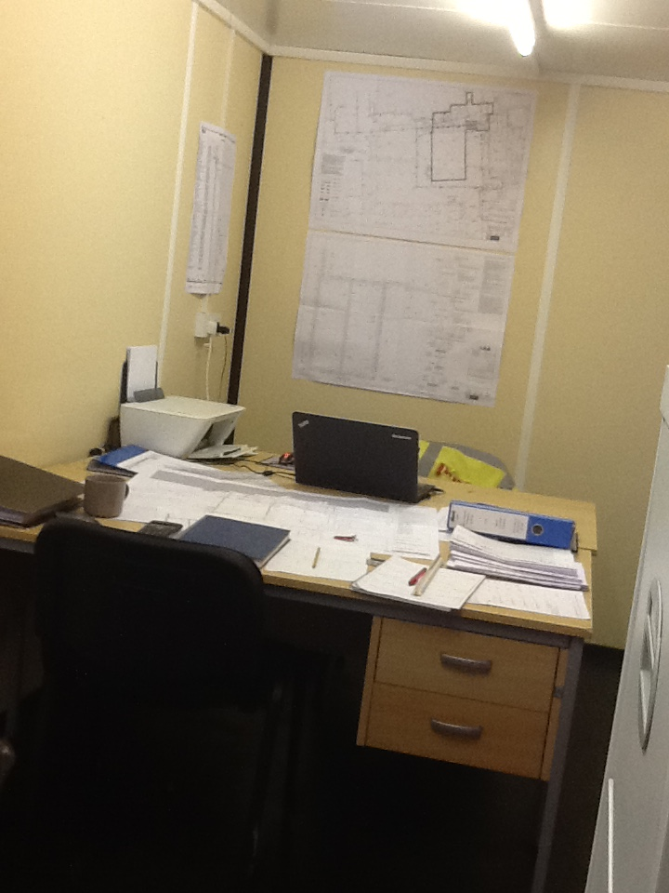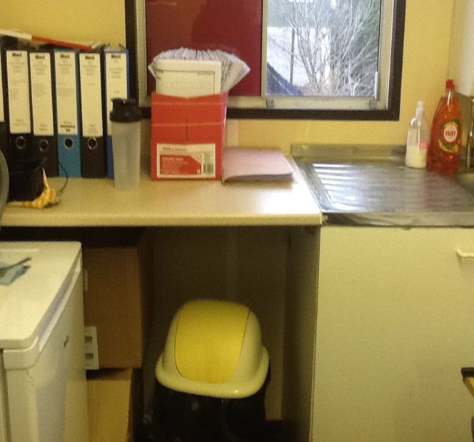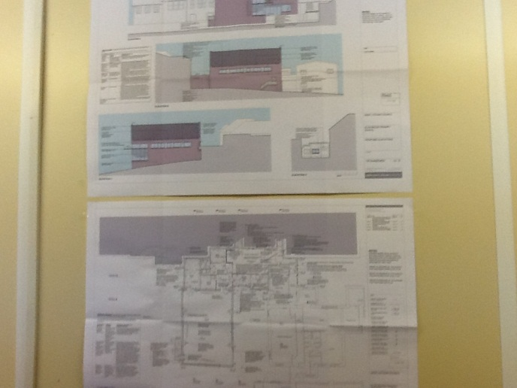

Here is Brian.
January’s update was written by
Poppy, Keenan, Amy and Ethan.
Primary 6.
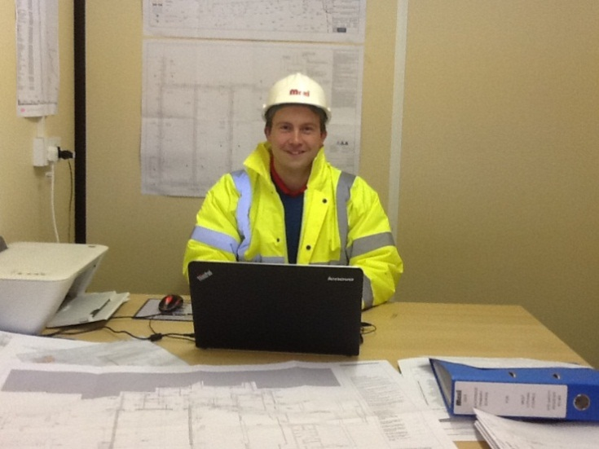
THE BIG BOSS

