

Blackridge Primary School

Main Street

Blackridge

[](http://www.clipartpanda.com/clipart_images/xmas-christmas-tree-5-png-1268212)West Lothian

EH48 3RJ

Tel. No. 01501 751223

December 5th 2014

Blackridge Primary School Newsletter

December 2014

Dear Parents/Carers,

Welcome to our December newsletter. There is a lot going on in school and in the community at Christmas so please take time to read all of the information included. A big thank you to all parents and friends who came to support our Scottish Week Open Morning. We had a fantastic morning of crafts, songs, poems and dancing.

This week some of our Primary 6 and 7 pupils have been practicing with the Armadale Learning Community Choir who will be singing in the old folks homes in Armadale. Primary 7 have also enjoyed a trip to the Forth Replacement Crossing in Queensferry. Our Primary 5 and 6 pupils have been out braving the cold to help plant trees in the local community. You can keep up to date with all of our activities on our brand new Blackridge Primary School Blog.

Our Christmas events include the whole school Christmas concert and Nativity performance, a trip to the pantomime at the Regal Theatre in Bathgate and of course our Christmas parties in school. We finish with our Church Service at Blackridge Parish Church on the morning of December 23rd to which all parents and friends are invited.

In January we welcome Mrs Ross (Head Teacher) back to school after her maternity leave. I would like to thank all pupils, staff and parents for their continued support during my time as Acting Head Teacher at Blackridge Primary School.

[](http://blogs.glowscotland.org.uk/wl/StoneyburnPS/files/2012/12/winter-ready-logo.jpg)Wishing you all a Merry Christmas and a Happy New Year.

Exciting News..!! Our new School Blog

After the success of our Nursery Blog we now have a School Blog. The address of the Blog is:

<https://blogs.glowscotland.org.uk/wl/blackridgeps/>

The Blog has lots of information about the school, upcoming events and photos. Keep up to date with what’s going on at Blackridge Primary School.

Winter Ready

If the school has to close unexpectedly due to bad weather we have packs of activities for your child. The Winter Ready packs can now be found on the School Blog. If you require a paper copy for your child please contact the school office.

Mrs J Russell (Acting Head Teacher)

Pupil Voice Update

Our Pupil Voice Committee has chosen some new playground equipment to be enjoyed by all pupils at break and lunch time. They also joined in with discussions on the council Better Outcomes Consultation. Our Head Boy and Girl and Depute Head Boy and Girl will be representing the school next week at the Armadale Learning Community Pupil Forum where they will be deciding on a joint project to organise.



UNICEF: Outright Day

Thursday 20th November was UNICEF’s Outright Day to commemorate the 25th Anniversary of the UNCRC. In school, each class was involved in writing a letter or creating a video message to send to the Scottish Minister of Children & Young People, Aileen Campbell about the importance of children’s rights. Each pupil wrote a right which was important to them and attached it to a balloon. The Rainbow Room put the balloons up around the school. We look forward to hearing back from the Minister and we also hope that you have taken the opportunity to read about which rights are important to the pupils in school.

[](http://www.google.co.uk/url?sa=i&rct=j&q=sports+clip+art&source=images&cd=&cad=rja&uact=8&ved=0CAcQjRw&url=http://www.clipartpanda.com/categories/sports-borders&ei=tXh8VP6GJsLSaNSBgoAD&psig=AFQjCNEfQFtifV6YFJpoblOaDsS7tF_Stg&ust=1417529828478767)

After Schools Club

This session we have run a very successful Multi-sport after schools club for Primary 1,2 and 3. Fifteen of our pupils enjoyed taking part in a variety of games and activities organised by Karen Brodie, our Active Schools Coordinator and run by Lynn. Next session we will be looking to run some more after school clubs for all pupils.

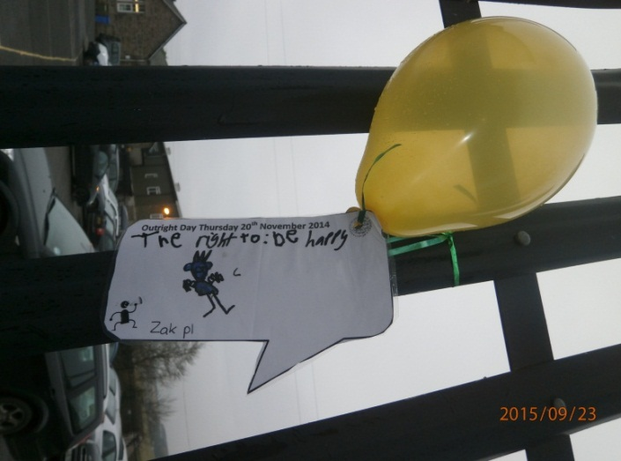

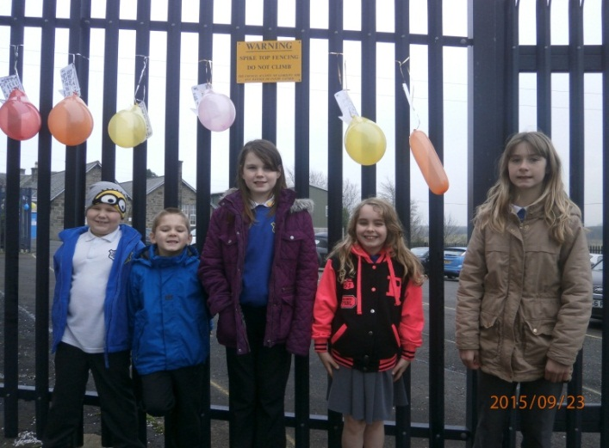

UNICEF: Outright Day - Sharing the rights that are important to us.

Christmas Dates for your Diary

[](http://www.clipartpanda.com/clipart_images/xmas-christmas-tree-5-png-1268212)December –

Monday December 8th Nursery Christmas concert – 10.00am and 2.00pm

Tuesday December 9th School Christmas dinner

Wednesday December 10th Flu Vaccinations

Nursery Christmas lunch

Nativity dress rehearsal (OAP’s only) 1.30pm

Thursday December 11th Nativity performance 1.30pm

Tuesday December 16th Nursery (am children) and Primary 1 to panto

Wednesday December 17th Nursery (pm children) and Primary 2 – Primary 7 to panto

Thursday December 18th Nursery party (am and pm children)

Primary 4 and 5 party (pm)

Primary 6 and 7 party at 6.30pm

Monday December 22nd Primary 1,2 and 3 party

Tuesday December 23rd Church service in Blackridge Parish Church (9.30am)

Wednesday December 24th Holiday

January –

Thursday January 8th 2015 All staff and pupils return to school

[](http://www.google.co.uk/url?sa=i&rct=j&q=Nativity+clip+art&source=images&cd=&cad=rja&uact=8&ved=0CAcQjRw&url=http://www.clipartbest.com/clipart-aceyRMpc4&ei=aXZ8VPmKLI7iaofHgVA&psig=AFQjCNFltBZlw2Q2uhKT2-Q4_PjCv18YyA&ust=1417529255145583)