Bathgate Early Years Centre
Whitburn Road
Bathgate EH48 2RD

Telephone & Fax - 01506 776234
e-mail – wlbathgate.eyc@westlothian.org.uk
Twitter - @wlbeyc

Head Teacher : Mrs Margaret Johns

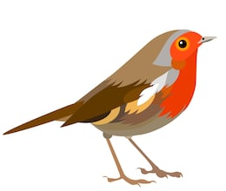
What are we learning about this month?
The children have been keen to learn more about birds and how they survive during the winter months. This topic has captured the imagination of the children allowing them to discover different types of birds from around the world. We would love to see what birds you spot in your garden or around the local community. You can share this with your child’s group via their online Learning Journal ‘Learning from home’ tab.
Please pop into nursery to have a look at our learning floor book where topics are detailed or look out for our learning Sway on our Blog and Twitter page coming soon.

Box Clever
Box Clever is an easily adaptable resource for nurseries aimed to improve vocabulary and social interactions. A theme is created along with a box of relevant resources. Over 5 small group sessions, nouns, verbs, adjectives, short phrases and conversations are developed. Our current Box Clever theme is birds, please take a Try at Home activity to support this initiative.

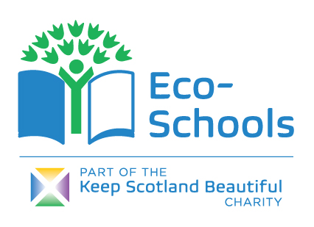
Eco School Appeal
We are appealing for donations of bulbs, seeds and plants to help develop our outdoor environment. Ged, one of our grandparent helpers has done a fantastic job revamping our orchard and surrounding grounds, if you would also like to volunteer to help maintain our garden space please speak to a member of staff.
Eco Meeting
We would like to invite parents and carers to join Miss Heenan, Mrs Ola and Margaret on Tuesday 25th February at 10am for our next Eco Meeting.

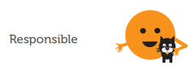
Fairtrade Fortnight
Fairtrade Fortnight February 24th – March 8th. During this fortnight we will be raising awareness and showing our support for the farmers and workers who grow our food in developing countries to ensure that they are paid fairly and earn a living income. We will make an effort in nursery to use as much Fairtrade produce as possible highlighting these issues to our young learners.
Extreme Weather Conditions – “Winter Ready”
Please check the weather conditions to ensure your child has the appropriate named clothing each day, (hat, scarfs, gloves and wellie boots) as we aim to be outdoors in all weather conditions if safe to do so.
In the event of severe weather, can we remind parents to listen to the local radio stations regarding school closures. West Lothian Council will also publish details of school closures on West Lothian Online Twitter and Facebook. For all details of West Lothian Council Winter Ready arrangements please look at: https://www.westlothian.gov.uk/winter

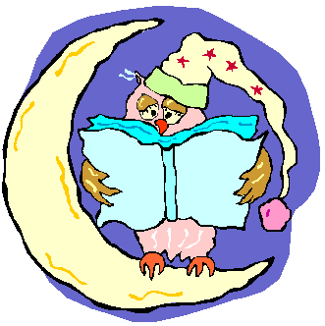
Big Bedtime Read
The re-launch of our BBR book packs (for pre-schoolers only) will begin week beginning 3rd Febuary and will be given out on a Tuesday and returned the following Monday. Please check the foyer every Tuesday for your child’s book pack. Pre School children who do not attend on a Monday/Tuesday will select their book packs on an alternative day.

Parent/Carer helpers
We would love to have lots of Parent/carer helpers to assist with walks, trips and nursery activities. Due to West Lothian Council policy it means our helpers are required to have a PVG. If you have a West Lothian PVG from disclosure Scotland please get in touch as we would really appreciate your help, alternatively if you would like to apply for a PVG please speak to Mrs Todd.


Bathgate Procession 2020
We would love the children to take part and represent BEYC in Bathgate’s procession this year but due to the increase in early learning and childcare hours we would rely entirely on parent/carer helpers to make this a possibility. Please look out for a theme suggestion board in the foyer and a Procession meeting date coming soon.

Safer Internet Day 2020

We are supporting Safer Internet Day on February 11th, As you know BEYC is a Digital School and as well as ensuring digital technology is thoroughly embedded in children’s learning experience we also highly value the importance of online safety. The children will be taking part in a variety of activities promoting online safety. Please check our blog and Twitter page @WLBEYC to keep up to date.


Winter Illnesses

As the colder months come, so do the coughs, colds and sickness bugs. To help minimise the spread of illnesses it is vital that children do not return to Nursery for at least 48 hrs after their last episode of sickness or diarrhoea. Another key step is to ensure that children are thoroughly washing their hands with soap and water at home and nursery. Please also see chickenpox guidance previously emailed from Mrs Todd.
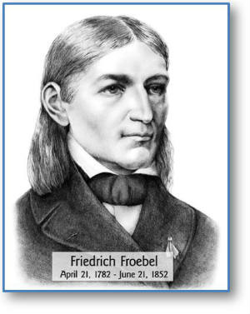
The child should experience nature ‘in all its aspects –form, energy, substance, sound and colour’. (Froebel in Lilley 1967:148).

Kind regards
The Nursery Team
Dates for the Diary
Date | Time | Event
Tuesday 4th February | Pre School Children | Big Bedtime Read Re launch
Tuesday, 11th February | Both Sessions | Safer Internet Day
Thursday 13th February | Both Sessions | Valentine’s Day Celebrations
Tuesday 25th February | Both Sessions | Shrove Tuesday
Tuesday 25th February | 10am | Eco Schools Meeting

