

**Balbardie Primary School**

**Primary 1 Parents**

**Tour our School**

**Wednesday 24th April**

Come and look around our school. Our Primary 7 pupils will take small groups of parents for a walk around our school at 9.15am or 2.30pm.

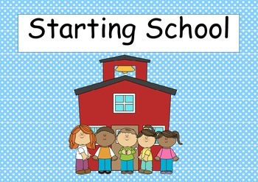If you are interested in coming please let a member of the nursery team know and they will book you in.