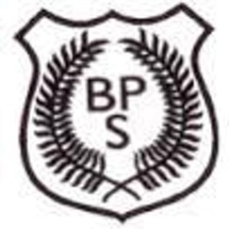New P1’s

**OPEN MORNING**

at

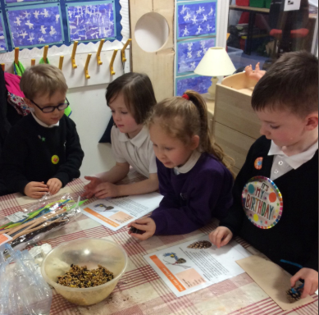Boghall Primary School

When: Friday 26th April 2019

Time: 9.15 - 10.15am

What? We will be holding an open morning for any P1 pupils who might be joining us in August.

There will be an opportunity to come and visit the P1 classrooms, watch learning in action and have a guided tour of the school by our Pupil Council. Teas/Coffees will be provided in the hall.

*This is an opportunity for you to bring along your child but we appreciate some pupils may be in Nursery so you are welcome to attend yourself if you would prefer.*

In the meantime, check out our school twitter page here: