Bathgate Early Years Centre
Whitburn Road
Bathgate EH48 2RD

Telephone & Fax - 01506 776234
e-mail – wlbathgate.eyc@westlothian.org.uk
Twitter - @wlbeyc

Head Teacher : Mrs Margaret Johns


What are we learning about this month?
The children have been keen to learn more about superheroes and how they can use their powers to help and save people. This topic has captured the imagination of the children allowing them to discover and create many characteristics of a superhero including promoting positive behaviours.
Please pop into nursery to have a look at our learning tree and learning floor book where topics are detailed or look out for our learning Sway on our Blog and Twitter page coming soon.


Wrigley Litter Less Campaign
Our launch day was a great success and had a real community feel as it not only involved our children and staff but also some parents, people from our community and children from the Eco committee at St Mary's Primary School. Local councillors visited and a worker from Sustrans also joined us on our litter picks on the cycle path. West Lothian Council media team took a short video and the West Lothian Courier took photographs. (See our Eco notice board) We collected 3kg 800g of litter on our first litter pick and we are hoping with your help to make a difference over the next three months. A big thank you to our parent helpers.
We also enjoyed recycling activities and games with Tracey the Tesco Community Champion, West Lothian Cleaner Communities Team and Eric the Dog.

Eco Meeting
We would like to invite parents and carers to join Miss Heenan, Mrs Ola and Margaret on Thursday 14th February at 10am for our next Eco Meeting. Please see dates for your diary below for more Eco activities this month.

Extreme Weather Conditions – “Winter Ready”
In the event of severe weather, can we remind parents to listen to the local radio stations regarding school closures. West Lothian Council will also publish details of school closures on West Lothian Online Twitter and Facebook. For all details of West Lothian Council Winter Ready arrangements please look at: https://www.westlothian.gov.uk/winter

Snack
If you would like to pay snack in a block up until the end of June it would be £34.50. Alternatively it can be paid each Monday at £1.50 per week. Please see Mrs Todd in regards to outstanding snack money.


Weekly Song Time
Mrs Frame’s very popular weekly song time is back, starting on the 20th February between 10.30 – 10.50am. Parents and Carers are invited to join Mrs Frame for selection of favourite, songs, stories and rhymes. Younger siblings also welcome!

Parent/Carer helpers
We would love to have lots of Parent/carer helpers to assist with walks, trips and nursery activities. Due to new policy from West Lothian Council it means our helpers are required to have a PVG. If you have a West Lothian PVG from disclosure Scotland please get in touch as we would really appreciate your help, alternatively if you would like to apply for a PVG please speak to Mrs Todd.


Cloakroom
Please can we ask that all wellington boots are going home each day. Ideally at this time of year children would come in their wellies/outdoor shoes, change into indoor school shoes and go home in wellies/outdoor shoes. As outdoor play is a core part of our provision can we please remind parents to provide appropriate named clothing for the changing weather conditions.

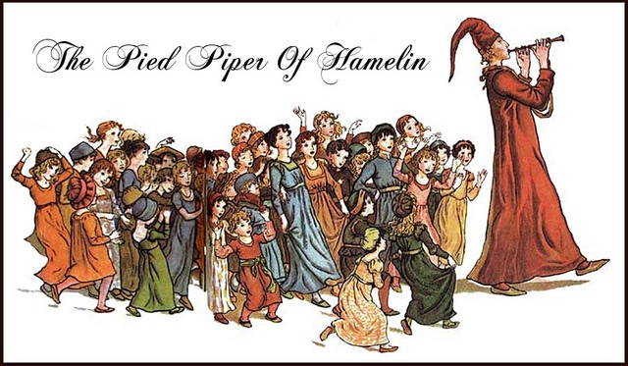
Bathgate Procession 2019
We would like to share a big thank you for some great theme suggestions, our theme is ‘the Pied Piper of Hamelin’. We are very much looking forward to walking in the procession and hope to see as many of our families walking with us as possible. Mrs McKay will be beginning work on the costumes and will shortly have samples ready for parents to see and order.

Parents Craft Group
Parents area craft group will return weekly starting on Wednesday 20th AM session & PM session. We need as many parents/carers as possible to pop in on occasion or stay weekly to begin work on the fabulous handmade procession costumes. To raise funds to purchase supplies and materials the nursery will be having a bake sale on Thursday the 28th February, all home baking welcome.


Winter Illnesses
As the colder months come, so do the coughs, colds and sickness bugs. To help minimise the spread of illnesses it is vital that children do not return to Nursery for at least 48 hrs after their last episode of sickness or diarrhoea. Another key step is to ensure that children are thoroughly washing their hands with soap and water at home and nursery.

Kind regards

The Nursery Team

Dates for the Diary

Date | Time | Event
Tuesday, 5th February | Both Sessions | Safer Internet Day
Tuesday 12th February | Both Sessions | Big Schools Birdwatch
Wednesday 13th February | AM Session | Morning Litter Pick  (Parent helpers required)
Thursday 14th February | Both Sessions | Valentine’s Day Celebrations
Thursday 14th February | 10am | Eco Meeting (All parents/carers welcome)
Monday, 18th February | Both sessions | Nursery closed for mid-term break.  Wraparound open as usual.
Tuesday, 19th February | Staff In-service | Nursery closed for mid-term break.  Wraparound open as usual.
Wednesday 20th February | Both Sessions | All children resume
Wednesday 20th February | Both Sessions | Parents Craft Group
Wednesday 20th February | 10.30am | Mrs Frame Song time
Thursday 21st February | Both Sessions | Switch off Day
Thursday 28th February | Both Session | Bake Sale (Procession funds)

