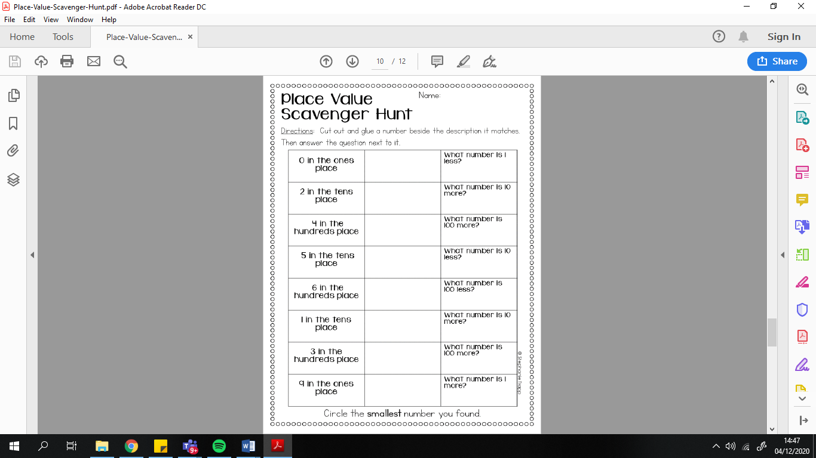

This page does not need to be printed off. Numbers can just be written on paper or verbally answered. Directions: Try to find numbers in books, magazines, adverts, listening on TV etc that match the instructions on the sheet.