Primary 2 Homework Grid for week beginning 7.12.20
Maths/Numeracy/Problem Solving  A candy cane costs less than 20p. How much could the candy cane cost if you paid with 3 of these coins?  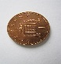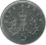  This Photo by Unknown Author is licensed under CC BY  This Photo by Unknown Author is licensed under CC BY-SA  Photo by Unknown Author is licensed under CC BY-SA  1p 2p 5p 10p | Literacy  You are working really well on the high frequency words and should be recognizing these in the Oxford Owl books. Using the high frequency word list and spelling selection sheet provided last term, continue to practise reading and spelling high frequency words.  The ’R’ column can be ticked when you can read the word and the ‘W’ column when you can write it.  You can go at your own pace with this and maybe do a couple of words a night. | Interdisciplinary  In class we have been discussing how Christmas is celebrated in Scotland. Can you find out how Christmas is celebrated in another country?  This Photo by Unknown Author is licensed under CC BY-SA
Reading  Continue to do some activities from this Christmas Reading Challenge.  https://misterbodd.wordpress.com/2020/11/29/christmas-reading-challenge/amp/?__twitter_impression=true  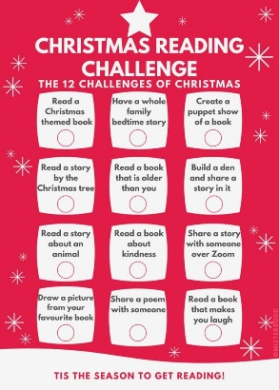 | What’s On This Week  - P.E. Days : Tues and Wed  - Outdoor Learning - Friday | Homework will be issued on a Monday and will be due for completion by the Thursday.  Your work should be uploaded to Teams/Learning Journals or emailed to the school office wlbellsquarry-ps@westlothian.org.uk if these options aren’t available.  If you have any problems with your homework, please speak to your teacher before Thursday.

