Primary Homework Grid for week beginning 23.11.20
Maths/Numeracy  We are delighted that so many of you were on Sumdog last week and were able to join up and compete with your friends. Please spend some time on Sumdog this week. | Literacy  You are working really well on the high frequency words and should be recognizing these in the Oxford Owl books. Using the high frequency word list and spelling selection sheet provided last term, continue to practise reading and spelling high frequency words.  The ’R’ column can be ticked when you can read the word and the ‘W’ column when you can write it.  You can go at your own pace with this and maybe do a couple of words a night. | Interdisciplinary  Please choose an activity to do this week from the Toys Home Learning Grid.  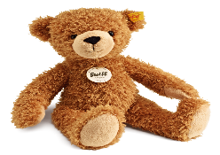  This Photo by Unknown Author is licensed under CC BY-NC
Reading  Please continue to access Oxford Owls and select a book to read-  https://www.oxfordowl.co.uk  Login details-  Go to ‘My Class Login’ and enter the following-  Class name : P2BQ  Password : BestClass  If there are 2 play activities at the top of the screen, try these after reading the book. | What’s On This Week  - P.E. Days : Tues and Wed  - Outdoor Learning - Friday | Homework will be issued on a Monday and will be due for completion by the Thursday.  Your work should be uploaded to Teams/Learning Journals or emailed to the school office wlbellsquarry-ps@westlothian.org.uk if these options aren’t available.  If you have any problems with your homework, please speak to your teacher before Thursday.

