Pupil’s Instruction: Procedure Genre Targets  To provide instructions about how to make or do something  Second Level  Name:………………………………………….  Assessed:……………………………………… | 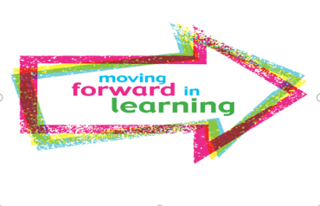
I can...
- understand the purpose and audience.
- include a title linked to the instructions/procedures.
- include a list of materials needed with some detail
- use numbers and bullet points to organise the information
- include a series of steps in the correct order e.g. cut, twist, turn
- write in the third person, in the present tense e.g. he, she, they, it
- use linking words such e.g. first, when, after etc
- record the main events into paragraphs in time order. Include details to help reader visualise the event. Use topic sentences at the beginning of the paragraph to say what the paragraph is about.
- use photos/graphics/illustrations to engage the reader
What went well… (Use the Success Criteria to help with comments)

Self –

Peer –

Teacher -

Even better if… (Use the Success Criteria to help with comments)

Self –

Peer –

Teacher –

