Stage:7 | Second Level
Hallo  I thought it would be nice for your final term to have a very creative topic.  I have decided that we would look at the creators of film. You have seen the Harry Potter theme outside my classroom. You saw the making of wands, portraits, and Hogwarts.  I am really sorry but we can’t make wands etc because of the resources but we can design and create many things from a ‘Film’ topic.  I am going to give you the choice of the theme you would like to undertake. This project is for you to start on Monday. Remember this is for a 50-minute lesson each week. Follow the tasks in number order. The extension activities do not have to be completed.  I will check in each Tuesday as normal so I can view your work but I will check in Fridays each week too. |  | Learning Intention.  I can create and present work that shows developing skill in using the visual elements and concepts. EXA 2-03a  I can respond to the work of artists and designers by discussing my thoughts and feelings. I can give and accept constructive comment on my own and others’ work.  Through observing and recording from my experiences across the curriculum, I can create images and objects which show my awareness and recognition of detail. EXA 2-04a | T  Task 3 We have looked at films of today and the wonderful animation that is present in the films we see on screen.  Disney is the person we have to thank for cartoons and early animation.  Draw a character from a recent Disney film.  - It can be of any film you like. Test your skills on other people see if they can name the character you have drawn.
 |  | Harry Potter and Star Wars have been on the TV a lot recently so I thought we would have a look at these film makers first.  Task 1  - Draw a character from either Star Wars or Harry Potter.  - Extension, if you have the materials colour or paint your character. | 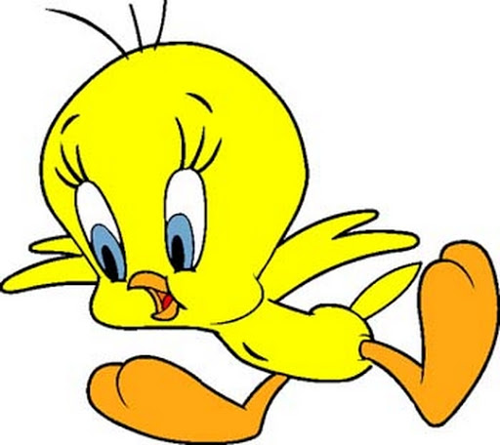  Task 4  - Draw any other cartoon character you  - like.  - Try and make the colours exact and cartoon like. Felt tips are good for this.
Task 2
- Draw or paint your character in their film environment. e.g. Chamber of Secrets, the Great Hall, Death Star etc.
- Extension, add some different mediums to you painting/drawing, e.g. tin foil, textured papers etc.
This is a two-week assignment. I really look forward to seeing your paintings and drawings.

