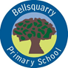

I hope you all had a wonderful weekend.  I look forward to seeing all your drawings and creations.  Your topic is the Vikings.  Our first task of your new grid starts on Monday 11th of May.  Learning Intentions.  I can create and present work using the visual elements of line, shape, form, colour, tone, pattern and texture. EXA 1-03a  I can create a range of visual information through observing and recording from my experiences across the curriculum.  EXA 0-04a / EXA 1-04a  TCH 1-01a  I can work with others to generate, discuss and develop imaginative ideas to create a product of the future | Task 1  https://content.twinkl.co.uk/resource/40/91/t-t-18457-viking-longboat-paper-model-template-_ver_1.pdf?__token__=exp=1588951065~acl=%2Fresource%2F40%2F91%2Ft-t-18457-viking-longboat-paper-model-template-_ver_1.pdf%2A~hmac=43943c908b4b68fa4bc0941daf1aed916b67c3b23484f60e082c392a68c9d23e  Link 2  https://www.google.com/search?q=pictures+of+vikings+for+children&tbm=isch&ved=2ahUKEwiKyI2GxaTpAhVGMRoKHZ1ZC_wQ2-cCegQIABAA&oq=pictures+of+vikings+for+children&gs_lcp=CgNpbWcQAzoHCCMQ6gIQJzoECCMQJzoECAAQQzoCCAA6BQgAEIMBOgYIABAFEB46BggAEAgQHjoECAAQGFCM401Y98JOYI7HTmgBcAB4AoABU4gBzhuSAQI1N5gBAKABAaoBC2d3cy13aXotaW1nsAEK&sclient=img&ei=A3W1Xsq6OcbiaJ2zreAP&bih=619&biw=1131&rlz=1C1CHBF_en-GBGB899GB899  Link 3https://hiddenheritage.org.uk/schools/craft-activities/  Task 3.  Draw armour from the days of the Vikings.  A shield, A sword and some form of head wear.  - If you look through link two or you can research yourself there are hundreds on line.  - Extension use tin foil or other materials on your armour.
Task 1  - Using the template from link one, you are going to test your folding skills and cutting skills. A great skill to learn in Technology. You might need an adult to help you?  - Make your Viking boat, take your time, compare it with your own.  - Extension… use different colours to create your boat.  Task 2.  Vikings were a force to be reckoned with.  - Look at Link 2 and draw your own Viking. Just head and shoulders. Again, take your time.  - Draw the shape of the head first, then add the beard and eyes etc.  - Try and use colours if you have them. | Task 4.  I love this task!  Draw the demon that will chase away the evil spirts on your boat. They MUST look scary!  Look at link 3 and seewhat other children have created.  Well done P4! There are a lot of instructions here but you can always refer to pictures or go on line to see what everything looks like.  This is a four-week task but I will be checking in every week to see how your doing and to see the great things you have drawn and constructed. | 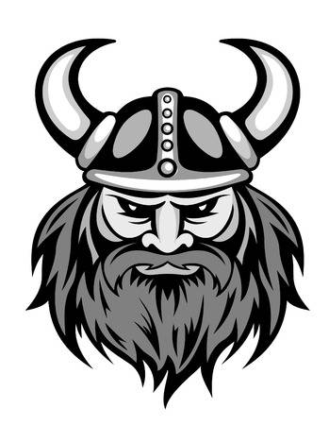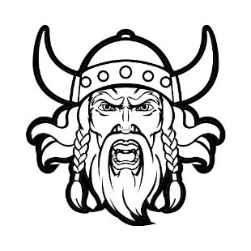  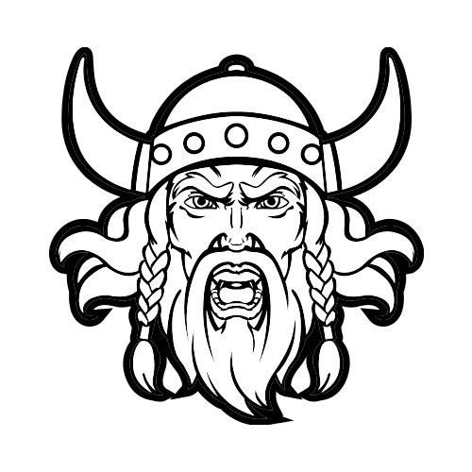
Mrs. Martins Learning Grid for Art and Technology. Grid 3 for Primary 4 May 11th

