**Name** __________________ **Date issued**: 6. 03. 18 **Date to be submitted**: 19.03.18 Parent signature __________________

**SPELL IT**! 

Please see jotter for words Look, Cover, Write, Read- Spelling words 3 times for each word.

 **READ IT**!   
Practise reading your reading book. Read the words using the pictures as clues and by sounding out short, regular words.

Guided reading sessions take place on a Tuesday and Thursday however children should have their reading books in their bags daily for extra practice.

**FEED IT!**

Remember to feed the birds during the cold days!

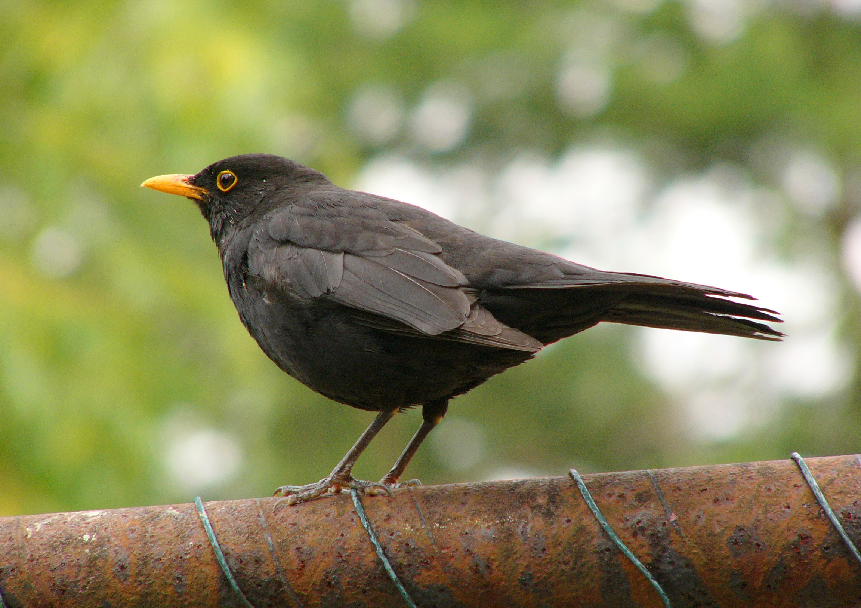



**Date Issued: To be submitted by:**



P2 Homework

**A note from your teacher**

Hope everyone was safe and warm during the snowy weather !

Please complete all the tasks with the stars.

**SPOT IT**! 

Go for a walk to see if there are any bulbs sprouting through the soil.

If you spot any take a photo or draw it!

**NUMBER IT!** 

Complete Home Activity Sheet.

Remember to check your answers and make sure numbers are correctly written.

Then ask an adult to sign it

**WEIGH IT!** 

Wrap some objects in foil to make asteroids (e.g. cotton wool, a stone, playdough). Which one is heaviest and which one is lightest?

Can you put them in order?

Can you weigh them on a scale?