Bellsquarry Primary School
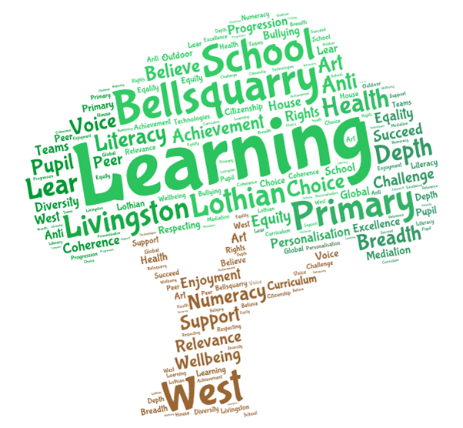
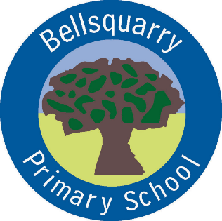
P3 Learning Overview
Term 3 (January – March 2018)
The main focus for learning this term will be:
Literacy
- Literacy Circles
- Whole class/group & partner discussions
- Written & verbal comprehension tasks
- Scottish Poetry
- SWST program with a variety of spelling strategies
- Variety of writing linked to topics
- Imaginative writing focus (linked to Harry Potter topic)
Numeracy
- Fractions, Decimals and Percentages
- Shape
- Problem solving
- Mental arithmetic (including Number Talks and Sumdog)
Health & Wellbeing
- Primary Drug and Alcohol Education Programme
- Emotion Works
- Internet safety
- Keeping Myself Safe
- P.E. – Gymnastics and Futsal
Interdisciplinary Learning
- Robert Burns and Scotland (including a comparison study with another country)
- Harry Potter
Discrete Subjects
- French
- Science – Energy
- RME – Carnival
- Art and Design - Tartan and Burns night
- Music improving ocarina skills, singing in parts, ensemble djembe palying building on previous experience
Opportunities for personal achievement and involvement in the ethos and wider life of the school
- Class representatives – Pupil Council, House captains, Eco, JRSOs, Peer mediation, Pollination group
- Classroom jobs – changed weekly
- Buddies for P1 pupils
- Star of the Week
- Daily Mile
- Assembly certificates
- House points
Other information
- PE – Monday and Thursday
- Literacy Circles’ on Tuesday due for the following Tuesday

