Bellsquarry Primary School
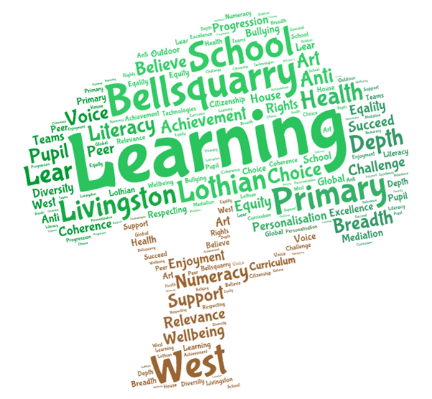
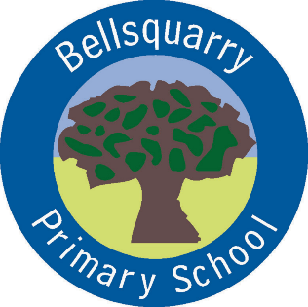
Primary 6 Learning Overview
Term 3 (January- April 2018)
The main focus for learning this term will be:
Literacy

Writing
Our focus for this term will be persuasive writing. We will be learning about the techniques we can use to persuade our readers to agree with our point of view. This will involve looking at emotive language, asking questions and giving evidence to support our argument.

We will also be using our imaginative writing skills and linking them with our topic of The Jacobites, in particular, a diary entry (recount) about the Massacre of Glencoe.

Reading
Our focus for reading this term will continue to be on ‘Reading for Understanding’. This will require pupils to read several pages at a time and to discuss their reading, as part of their group. This may be done individually, ‘paired and shared’ or as a whole group. Through discussion, themes and sub-themes can be discussed and ideas and thoughts shared. Literal and inferential skills will also be developed as well as the author’s use of language.

Activities such as ‘Characters on a Roll’, ‘Shoebox Book Project’, ‘Rolling Through the Text’ as well as comprehension related activities will provide opportunities for pupils (and parents) to engage with the text in a fun and inter-active way.

We will also be using non-fiction texts to help us research our topics for this term.

Listening and Talking
Our focus on listening and talking this term will centre on group work. Pupils will be participating in team building activities across curricular areas, which will require them to listen to others, co-operate as part of a team and to propose their own ideas. We will also be preparing and performing a class assembly, giving the children an opportunity to perform in front of an audience.

Numeracy

‘Talking Maths’
We will continue to focus upon the process and strategies which pupils adopt. Through discussion, this will provide pupils an opportunity to discuss which strategies ‘best fit’ their way of learning and which strategies they can use as a back up to cross check their work – dialogue is the key to understanding and learning.

Addition and Subtraction
We will be using a range of strategies to help us solve addition and subtraction questions, including those that require us to work with larger numbers. We will focus on mental strategies as well as written methods.

Multiplication and Division
We will be investigating the many different strategies which pupils use / will be using in order to multiply and divide. We will investigate the standard written method as well as multiplication using a grid system which deconstructs numbers into manageable chunks. In division, we will be investigating different strategies which pupils use and, as with multiplication, we will be learning to divide using the standard written method as well being introduced to division through repeated multiplication.
Health & Wellbeing

Emotion Works
Working with Mrs Gilmour, the pupils will be using this resource to investigate emotions. We will be learning about how our emotions affect our bodies, behaviours related to our different emotions and coping strategies.

Interdisciplinary Learning

The Jacobites
This topic will encompass Social Studies, Literacy and Expressive Arts, in particular Art, Music and Drama, with the following skills being developed:

- Social Studies: Linking and sequencing significant historical events and figures;
- Literacy: Reading for Information, Note making, Presenting Information and Personal/Imaginative writing;
- Art: Character Portraits with attention to detail, depicting history through Art;
- Music: Listening to, responding and performing Jacobite songs;
- Drama: ‘I am MacIain’ drama performance with pupils assuming roles and conveying the emotions of a character;

Applying all our knowledge and skills of the above, will present to the school, as well as parents our drama, ‘I am MacIain;

Discrete Subjects

Religious & Moral Education
We will be learning about the beliefs and traditions associated with Easter and Ramadan.

Science
This term, we will be attempting to answer the question, ‘What is Extreme Weather?’ Researching the many different types of extreme weather on Planet Earth, pupils will create their own fact file or mini presentation about one form of extreme weather and will feedback to the class. We will also don the white coat and lab goggles and attempt to create some of these experiments in the classroom……watch this space!

Opportunities for personal achievement & involvement in the ethos/wider life of the school

Pupils will continue to take on roles and responsibilities within the school. These include Eco rep, Rights Respecting School rep, Pupil Council rep, Junior Road Safety Officers, classroom helper jobs, nursery buddies and helping in the playground.

The focus of Learning and the Success Criteria will always be shared and discussed with the pupils to ensure they understand how they can achieve their targets. Formative Assessment strategies such as ‘thumbs up, middle or down’ and ‘Fist to 5’ will also be used to ensure that each pupil understands the task required. Success is also celebrated through Self and Peer Assessment and meeting personal targets.

Effort is valued highly, with pupils encouraged to ‘be the best we can be’. Where a pupil does well i.e. produces a very good piece of work, demonstrates polite manners and/or promotes the school in a positive way, not only can they receive House Points, but within the class they can receive Raffle Tickets. There is no limit on the amount of Raffle Tickets they can receive and they will be entered into a prize draw in June. Table Points can also be awarded should a table be working well together with a weekly ‘Table of the Week’ award and prize. Finally, there is also a ‘Pupil of the Week’ award where the teacher feels that a pupil has worked consistently to the best of their ability. They will receive the ‘Pupil of the Week’ trophy to keep for their week, along with a Raffle Ticket, mini credit card style ‘Superstar’ award and a Certificate for their efforts.

We also love to hear about pupils’ achievements from beyond the classroom. Please let us know and we can share these successes in the class and at our weekly whole school assembly.

Other information

PE
Our PE times this term will be: Monday mornings with Mrs Green, a Tuesday morning with Mr Hunter and a Wednesday morning with Mrs Gilmour. Please ensure that your child has their PE kit with them on these days so that they can take part. It is also recommended that jewellery, such as earrings, is not worn on these days.

French
Pupils will begin to develop their knowledge of French, in particular basic conversations as well as the written aspects of the language.

Music
Music will be on a Wednesday morning with Mrs England.

We hope your child has an enjoyable experience in Primary 6, however, should you have any issues or concerns, please let us know and we can get together to ensure your child has a happy, memorable and exciting learning experience in Primary 6.

