Bellsquarry Primary School
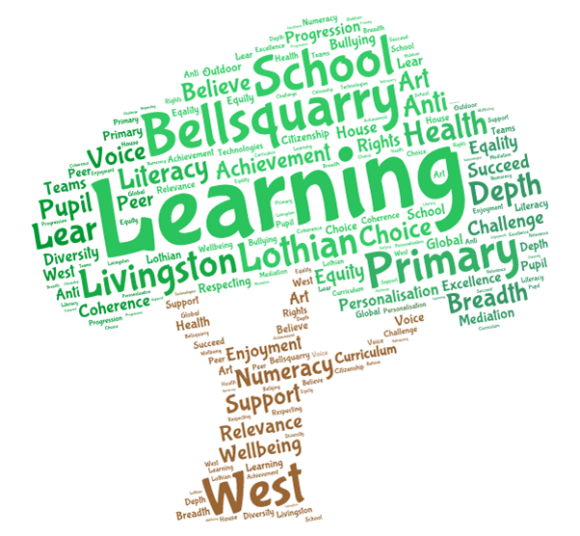
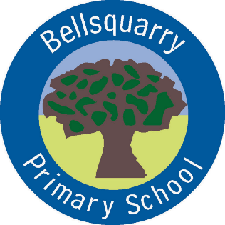
P5 Learning Overview
Term 3 (January – March 2018)
The main focus for learning this term will be:

Literacy
- Literature circles
- Poetry
- Imaginative writing (linked to Scottish/Titanic topic work)
- French
- Spelling patterns
Numeracy
- Mental and written multiplication and division
- Fractions
- Measure: length and area
Health & Wellbeing
- Substance misuse education
- Gymnastics (continuation)
- Scottish country dancing
- Daily mile
Interdisciplinary Learning
- Scottish topic: Highland Clearances
- Titanic
Discrete Subjects
- Science: floating and sinking
- RME: Pesach and Easter
Opportunities for personal achievement and involvement in the ethos and wider life of the school
- Class Assemblies
- House Points
- Table of the Week
- Assembly Certificates
- Leadership Roles
Other information
- PE is on a Monday, Thursday and alternate Wednesdays
- Reading homework due dates will vary and will be found in reading record
- Our Lorax assembly for the children in school is on Friday 19th January

