Bellsquarry Primary School
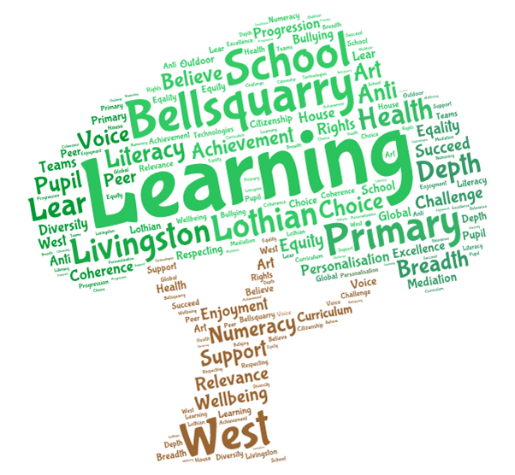
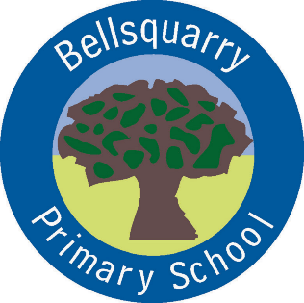
P4 Learning Overview
Term 3 (January – March 2018)
The main focus for learning this term will be:

Literacy
- Practising fluency and expression in Reading Groups
- Imaginative Writing
- Functional writing (linked to Topic work on Mountains and Rivers)
- French & German
- Spelling Patterns
Numeracy
- Mental and written addition methods (continuation)
- Addition and Subtraction
- Fractions
- Problem solving strategies and activities
- 2D/3D Shape, symmetry & angles
Health & Wellbeing
- Emotion Works (continuation)
- Healthy Living: Medicine and Drug Education
- Internet Safety & Road Safety
- Gymnastics & Basketball
Interdisciplinary Learning
- Rivers and Mountains of the World
- Scottish poems and stories
Discrete Subjects
- Science: Identifying Living Things & Water
- RME: Easter, Islam, Christianity & Judaism
- ICT: Digital Learning through Glow
Opportunities for personal achievement and involvement in the ethos and wider life of the school
- Digital Learning
- House Points
- Table of the Week
- Assembly Certificates
- Leadership Roles
Other information
- PE is on a Tuesday, Thursday and Friday
- Reading practise days are Monday and Wednesday

