Bellsquarry Primary School
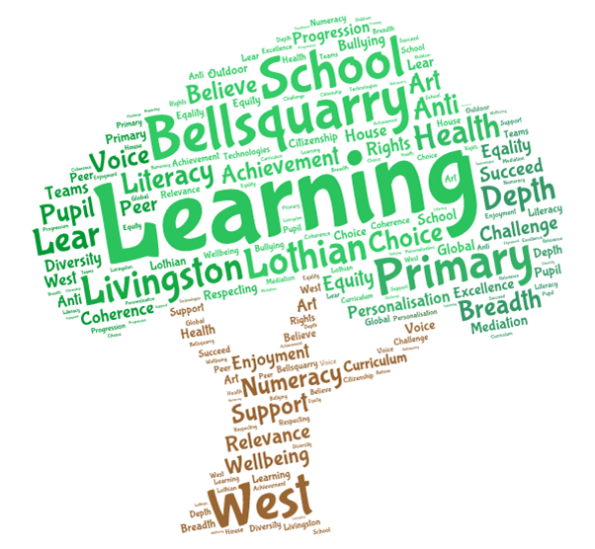
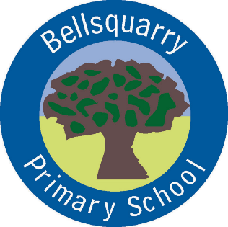
P3 Learning Overview
Term 3 (January – March 2018)
The main focus for learning this term will be:

Literacy
Jolly Phonics spelling and grammar
Writing – different formats of writing using ambitious vocabulary, connectives, openers, punctuation and structures
Listening and talking through Show and Tell
Numeracy
Multiplication and division – building times tables
Addition and subtraction
Time, measure

Health & Wellbeing
PE
Growth Mindset
Positive friendships and attitudes
Skills for Life, Learning and Work
Rights-Respecting Schools and community-building
Interdisciplinary Learning
Celebrating Scotland
Romans and Caledonians

Discrete Subjects
French – Mrs Weatherston Sharma
Science – Materials and their properties (continued from last term)
RME – Bible stories, Easter
Art – Mrs Martin –Tuesday
Music – Mrs England – Wednesday
Opportunities for personal achievement and involvement in the ethos and wider life of the school
House Points
Classroom jobs and responsibilities
Table Group of the Fortnight
CfE certificates
Sharing wider achievements at Show and Tell, through Profiling and on an ad-hoc basis
Reading buddies

Other information
PE – Mrs Green - gymnastics

