Bellsquarry Primary School
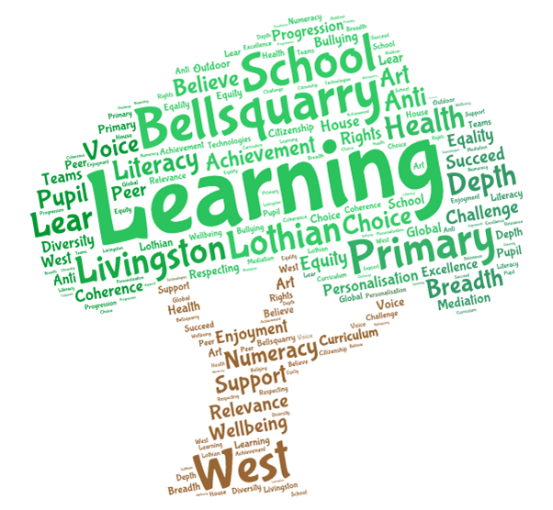
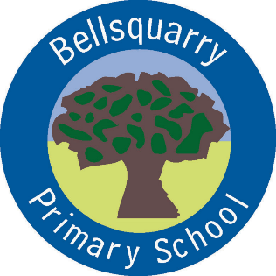
P2 Learning Overview
Term 3 (January – March 2018)
The main focus for learning this term will be:

Literacy
- Imaginative/ Personal Writing
- Scots Poetry/ Functional recipe
- Jolly Phonics -Tense

Numeracy
- Addition and Subtraction within 20
- Multiplication and Division – x2,5 and 10
- Money, Measure and non-routine questions

Health & Wellbeing
- Ways of Getting Help
- P.E. Mrs Green - gymnastics
- The Daily Mile twice a week

Interdisciplinary Learning
- Space and the Planets
- Scotland (Mini Topic)
- Local Community Study

Discrete Subjects
- Music: Songs relating to themes
- French: Mrs Weatherston Sharma
- Looking at Scottish Country Dancing
- Art Mrs Martin – linked to topic

Opportunities for personal achievement and involvement in the ethos and wider life of the school
- Classroom responsibilities
- Pupil of the Week
- Local Walk
Other information
- P.E. on Monday and Wednesday. Please make sure children have shorts, tee-shirt and gym rubbers which fit well.
- P.E. kit should be left in school to make sure it is always available.
- Children should wear gym rubbers at all times in school for Health and Safety reasons. Please ensure these are left in school.

