Bellsquarry Primary School
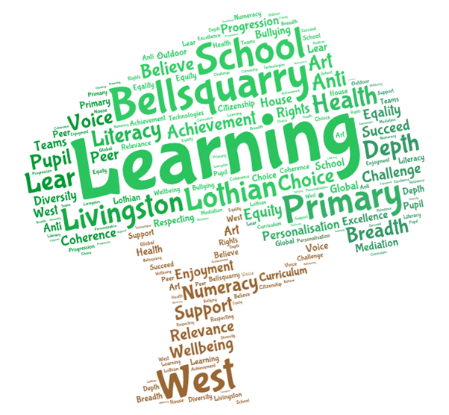
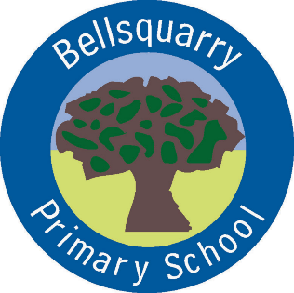
P1 Learning Overview
Term 3 (January – March 2018)
The main focus for learning this term will be:
Literacy
- Jolly Phonics Programme of Study
- Independent writing and reading
- Development of talking and listening skills

Numeracy
- Number Sense to 10 using the SEAL approach - Numicon, five and ten frames
- Numbers to 20
- Time
- 3D shape

Health & Wellbeing
- Food Choices and Healthy Eating
- Medicines
- P.E. - gymnastics and yoga
- The Daily Mile twice a week

Interdisciplinary Learning
- Celebrating Scotland
Discrete Subjects
- Science: Materials
- RME: Caring, Naming Ceremonies, Easter
- Music: Specialist (Mrs England)
- French: Specialist (Mrs Weatherston Sharma)

Opportunities for personal achievement and involvement in the ethos and wider life of the school
- Classroom responsibilities
- Pupil of the Week
- Whole school assembly presentation
- Pollination
Other information
- P.E. on Monday and Wednesday. Please make sure children have shorts, tee-shirt and gym rubbers which fit well.
- P.E. kit should be left in school to make sure it is always available.
- Children should wear gym rubbers at all times in school for Health and Safety reasons. Please ensure these are left in school.

