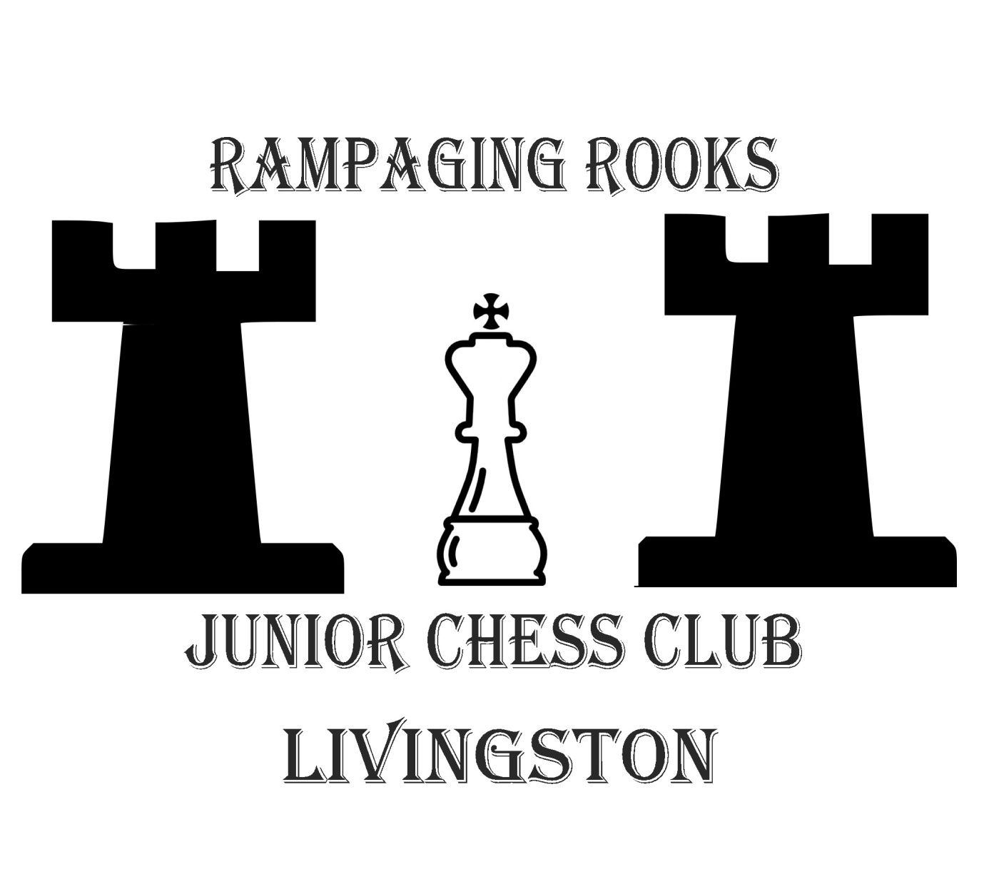Are you under 18 and interested in chess?
Want to improve your game?
Why not join us at -
Rampaging Rooks junior chess club, every Wednesday from 5:30 – 7:00
Location - Deans Community High School
Eastwood Park
Livingston EH54 8PS

All abilities welcome
For more information contact Rampagingrooks@gmail.com
Rampaging Rooks Chess Club is run under the auspices of West Lothian Junior Chess Club

