Bellsquarry Primary School
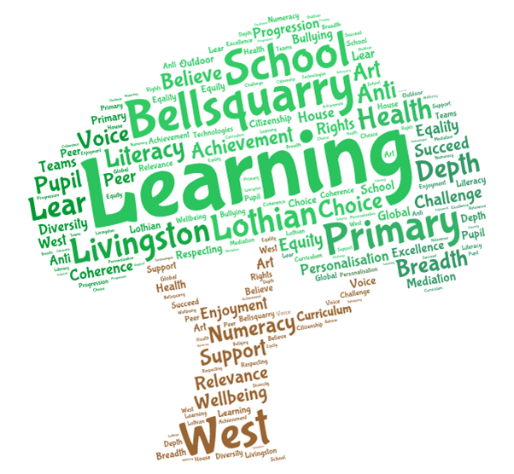
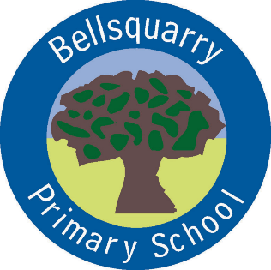
P7 Learning Overview
Term 1 (August – October 2017-18)
The main focus for learning this term will be:
Literacy
- Literacy Circles’
- Whole class/group & partner discussions
- Written & verbal comprehension tasks
- Class novel – ‘Friend or Foe’ by Michael Murpurgo
- SWST program with a variety of spelling strategies
- Variety of writing linked to topics
- Imaginative writing focus
Numeracy
- Place value
- Estimation & rounding
- Number & number processes
- 4 number operations
- Problem solving
- Mental arithmetic (including Number Talks and Sumdog)
Health & Wellbeing
- Social and emotional wellbeing
- Emotion Works
- Internet safety
- Keeping Myself Safe
- P.E. – Yoga, circuits and Futsal
Interdisciplinary Learning
- WW2 - compare and contrast a society in the past with my own
Discrete Subjects
- French – Mrs Weatherston Sharma – building on conversational language
- Mandarin – Vivien (teacher) – introduction to the language and culture
- Science – Structure of the Earth
- RME – Creation and Judaism
- Art and Design - The Blitz and Anderson shelters
- Music improving ocarina skills, singing in parts, ensemble djembe palying building on previous experience
Opportunities for personal achievement and involvement in the ethos and wider life of the school
- Class representatives – Pupil Council, House captains, Eco, JRSOs, Peer mediation, Pollination group
- Classroom jobs – changed weekly
- Buddies for P1 pupils
- Star of the Week
- Daily Mile
- Assembly certificates
- House points
Other information
- PE – Monday, Tuesday and Thursday
- Literacy Circles’ on Tuesday due for the following Tuesday

