Bellsquarry Primary School
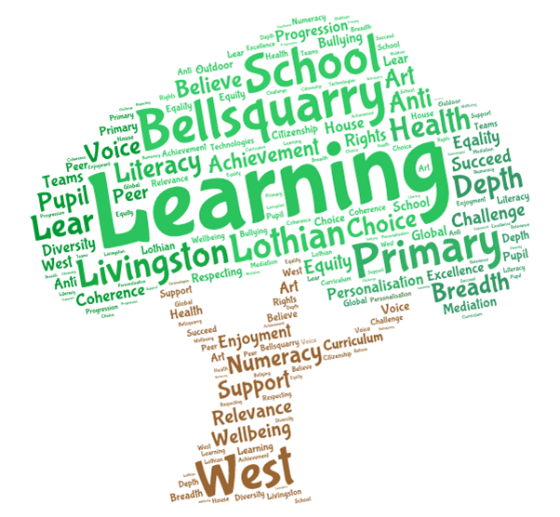
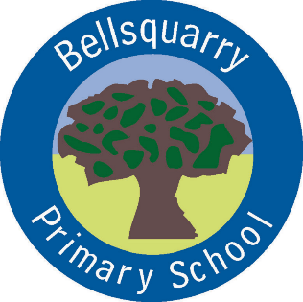
P3 Learning Overview
Term 1 (August – October 2017-18)
The main focus for learning this term will be:
Literacy
Jolly Phonics spelling and grammar
Writing – imaginative stories, personal writing, functional formats
Listening and talking through Show and Tell
Numeracy
Time
Concepts of multiplication and division
Addition and subtraction
Health & Wellbeing
Emotion Works
Yoga and Fitness with Mrs Green
Growth Mindset
Rights-Respecting Schools and community-building
Interdisciplinary Learning
Birds

Discrete Subjects
French - Mrs Weatherston Sharma – more complex greetings, numbers to 20, favourite colours, weather
Music – Singing, accompaniment
Science – Materials and their properties
RME – Caring: God and Allah
Art – Mrs Martin –Tuesday - Birds
Opportunities for personal achievement and involvement in the ethos and wider life of the school
House Points
Classroom jobs and responsibilities
Group of the Week
CfE certificates
Sharing wider achievements at Show and Tell, through Profiling and on an ad-hoc basis
Other information
PE – Mrs Green – Monday

