Bellsquarry Primary School
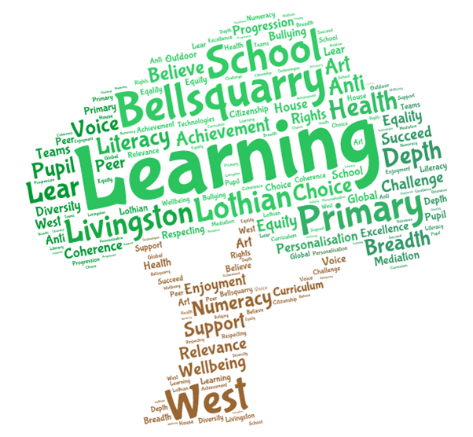
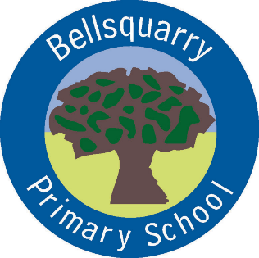
P4 Learning Overview
Term 2 (October – December 2017-18)
The main focus for learning this term will be:

Literacy
- Practising fluency and expression in Reading Groups
- Personal Writing
- Functional writing (linked to Topic work on the Vikings)
- French
- Spelling Patterns
Numeracy
- Mental and written addition methods (continuation)
- Working on times tables and division facts
- Shape
- Problem solving strategies and activities
- Money addition and subtraction
Health & Wellbeing
- Emotion Works (continuation)
- Discovering Myself and Keeping Safe
- Basketball
- Scottish Country Dancing
Interdisciplinary Learning
- The Vikings ( prepare for parent assembly)
- Christmas Fayre Enterprise: market research and creating products
Discrete Subjects
- Science: Water (continued)
- RME: Stories about key figures (continued) and Christmas
Opportunities for personal achievement and involvement in the ethos and wider life of the school
- Christmas Fayre
- House Points
- Table of the Week
- Assembly Certificates
- Leadership Roles
Other information
- PE is on a Thursday and Friday
- Reading practise days are Monday and Wednesday

