Bellsquarry Primary School
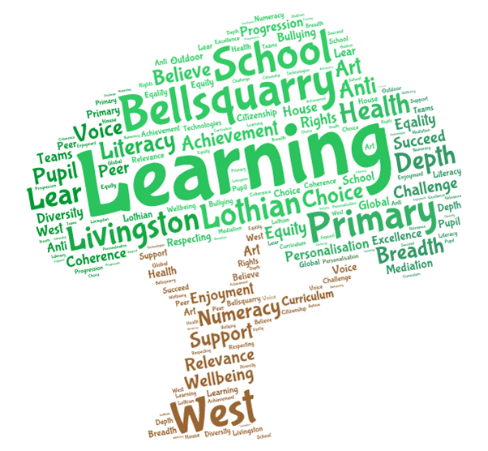
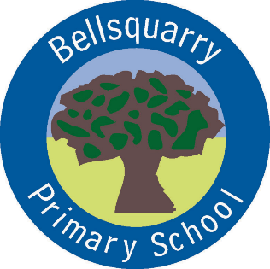
P3 Learning Overview
Term 2 (October- December 2017-18)
The main focus for learning this term will be:
Literacy
Jolly Phonics spelling and grammar
Writing – imaginative stories, personal writing, functional formats
Listening and talking through Show and Tell
Numeracy
Concepts of multiplication and division
Addition and subtraction
Fractions
Information Handling
Shape
Health & Wellbeing
Emotion Works
PE
Growth Mind-set
Rights-Respecting Schools and community-building
Interdisciplinary Learning
Nativity

Discrete Subjects
French – Greetings, Personal Information, Numbers: Mrs Weatherston Sharma
Science – Materials and their properties
RME – Christmas, Bible stories
Art – Mrs Martin –Tuesday
Opportunities for personal achievement and involvement in the ethos and wider life of the school
House Points
Classroom jobs and responsibilities
Group of the Week
CfE certificates
Sharing wider achievements at Show and Tell, through Profiling and on an ad-hoc basis
Children in Need fundraising and class assembly
Christmas Fayre
Blog and Twitter contributions
Other information
PE – Mrs Green – Monday - Basketball

