Bellsquarry Primary School
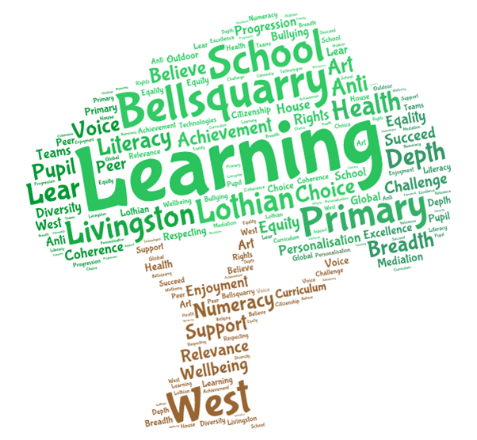
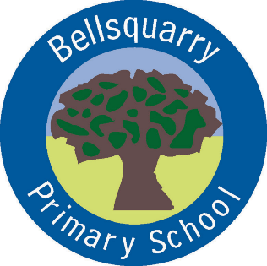
P1 Learning Overview
Term 2 (October to December 2017-18)
The main focus for learning this term will be:

Literacy
- Jolly Phonics Programme of Study
- Letter formation
- Foundations of Writing
- Development of talking and listening skills

Numeracy
- Number Sense to 10 using the SEAL approach - Numicon, five and ten frames
- Time
- Number Pattern

Health & Wellbeing
- Emotion-works
- Personal Care
- P.E. Ball skills and games
- The Daily Mile twice a week

Interdisciplinary Learning
- Nativity

Discrete Subjects
- Science: Processes of life (plants), Materials
- RME: Bible Stories, Chaplain visit, Christmas
- Music: Specialist (Mrs England)
- French: Specialist (Mrs Weatherston Sharma)

Opportunities for personal achievement and involvement in the ethos and wider life of the school
- Classroom responsibilities
- Pupil of the Week
- Performing in the Nativity
- Christmas Fayre

Other information
- P.E. on Monday and Wednesday. Please make sure children have shorts, tee-shirt and gym rubbers which fit well.
- P.E. kit should be left in school to make sure it is always available.
- Children should wear gym rubbers at all times in school for Health and Safety reasons. Please ensure these are left in school.
- Visit to New Lanark
- Christmas parties

