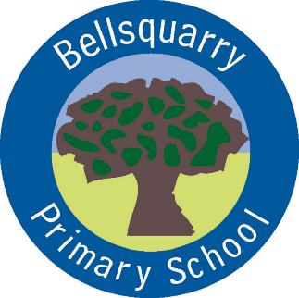

Agenda – Parent Council Meeting
Monday 23rd January 2017
7pm
7pm Apologies / review of minutes
7.05pm Head Teacher Report
7.15pm Governance Reviews Follow-up – Jon Reid
7.25pm Treasurer’s report – Linda Hennessay
7.40pm Fundraising update
7.50pm School / Parent Council partnership Development
Playground/ trim trail
Sponsor-a-book campaign
Road safety
8.15pm Cllr Fitzpatrick
8.25pm Bellsquarry Community Council Update
AOB
DONM Monday 13th March

