Bellsquarry Primary School
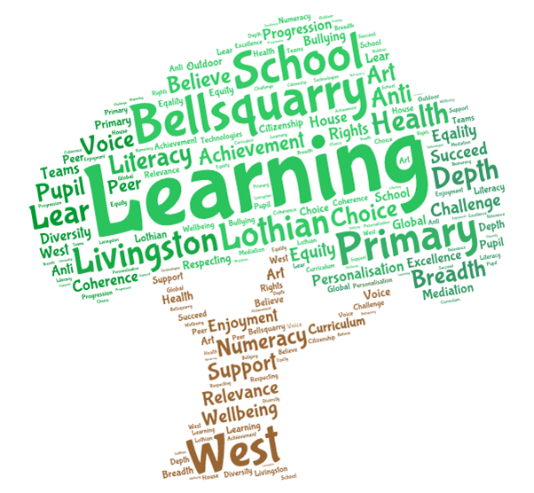
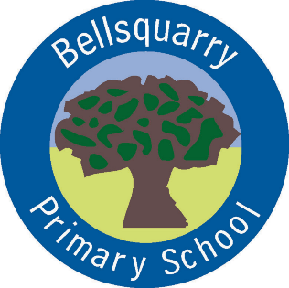
P2 Learning Overview
Term 1 (August – October 2017-18)
The main focus for learning this term will be:

Literacy
Capital Letters, Full Stops, Word Banks
Imaginative/Personal writing
Reading Jolly Phonics/ Novel Study
Diagraphs
Whole body listening
Numeracy
Shape-2D
Mathematical Language
Exploring number (differentiated)

Health & Wellbeing
Circle Time
Friendships and Emotions
PE Mrs Green – yoga and Fitness
Daily Mile
Interdisciplinary Learning
Rainbow Fish
Discrete Subjects
Science Energy
RME Class Charter, Bible Stories
Art Mrs Martin – Rainbow Fish line drawing, patterns
French Specialist (Mrs Weatherston Sharma) - introductory language, greetings, saying your name,
classroom organisation, days of the week
Music NYCOS
Opportunities for personal achievement and involvement in the ethos and wider life of the school
Classroom responsibilities
Pupil of the Week
Other information
All children are expected to wear a jacket to school in the winter months
Gym kits are to be kept in school from Monday to Friday
Can you ensure your child brings their reading folder to school every day

