Bellsquarry Primary School
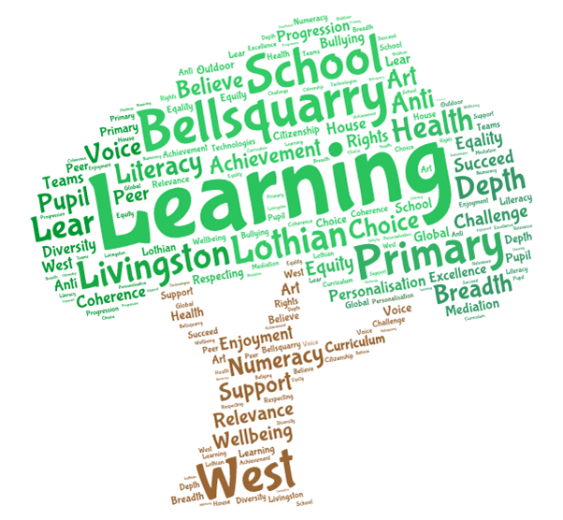
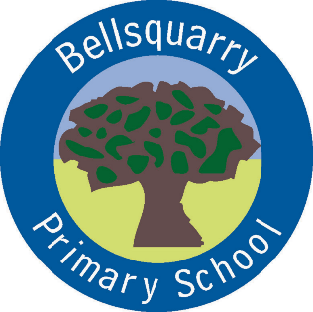
Primary 6 Learning Overview : Term 1 (August – October/December 2017)
The main focus for learning this term will be:
Literacy
Writing
Our focus for this term will be imaginative writing using the stimulus of ‘The Monsters’ Feast’ to develop skills in setting the scene and of characterisation. This will involve the use of Vocabulary, Connectives, Openers and Punctuation (VCOP). Pupils will write an imaginative story book over five chapters, with a specific focus placed upon each chapter.
We will also be using our imaginative writing skills and linking them with our topic of The Jacobites, in particular, an eye witness account of the Massacre of Glencoe.

Reading
Our focus for reading this term will be on ‘Reading for Understanding’. This will require pupils to read several pages at a time and to discuss their reading, as part of their group. This may be done individually, ‘paired and shared’ or as a whole group. Through discussion, themes and sub-themes can be discussed and ideas and thoughts shared. Literal and inferential skills will also be developed as well as the author’s use of language.
Activities such as ‘Characters on a Roll’, ‘Shoebox Book Project’, ‘Rolling Through the Text’ as well as comprehension related activities will provide opportunities for pupils (and parents) to engage with the text in a fun and inter-active way.
As well as the above, pupils will develop their ability to read for information using non-fiction texts relating to the Jacobites. They will use the information they find to make notes and to present their findings to others in their own words.

Listening and Talking
Our focus on listening and talking this term will centre on group work. Pupils will be participating in team building activities across curricular areas, which will require them to listen to others, co-operate as part of a team and to propose their own ideas. Within this ‘umbrella of group working’, pupils will also assume different roles such as Scribe, Materials Manager, Reporter, Time Keeper, Co-ordinator and Researcher. This will ensure they experience all the roles required in order to produce an effective team.
In addition, pupils will also develop their ability to speak in front of an audience through presenting their research on the Jacobites to the class.

Numeracy
Mental Maths - ‘Number Talks’
We will have a daily focus upon mental maths through our Number Talks. This will involve the pupils developing and sharing mental strategies to solve a maths problem. For example 31 + 29 could be shared as 30 + 29 plus 1 = 60 or 31 + 30 – 1 = 60. Through discussion, this will provide pupils an opportunity to discuss which strategies ‘best fit’ their way of learning and which strategies they can use as a back up to cross check their work – dialogue is the key to understanding and learning.

‘Number’
We will also be investigating everything ‘number’ from rounding and estimating numbers to the nearest 50, 100, 1000 and/or 1,000,000 to comparing and ordering numbers of varying sizes. We will investigate more complex numbers as part of a sequence as well as revisiting Place Value to ensure pupils’ knowledge of Thousands, Hundreds, Tens and Units is securely embedded.

Problem Solving
Using everyday contexts such as Wine Gums, Nutella and money, as well as the game shows such as ‘Pointless' and ‘The Chase’, we will apply our knowledge of number to solve a variety of problems.

Pupils will also do a Baseline Assessment in September. This will give them an opportunity to showcase what they know as well as those areas which may need to be revisited in order to ensure learning is embedded before progressing onto the more complex areas.

Health & Wellbeing
UN Rights of the Child
This term, pupils will start by revisiting their rights and how these link to increasing responsibilities. This will be used as a basis for creating our Primary 6 Class Charter, which will link into specific articles. Within each article, the responsibilities of pupil and teacher will be discussed and decided upon as well as the overlapping section which will be the ‘responsibility for all’.

Growth Mind-sets
We will also be investigating and discussing the debate surrounding Fixed and Growth Mind-sets – the pupil who thinks ‘I have a certain amount of intelligence and that’s it’ against the pupil who thinks ‘I can become smarter and more talented if I persevere and work at it’. Which one will have limited potential and which one will fulfil their potential?

Emotion Works
Working with Mrs Green, the pupils will be using this resource to investigate emotions. Starting with the question, ‘What is an Emotion?’ the pupils will embark on a learning journey discovering the many emotions we have, the different reactions which can be associated with an emotion as well as strategies for dealing with the many different emotions.
Interdisciplinary Learning
The Jacobites
This topic will encompass Social Studies, Literacy and Expressive Arts, in particular Art, Music and Drama, with the following skills being developed:

- Social Studies: Linking and sequencing significant historical events and figures;
- Literacy: Reading for Information, Note making, Presenting Information and Personal/Imaginative writing;
- Art: Character Portraits with attention to detail, depicting history through Art;
- Music: Listening to, responding and performing Jacobite songs;
- Drama: ‘I am MacIain’ drama performance with pupils assuming roles and conveying the emotions of a character;

We may also have a class trip to the National Museum of Scotland in Edinburgh to visit the Jacobite Exhibition, ‘Bonnie Prince Charlie and the Jacobites’. From there we will either visit Edinburgh Castle or Holyrood Palace to follow in the footsteps of Bonnie Prince Charlie.

Discrete Subjects
Religious & Moral Education and/or
This term we will be creating our Class Rules. Using the Growth Mind-set philosophy of ‘Changing your Words, Changing Your Mind-set’, we will investigate general everyday rules, discuss the use of language and decide how to make them more ‘positive’. We will develop this philosophy further by creating our own posters to reflect the use of positive language around the school.

Science
This term, we will be attempting to answer the question, ‘What is Extreme Weather?’ Researching the many different types of extreme weather on Planet Earth, pupils will create their own fact file or mini presentation about one form of extreme weather and will feedback to the class. We will also don the white coat and lab goggles and attempt to create some of these experiments in the classroom……watch this space!
Music with Mrs England
Improving ocarina skills, singing in parts, ensemble djembe playing building on previous experiences.
French
Building on conversational vocabulary.
Opportunities for personal achievement & involvement in the ethos/wider life of the school
Pupils will have a variety of opportunities to take on roles and responsibilities within the school. These include Eco rep, Rights Respecting School rep, Pupil Council rep, Junior Road Safety Officers, classroom helper jobs, nursery buddies and helping in the playground.

The focus of Learning and the Success Criteria will always be shared and discussed with the pupils to ensure they understand how they can achieve their targets. Formative Assessment strategies such as ‘thumbs up, middle or down’ and ‘Fist to 5’ will also be used to ensure that each pupil understands the task required. Success is also celebrated through Self and Peer Assessment and meeting personal targets.

Effort is valued highly, with pupils encouraged to ‘be the best we can be’. Where a pupil does well i.e. produces a very good piece of work, demonstrates polite manners and/or promotes the school in a positive way, not only can they receive House Points, but within the class they can receive Raffle Tickets. There is no limit on the amount of Raffle Tickets they can receive and they will be entered into a prize draw in December and June. Table Points can also be awarded should a table be working well together with a weekly ‘Table of the Week’ award and prize. Finally, there is also a ‘Pupil of the Week’ award where the teacher feels that a pupil has worked consistently to the best of their ability. They will receive the ‘Pupil of the Week’ trophy to keep for their week, along with a Raffle Ticket, mini credit card style ‘Superstar’ award and a Certificate for their efforts.

We also love to hear about pupils’ achievements from beyond the classroom. Please let us know and we can share these successes in the class and at our weekly whole school assembly.

Other information
We hope your child has an enjoyable experience in Primary 6, however, should you have any issues or concerns, please let us know and we can get together to ensure your child has a happy, memorable and exciting learning experience in Primary 6.

