Bellsquarry Primary School
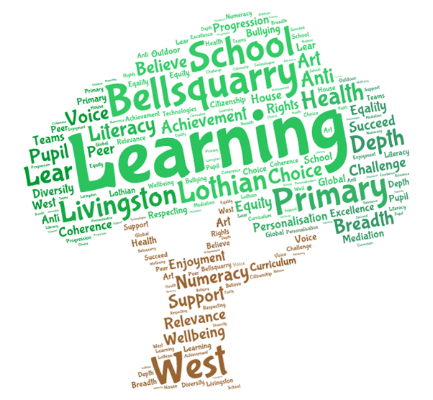
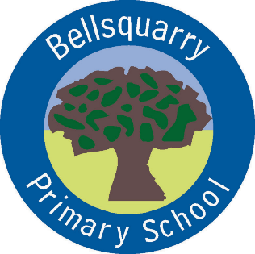
P5 Learning Overview
Term 1 (August – October 2017-18)
The main focus for learning this term will be:
Literacy
- ‘Stig of the Dump’ class novel study
- Introduction of Literature Circles
- Personal Writing
- Functional and Imaginative writing (linked to Explorers topic work)
- French
- Spelling Patterns

Numeracy
- Developing understanding of place value
- Mental and written addition methods
- Problem solving strategies and activities
- Practice and development of multiplication facts

Health & Wellbeing
- Emotion Works
- Yoga
- Fitness Circuits, Daily Mile

Interdisciplinary Learning
- Pixar’s ‘Up’ Explorers: Mountains, Deserts and The Great Barrier Reef
- Art and Design: Landscapes (extreme weather)

Discrete Subjects
- Science: Light and Sound
- RME: Key Figures – stories and influences
- Music: Mrs England – improving ocarina skills, singing in parts, ensemble djembe playing building
on previous experiences
- French: increasingly complex greetings, sharing personal information, writing accurately in French

Opportunities for personal achievement and involvement in the ethos and wider life of the school
- House Points
- Table of the Week
- Assembly Certificates
- Leadership Roles

Other information
- PE is on a Monday, Thursday and alternate Wednesdays
- Reading homework due dates will vary and will be found in reading record

