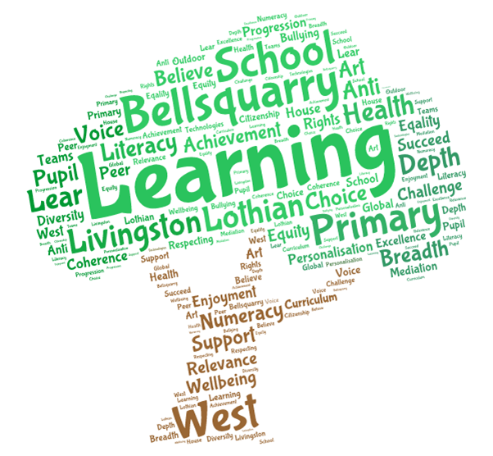
Bellsquarry Primary School & Nursery Class
Support for Parents / Carers of Children with Autism

All classrooms in Bellsquarry Primary School are autism friendly and staff are regularly upskilled in using appropriate strategies to meet the needs of children with Autistic Spectrum Disorders (ASD). We aim to meet regularly with parents through Assessment of Wellbeing Meetings, Child Planning Meetings and Reviews to consider what is going well for our ASD pupils and to set next steps.

We are committed to developing skills through a variety of strategies and we work actively with other schools to share this practice.

We are aiming to set up an Autism Support Parents Group which will regularly meet in school for tea/coffee and peer support. If you are interested in getting involved, please contact the school office.

Below are some useful websites with supportive information for parents and carers.

http://www.autism.org.uk/–
The National Autistic Society website which has guidance on all of the following topics:
Communication
Social Skills
Social Isolation
Shopping
Holidays and days out
Guidance on use of technology
Sex Education and Puberty

http://www.youngminds.org.uk/for_parents/worried_about_your_child/living_autism
This website has a Parents’ Survival Guide

http://signpost-online.co.uk/
This website is run by parent volunteers who are willing to give advice and support in West Lothian. Signpost is based within Beatlie School Campus in Craigshill, Livingston.

