A Parents’ Guide to Talking to your Child About Learning
The James Young Cluster
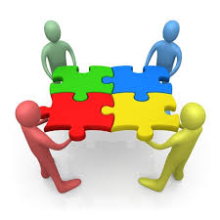
Within Curriculum for Excellence, the emphasis is on making sure each child experiences deep learning. Teachers and parents need to find out ‘How much?’ and ‘How well?’ children are learning. One of the ways to do this is by having learner conversations.
Below are some questions to help you have meaningful conversations with your child in relation to their learning. They can be used with any kind of learning, across all areas of the curriculum.

- Tell me about your learning today. What skills did you develop?

- Can you explain your thinking? How did you get your answer?

- What are you really good at in maths / science /art/ etc?

- What do you need to do to get better?

- Can you show me what you have learned by drawing a diagram or making a model?

- Can you read these instructions and complete the task by yourself?

- Can you play a computer game to demonstrate your learning?

- Can you measure the ingredients to bake a cake? / measure the floor for a carpet / calculate the change from buying a birthday present?

- Can you teach me a new skill you have learned today?

- Can you demonstrate your skills development at the airport / on holiday / at the theme park /farm /zoo?

- Show me how you could solve this problem.

- Can you work with me / Mum or Dad / brother /sister to complete this challenge?

