HIGHER MATHEMATICS

Sequences (Recurrence Relations)

1. Non-Calculator (Multiple Choice)
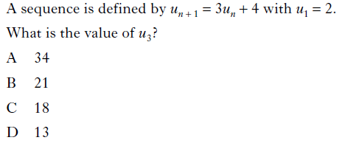

2. Non-Calculator (Multiple Choice)
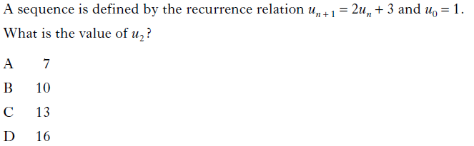

3. Non-Calculator (Multiple Choice)
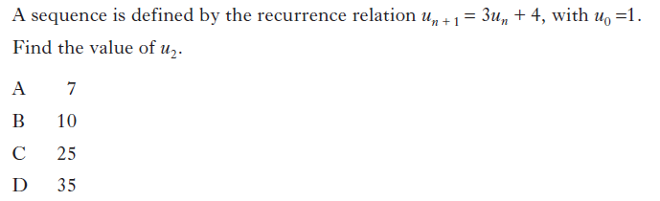

4. Non-Calculator (Multiple Choice)
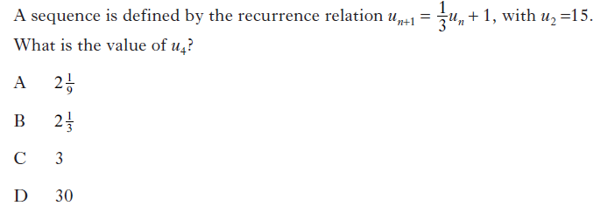

5. Non-Calculator (Multiple Choice)
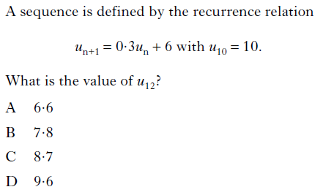

6. Non-Calculator (Multiple Choice)
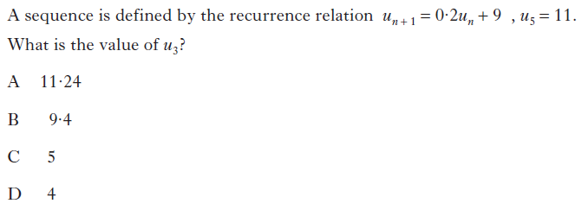

7. Non-Calculator (Multiple Choice)
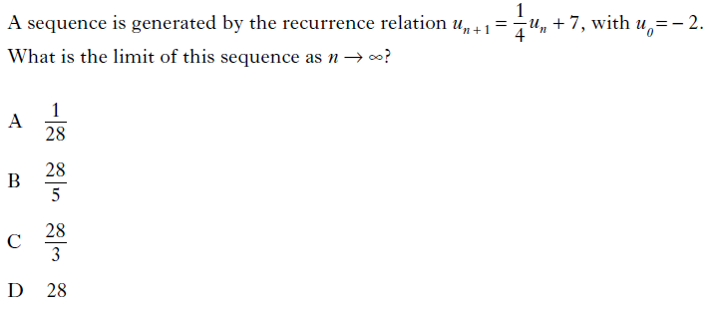

8. Non-Calculator (Multiple Choice)
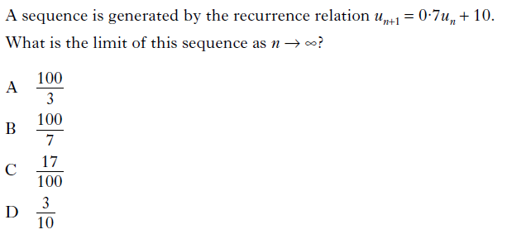

9. Non-Calculator (Multiple Choice)
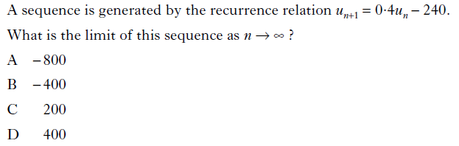

10. Non-Calculator (Multiple Choice)
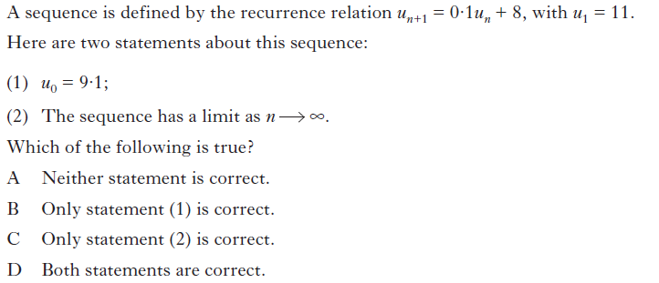

11. Non-Calculator (Multiple Choice)
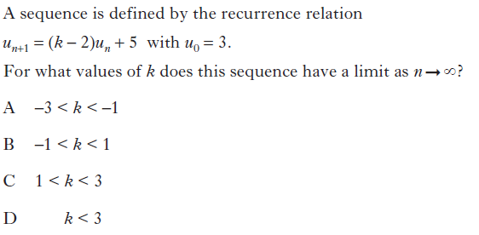

12. Non-Calculator
A sequence is defined by the recurrence relation $u_{n+1}=\frac{1}{3}u_{n}+\text{10}$ with $u_{3}=6$.

- Find the value of $u_{4}$.
- Explain why this sequence approaches a limit as $n→∞$.
- Calculate this limit.

13. Non-Calculator
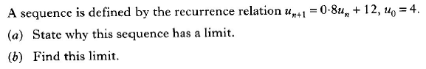

14. Non-Calculator
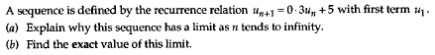

15. Non-Calculator
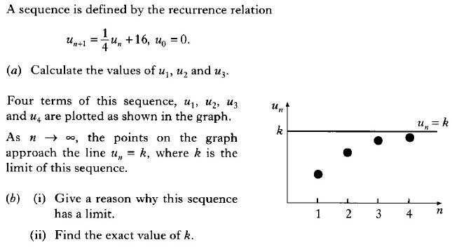

16. Calculator
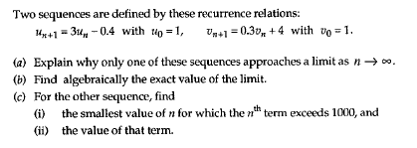

17. Calculator
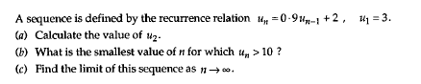

18. Calculator
(a) Calculate the limit as $n→∞$ of the sequence defined by

$u_{n+1}=0⋅9u_{n}+\text{10}$, $u_{0}=1$.

(b) Determine the least value of n for which $u_{n}$ is greater than half of this limit.

19. Calculator
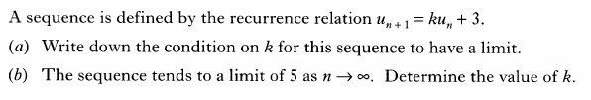

20. Non-Calculator
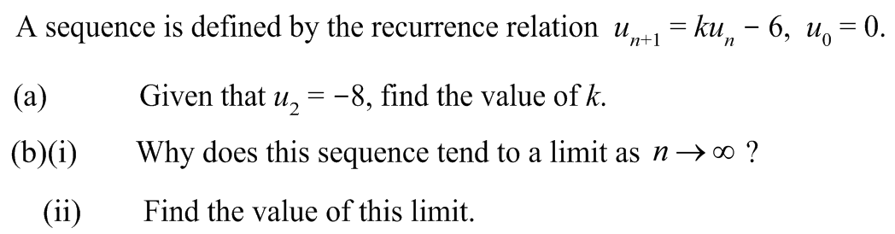

21. Non-Calculator
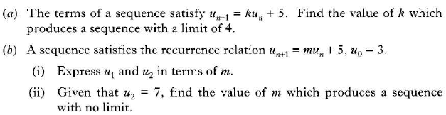

22. Calculator
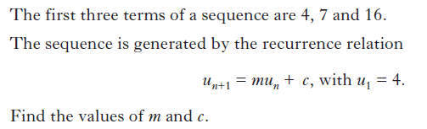

23. Non-Calculator
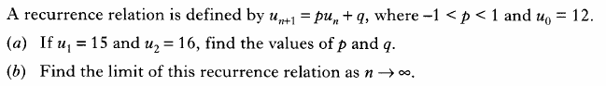

24. Calculator
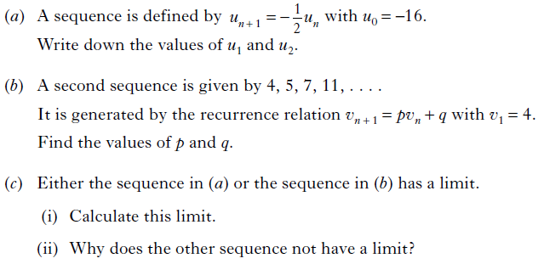

25. Non-Calculator
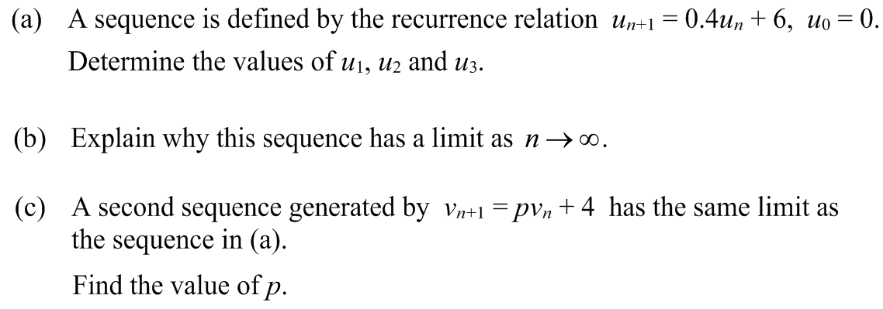

26. Non-Calculator
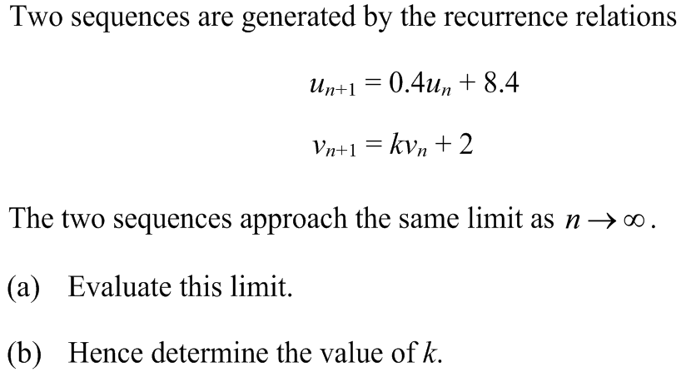

27. Non-Calculator
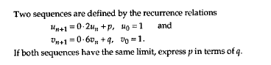

28. Non-Calculator
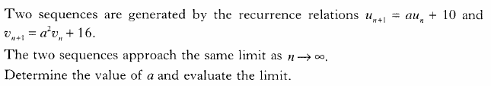

29. Calculator
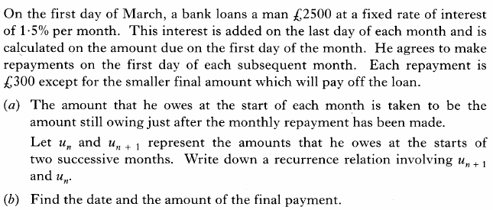

30. Calculator
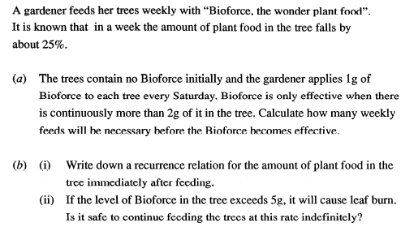

31. Calculator
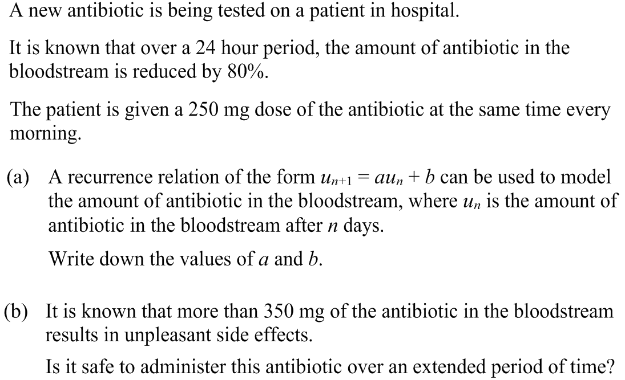

32. Calculator
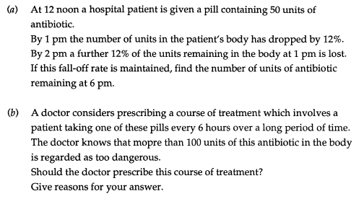

33. Calculator
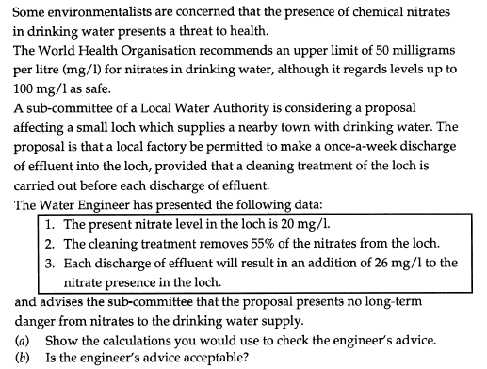

34. Calculator
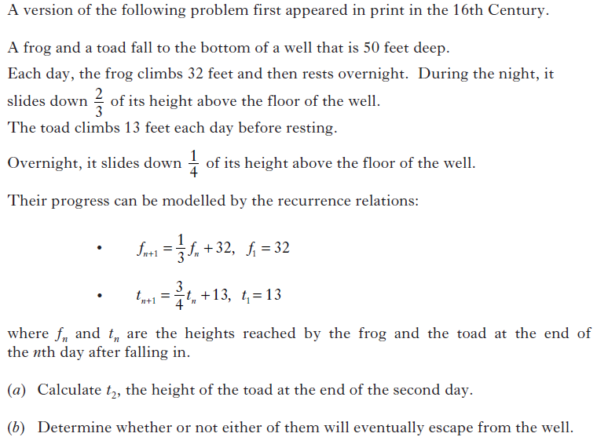

35. Calculator
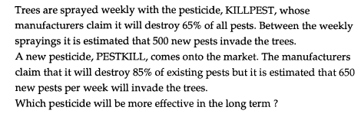

36. Calculator
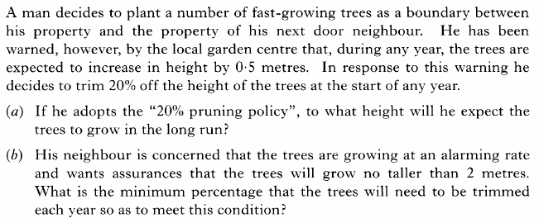

37. Calculator
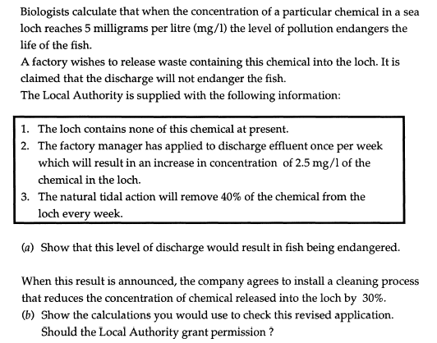
38. Calculator
