HIGHER MATHEMATICS

**Polynomials & Quadratics**

**1. Non-Calculator (Multiple Choice)**

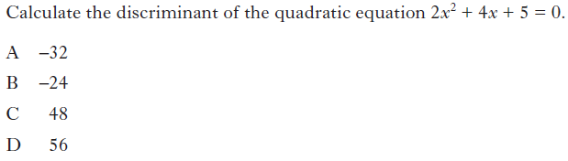

**2. Non-Calculator (Multiple Choice)**

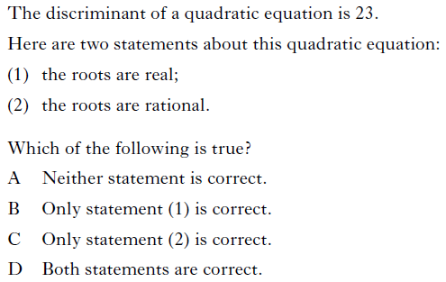

**3. Non-Calculator (Multiple Choice)**

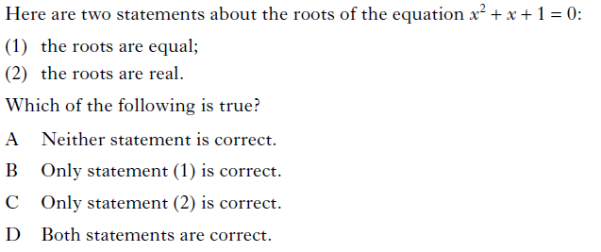

**4. Non-Calculator (Multiple Choice)**

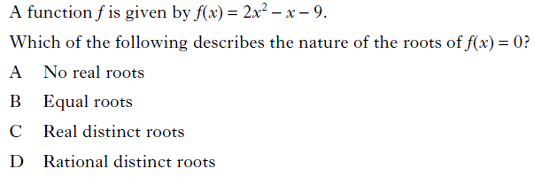

**5. Non-Calculator (Multiple Choice)**

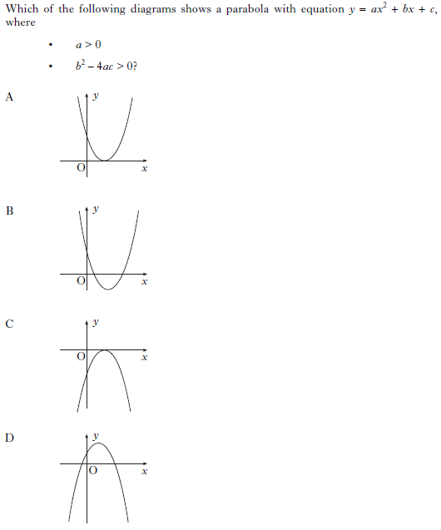

**6. Non-Calculator (Multiple Choice)**

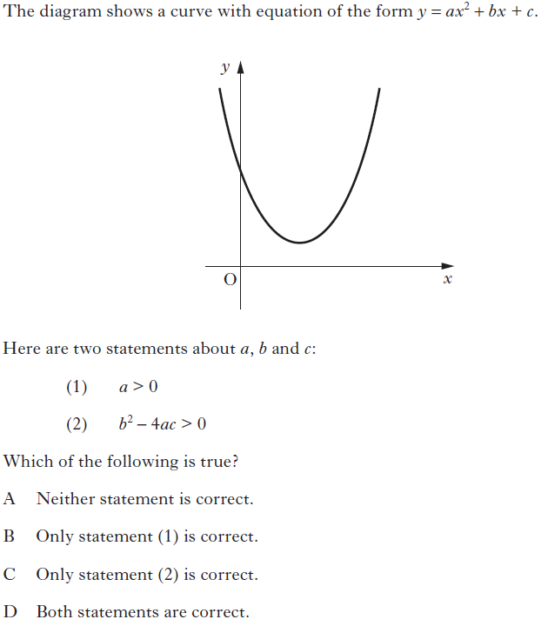

**7. Non-Calculator (Multiple Choice)**

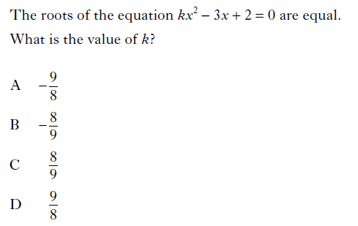

**8. Non-Calculator (Multiple Choice)**

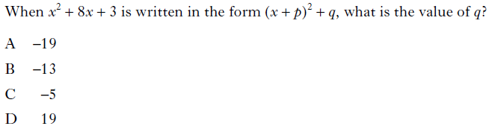

**9. Non-Calculator (Multiple Choice)**

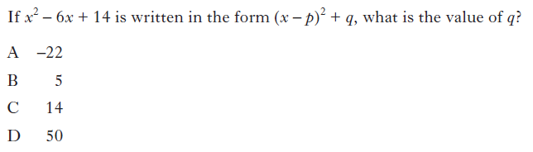

**10. Non-Calculator (Multiple Choice)**

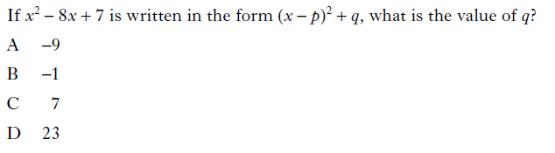

**11. Non-Calculator (Multiple Choice)**

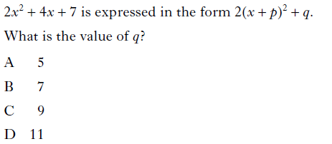

**12. Non-Calculator (Multiple Choice)**

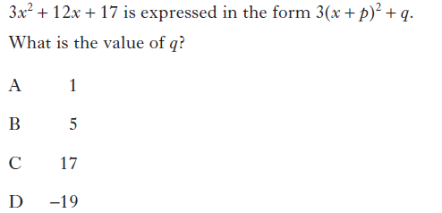

**13. Non-Calculator (Multiple Choice)**

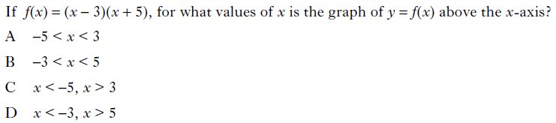

**14. Non-Calculator (Multiple Choice)**

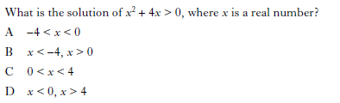

**15. Non-Calculator (Multiple Choice)**

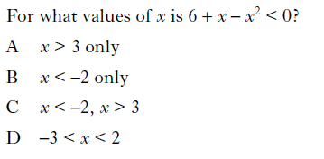

**16. Non-Calculator (Multiple Choice)**

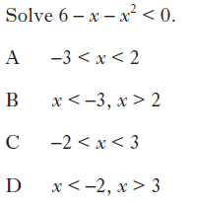

**17. Non-Calculator (Multiple Choice)**

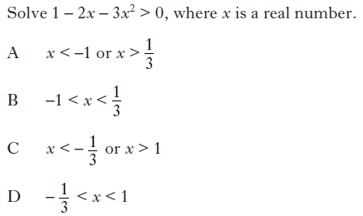

**18. Non-Calculator (Multiple Choice)**

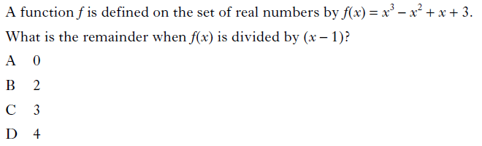

**19. Non-Calculator (Multiple Choice)**

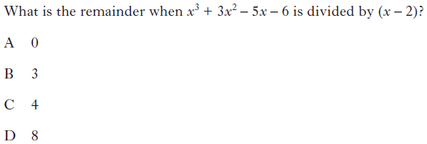

**20. Non-Calculator (Multiple Choice)**

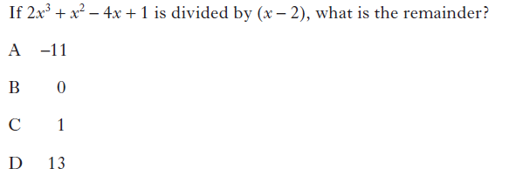

**21. Non-Calculator (Multiple Choice)**

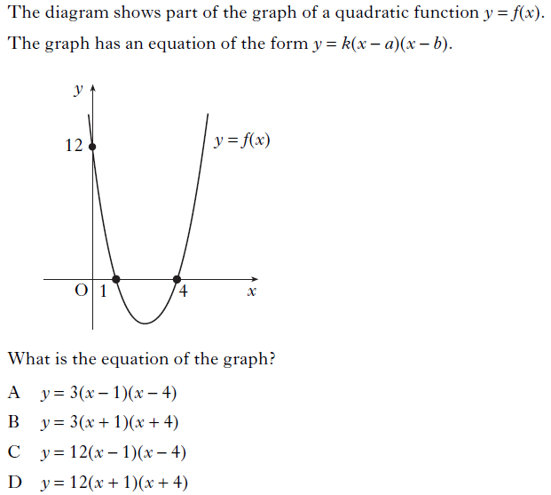

**22. Non-Calculator (Multiple Choice)**

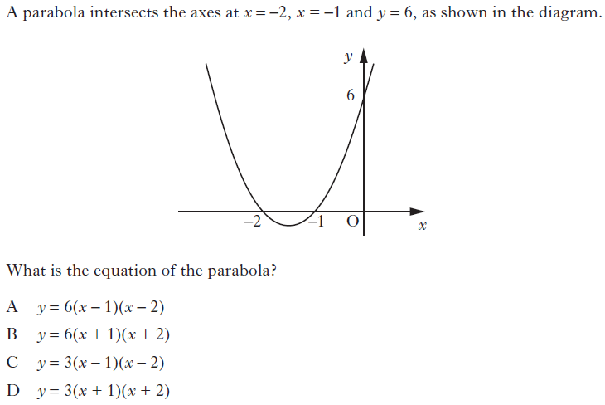

**23. Non-Calculator (Multiple Choice)**

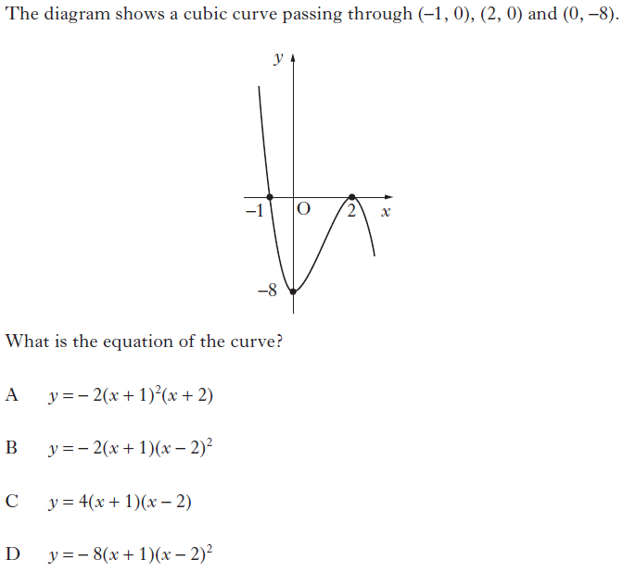

**24. Non-Calculator (Multiple Choice)**

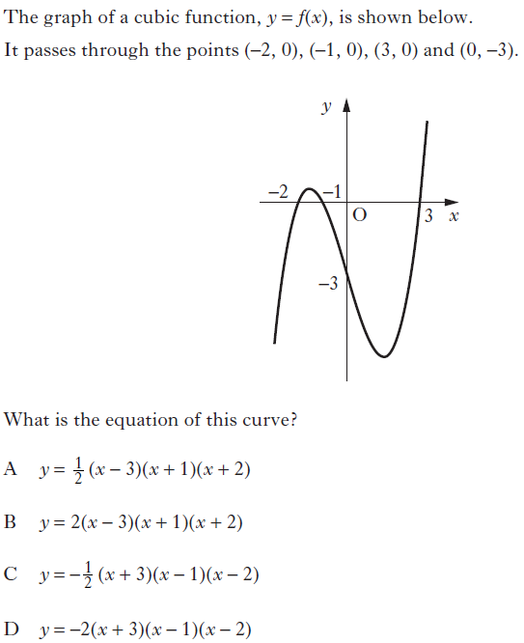

**25. Non-Calculator (Multiple Choice)**

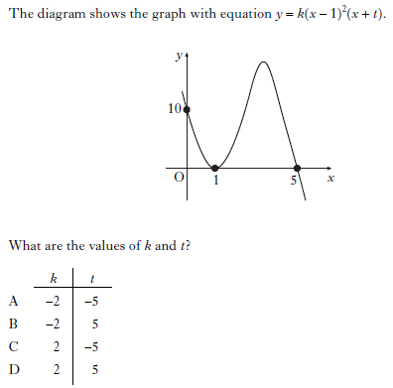

**26. Non-Calculator (Multiple Choice)**

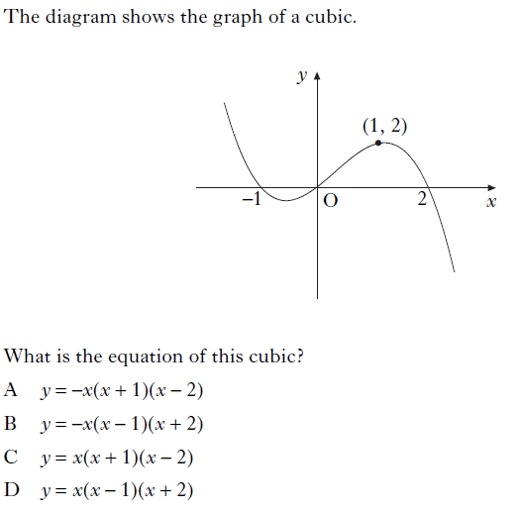

**27. Non-Calculator (Multiple Choice)**

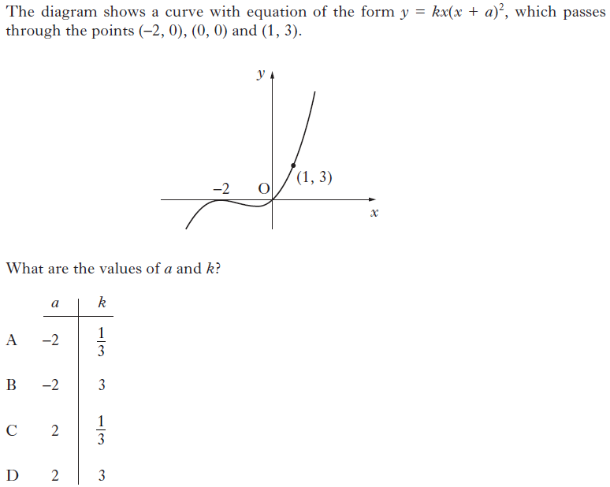

**28. Non-Calculator**



**29. Calculator**

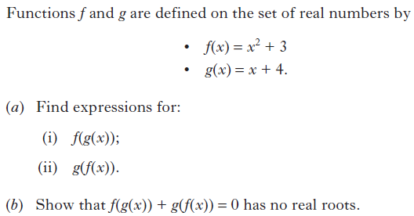

**30. Non-Calculator**



**31. Non-Calculator**



**32. Non-Calculator**



**33. Non-Calculator**



**34. Calculator**



**35. Calculator**

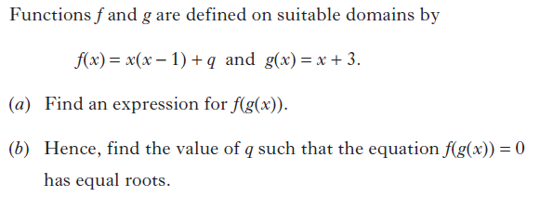

**36. Non-Calculator**

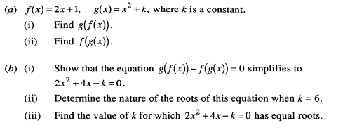

**37. Non-Calculator**

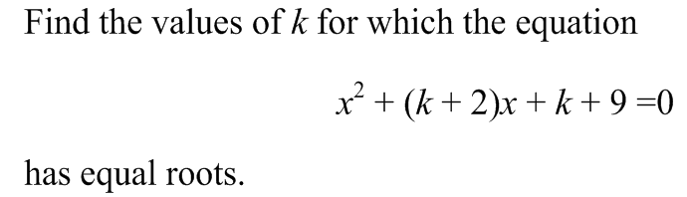

**38. Non-Calculator**



**39. Non-Calculator**

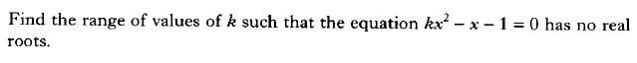

**40. Calculator**

Find the range of values for *p* such that  has no real roots.

**41. Non-Calculator**

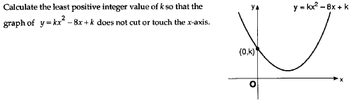

**42. Non-Calculator**



**43. Calculator**



**44. Non-Calculator**



**45. Non-Calculator**



**46. Non-Calculator**



**47. Non-Calculator**



**48. Non-Calculator**

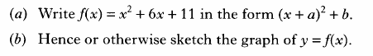

**49. Non-Calculator**



**50. Non-Calculator**

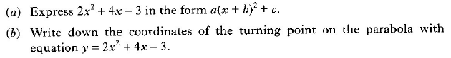

**51. Non-Calculator**

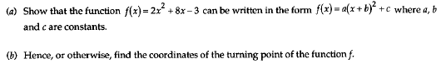

**52. Non-Calculator**



**53. Non-Calculator**



**54. Non-Calculator**

The functions *f* and *g* are defined on the set of real numbers by

 and .

1. Given , show that .
2. Express  in the form .

**55. Non-Calculator**



**56. Non-Calculator**

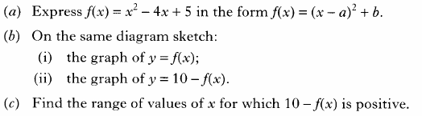

**57. Non-Calculator**

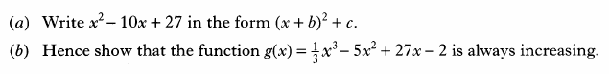

**58. Non-Calculator**



**59. Calculator**

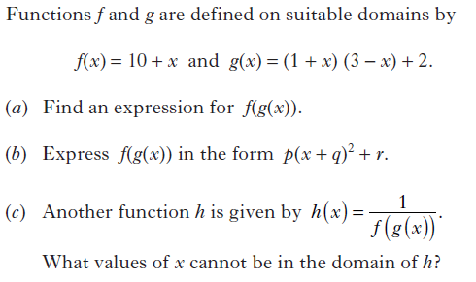

**60. Non-Calculator**

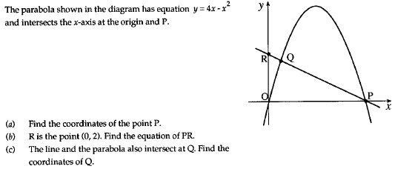

**61. Non-Calculator**



**62. Calculator**

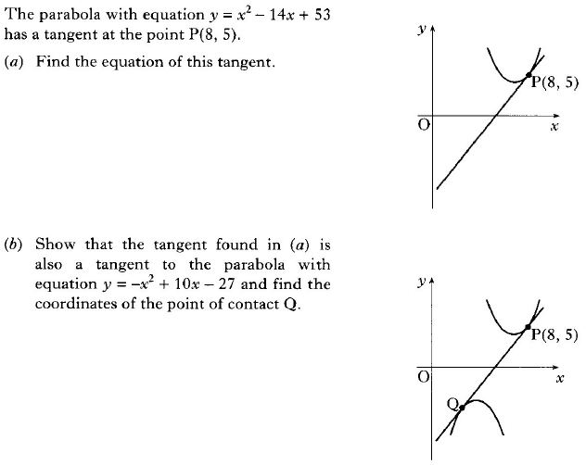

**63. Non-Calculator**

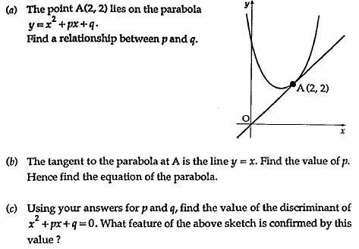

**64. Non-Calculator**



**65. Calculator**



**66. Non-Calculator**

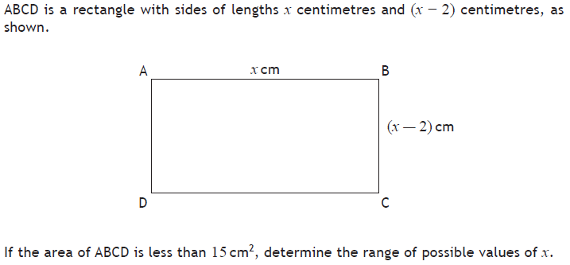

**67. Non-Calculator**



**68. Non-Calculator**



**69. Non-Calculator**

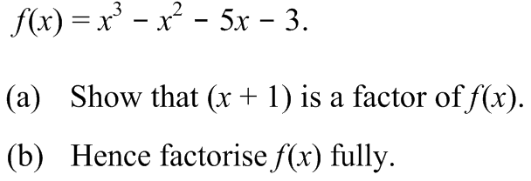

**70. Non-Calculator**



**71. Non-Calculator**



**72. Calculator**

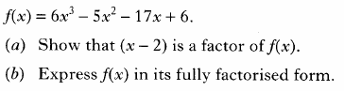

**73. Non-Calculator**



**74. Non-Calculator**



**75. Non-Calculator**



**76. Non-Calculator**

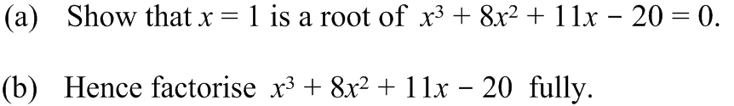

**77. Non-Calculator**



**78. Non-Calculator**



**79. Non-Calculator**

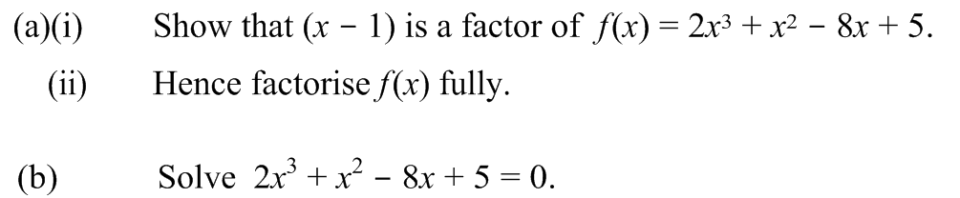

**80. Non-Calculator**

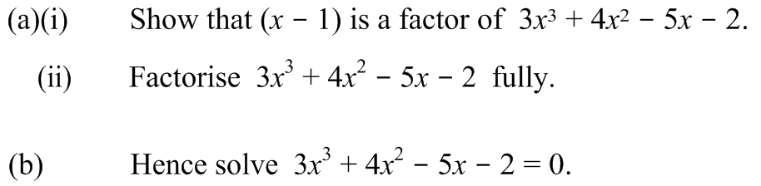

**81. Non-Calculator**



**82. Calculator**

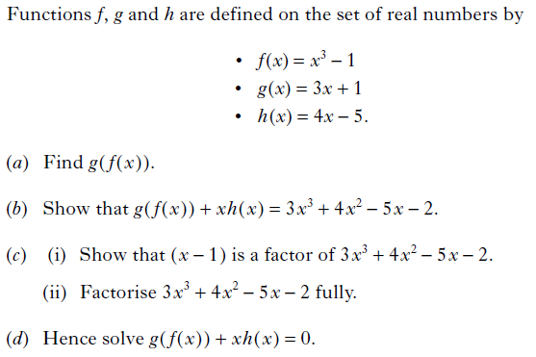

**83. Non-Calculator**

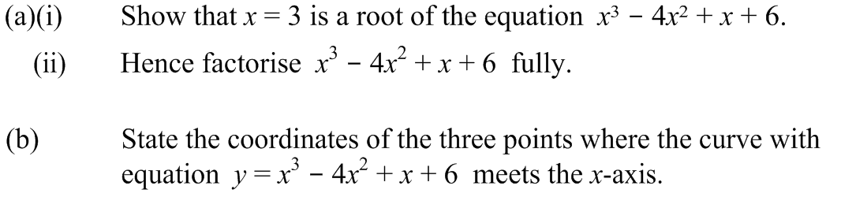

**84. Non-Calculator**

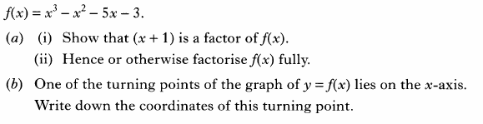

**85. Non-Calculator**

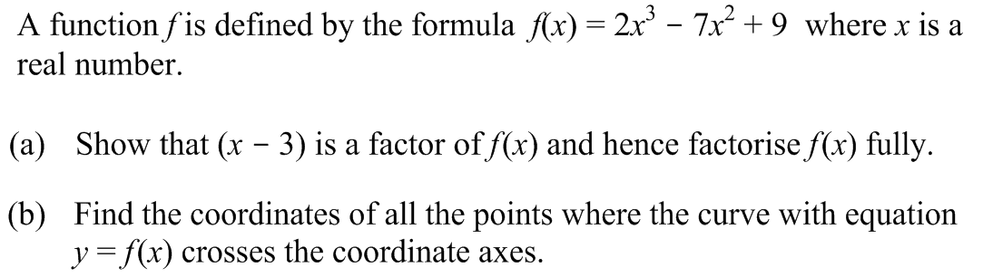

**86. Non-Calculator**

The diagram below shows the graph with equation , where .

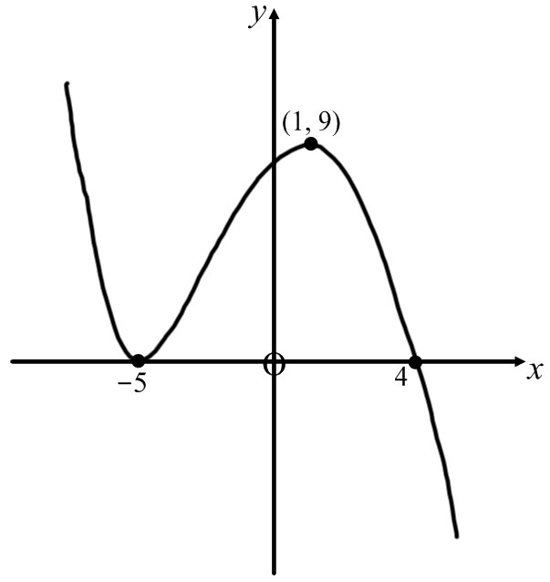

1. Find the values of *a*, *b* and *k*.
2. For the function , where *d* is positive, determine the range of values of *d* for which  has exactly one real root.

**87. Non-Calculator**

(a) Show that  is a factor of  and factorise  fully.

(b) Write down the coordinates of the points at which the graph of  meets the

coordinate axes.

(c) Find the coordinates of the stationary points of  and determine the nature of each.

(d) Sketch the graph of .

**88. Non-Calculator**

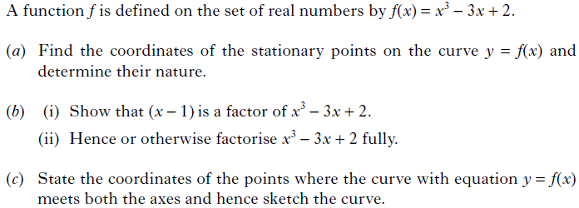

**89. Non-Calculator**

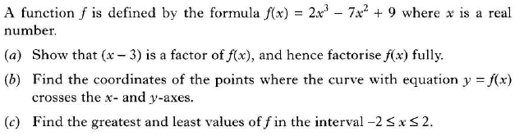

**90. Calculator**

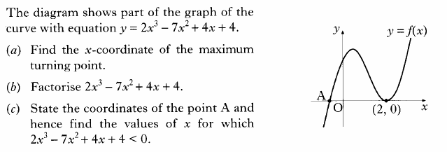

**91. Non-Calculator**

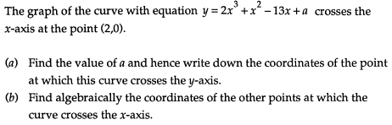

**92. Non-Calculator**

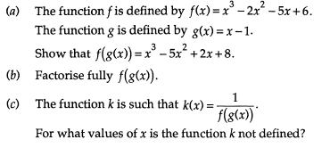

**93. Calculator**

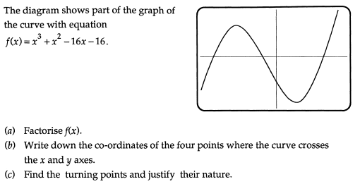

**94. Calculator**

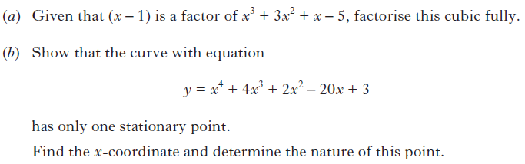

**95. Non-Calculator**



**96. Non-Calculator**



**97. Calculator**

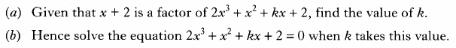

**98. Non-Calculator**



**99. Non-Calculator**

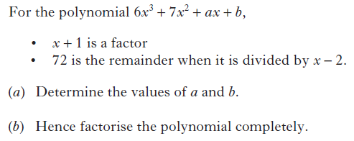

**100. Non-Calculator**



**101. Non-Calculator**

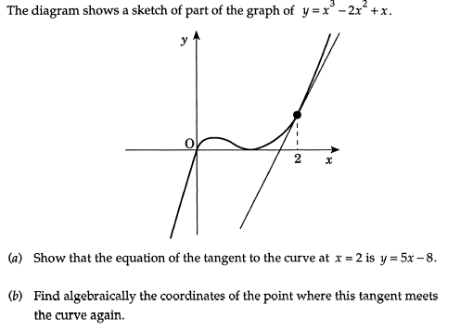

**102. Calculator**

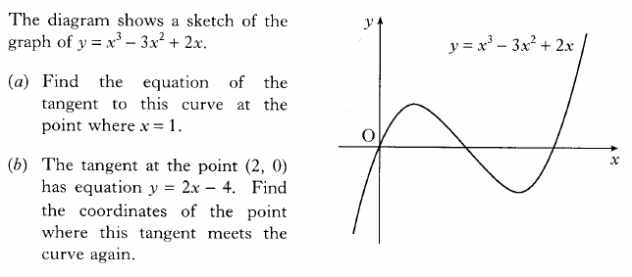

**103. Non-Calculator**

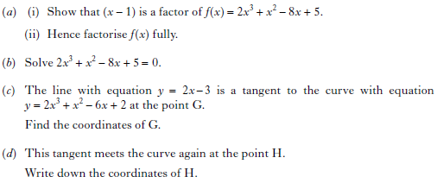

**104. Calculator**

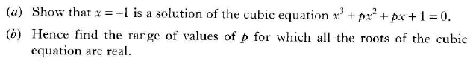

**105. Calculator**

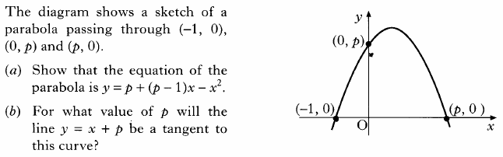

**106. Non-Calculator**

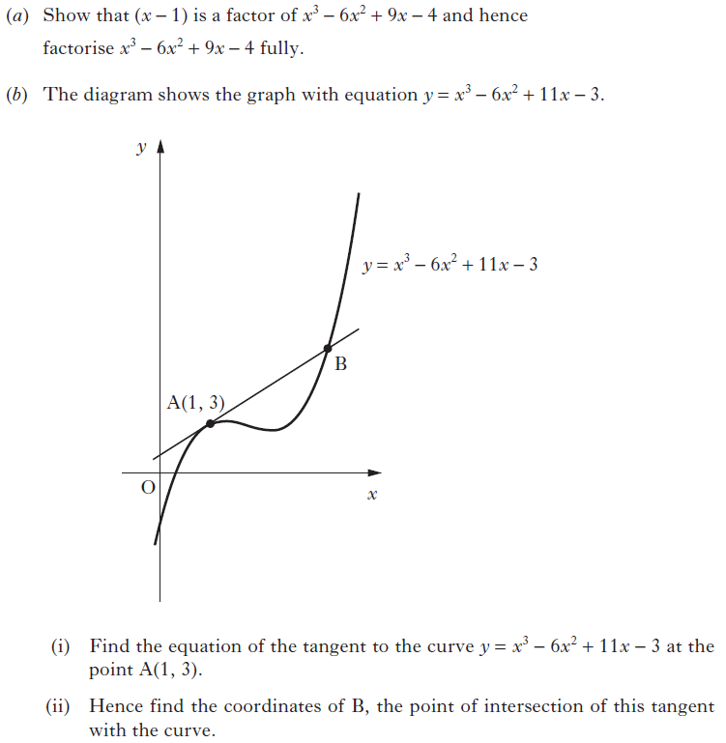

**107. Non-Calculator**

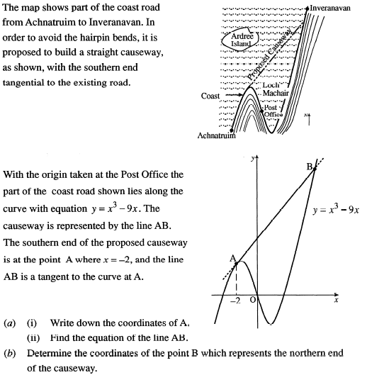

**108. Non-Calculator**

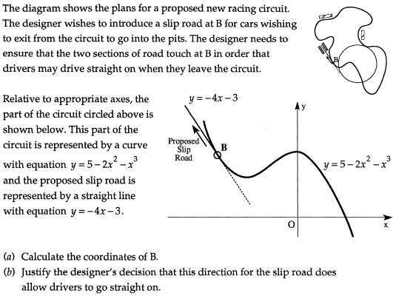

**109. Calculator**

