HIGHER MATHEMATICS

**Integration**

**1. Non-Calculator (Multiple Choice)**

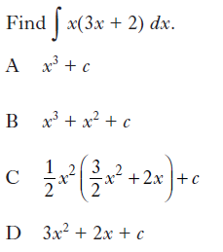

**2. Non-Calculator (Multiple Choice)**

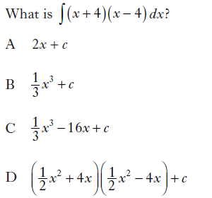

**3. Non-Calculator (Multiple Choice)**

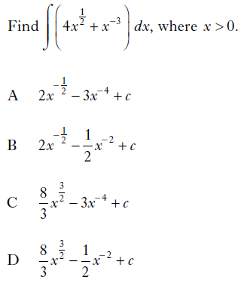

**4. Non-Calculator (Multiple Choice)**

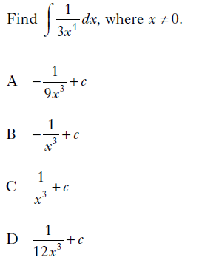

**5. Non-Calculator (Multiple Choice)**

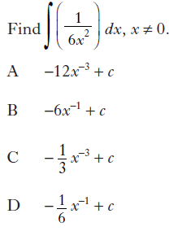

**6. Non-Calculator (Multiple Choice)**

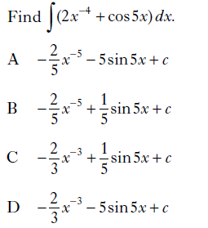

**7. Non-Calculator (Multiple Choice)**

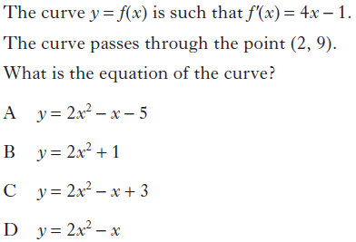

**8. Non-Calculator (Multiple Choice)**

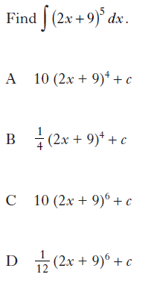

**9. Non-Calculator (Multiple Choice)**

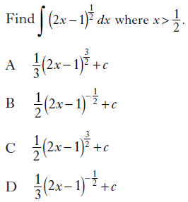

**10. Non-Calculator (Multiple Choice)**

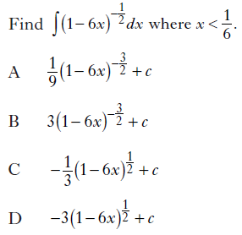

**11. Non-Calculator (Multiple Choice)**

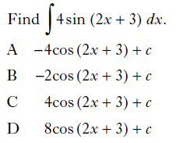

**12. Non-Calculator (Multiple Choice)**

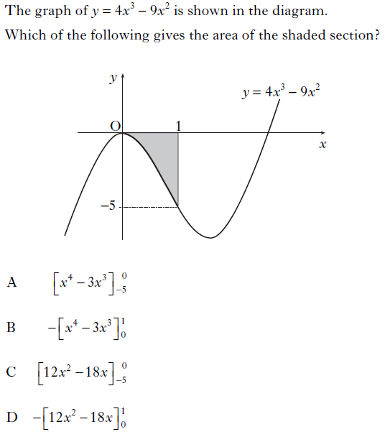

**13. Non-Calculator (Multiple Choice)**

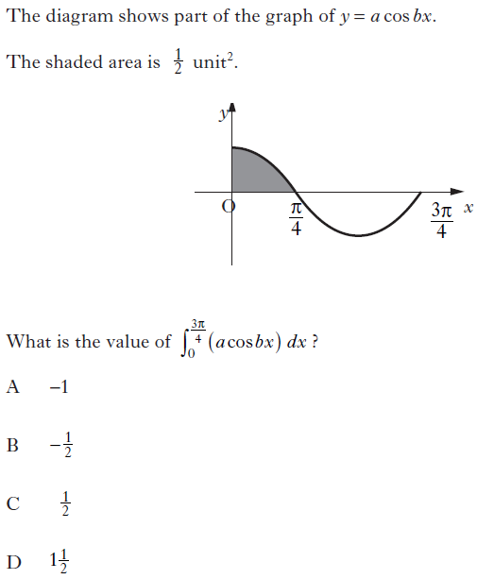

**14. Non-Calculator (Multiple Choice)**

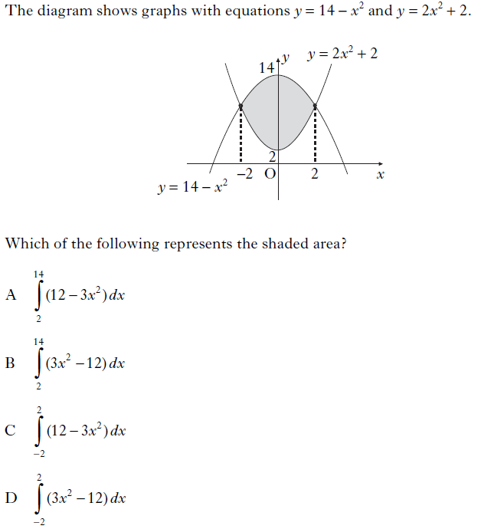

**15. Non-Calculator**



**16. Non-Calculator**



**17. Non-Calculator**



**18. Calculator**



**19. Calculator**

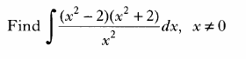

**20. Non-Calculator**

Find .

**21. Calculator**



**22. Non-Calculator**

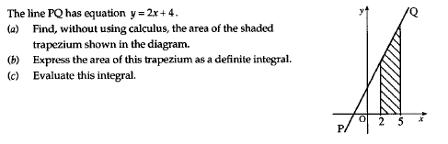

**23. Non-Calculator**



**24. Non-Calculator**

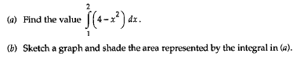

**25. Non-Calculator**



**26. Non-Calculator**



**27. Non-Calculator**



**28. Calculator**



**29. Non-Calculator**



**30. Non-Calculator**

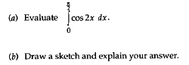

**31. Non-Calculator**



**32. Non-Calculator**



**33. Non-Calculator**



**34. Non-Calculator**



**35. Calculator**

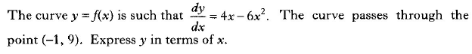

**36. Non-Calculator**



**37. Calculator**

For a function *f*, defined on a suitable domain, it is known that:

* 
* 

Express  in terms of *x*.

**38. Non-Calculator**

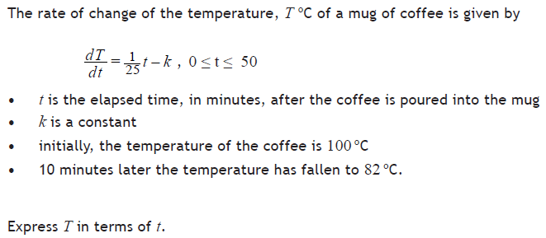

**39. Non-Calculator**

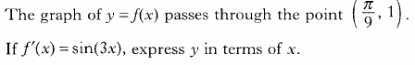

**40. Non-Calculator**



**41. Calculator**

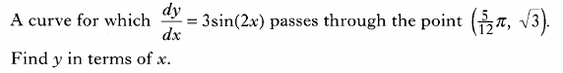

**42. Calculator**

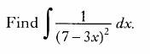

**43. Non-Calculator**



**44. Non-Calculator**



**45. Non-Calculator**



**46. Non-Calculator**

Find .

**47. Calculator**



**48. Calculator**



**49. Calculator**

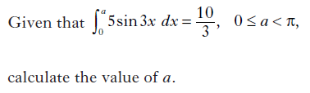

**50. Calculator**

(a) Given that , find .

(b) Hence find .

**51. Non-Calculator**

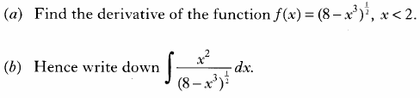

**52. Non-Calculator**



**53. Non-Calculator**

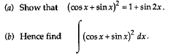

**54. Calculator**

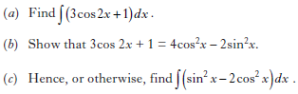

**55. Non-Calculator**

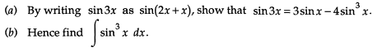

**56. Non-Calculator**

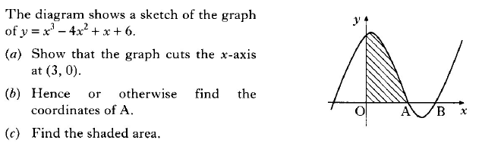

**57. Non-Calculator**

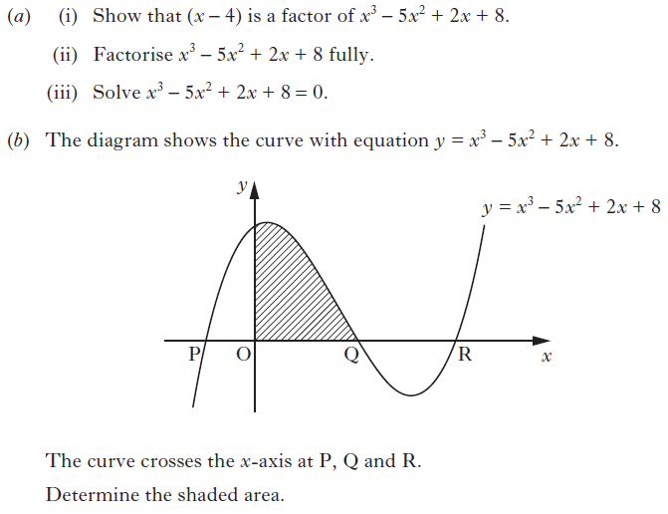

**58. Calculator**

(a) (i) Show that  is a factor of .

(ii) Hence solve the equation .

(b) The diagram below shows the graph with equation .

The curve cuts the *x*-axis at A, B and C.

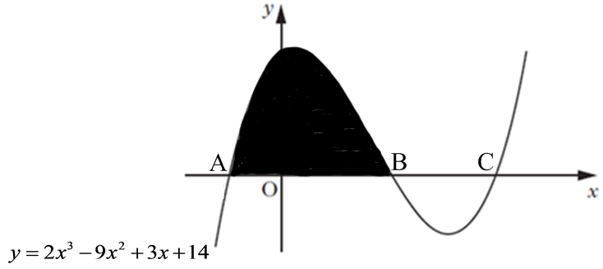

(i) Write down the coordinates of the points A and B.

(ii) Hence calculate the shaded area in the diagram.

**59. Non-Calculator**

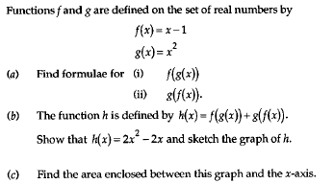

**60. Calculator**

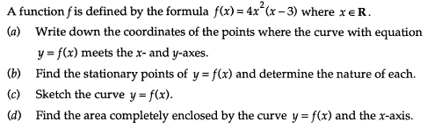

**61. Calculator**

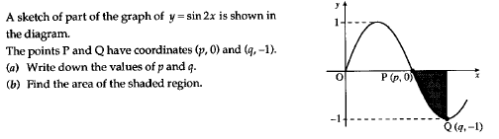

**62. Non-Calculator**

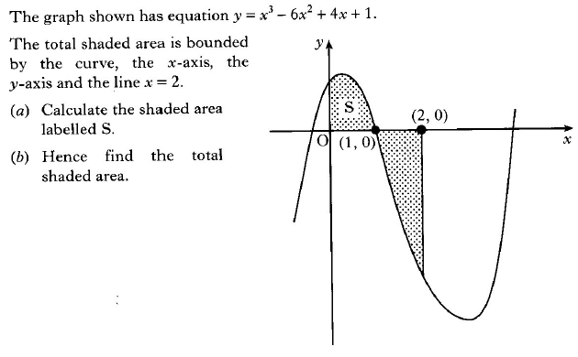

**63. Calculator**

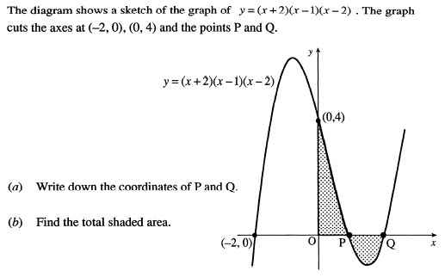

**64. Non-Calculator**

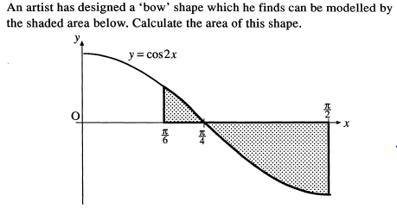

**65. Calculator**

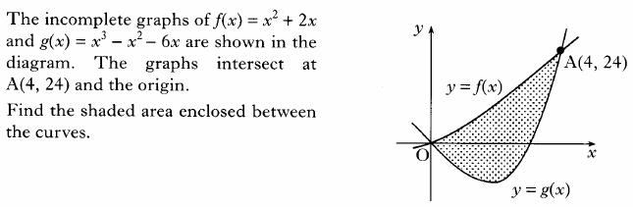

**66. Calculator**

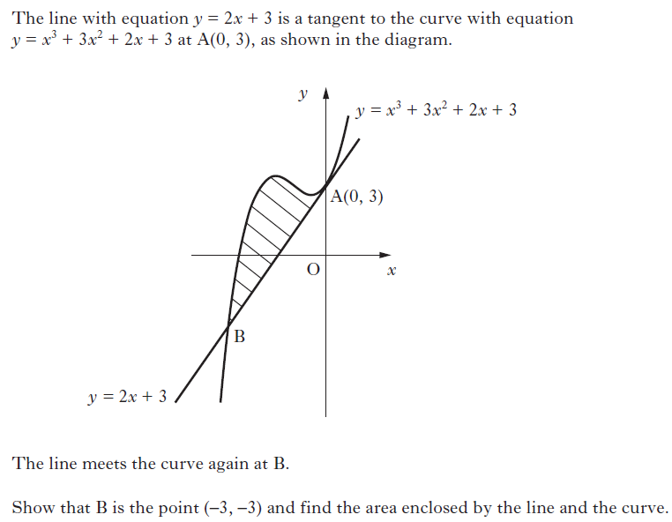

**67. Calculator**

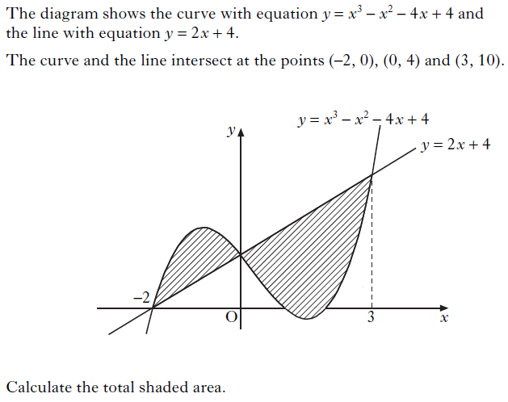

**68. Calculator**

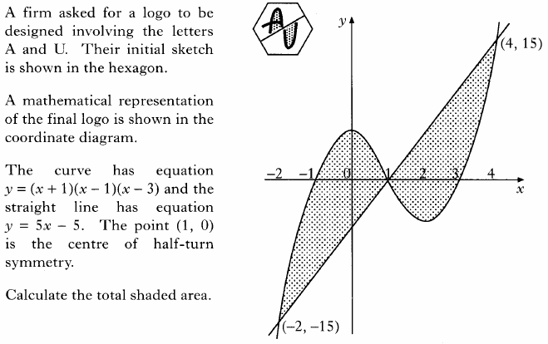

**69. Calculator**

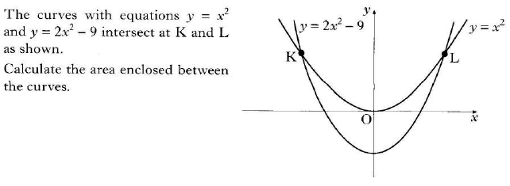

**70. Calculator**

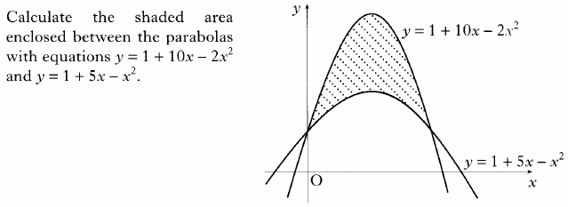

**71. Calculator**

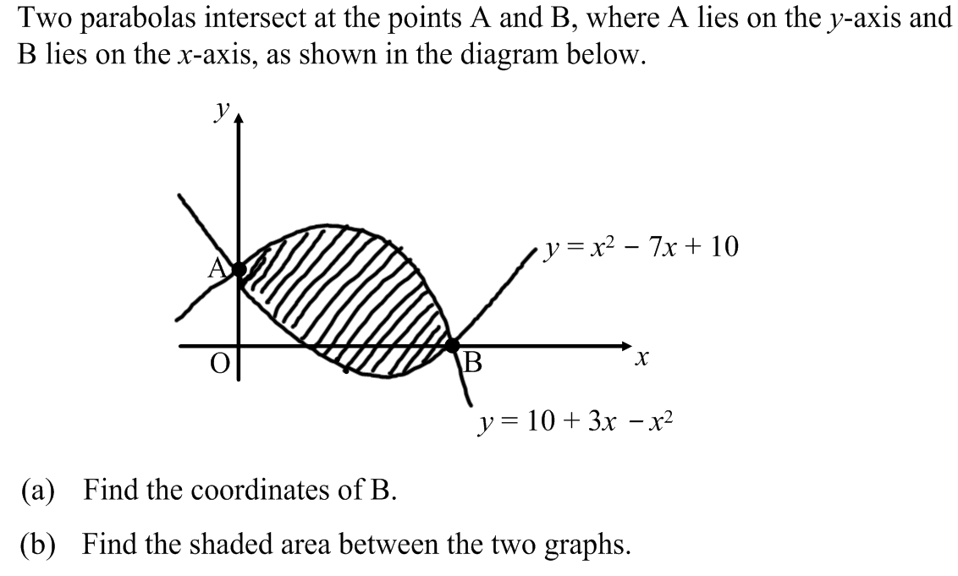

**72. Calculator**

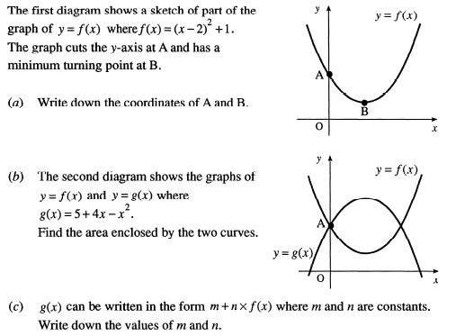

**73. Calculator**

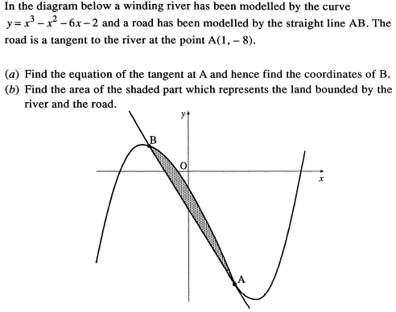

**74. Calculator**

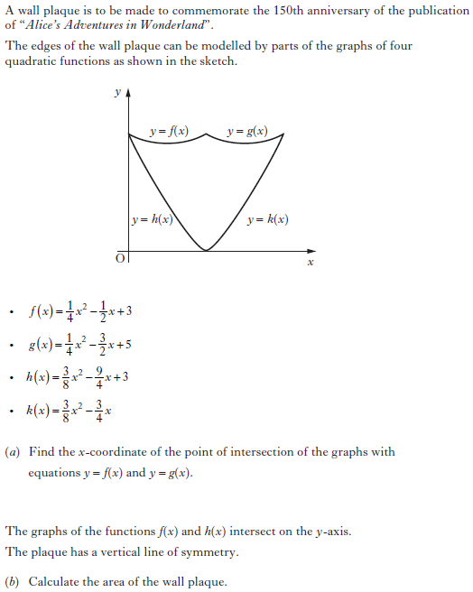

**75. Non-Calculator**

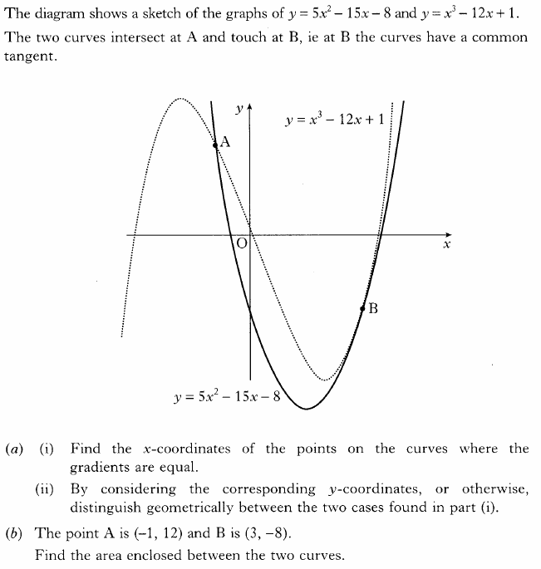

**76. Non-Calculator**



**77. Calculator**

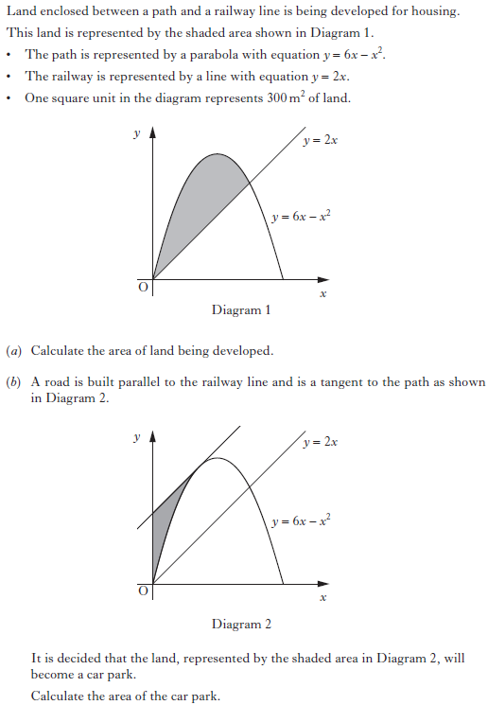

**78. Calculator**

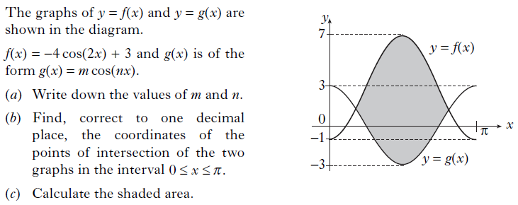

**79. Calculator**

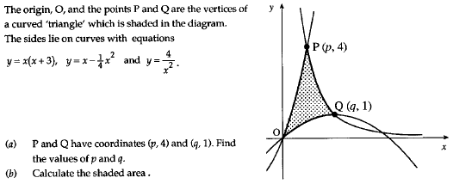

**80. Calculator**

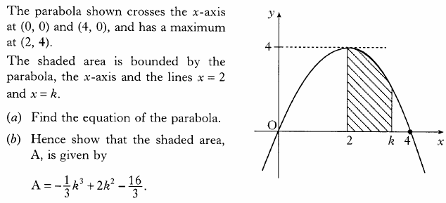

**81. Non-Calculator**

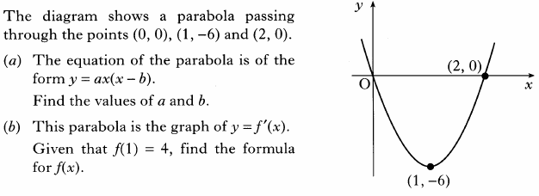

**82. Calculator**

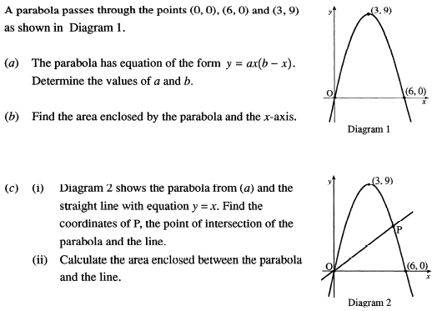

**83. Calculator**

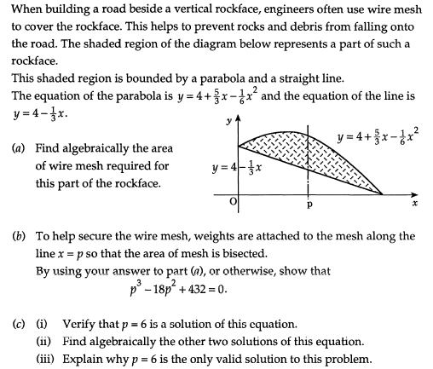

**84. Calculator**

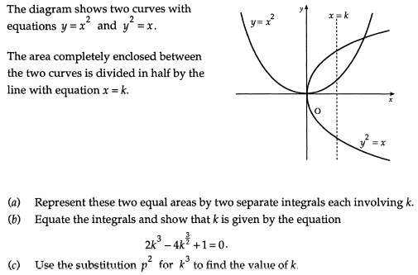

**85. Calculator**

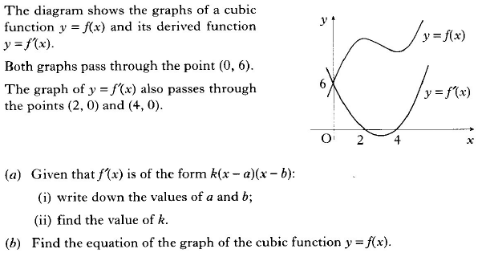

**86. Calculator**

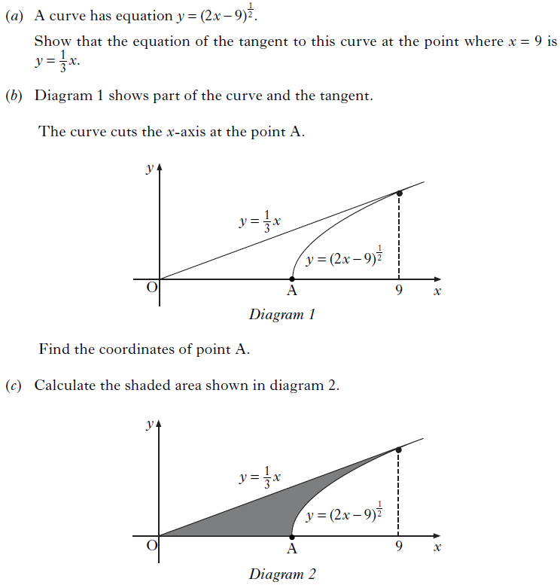

**87. Calculator**

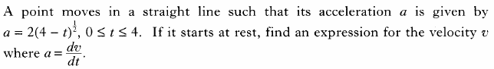

**88. Calculator**

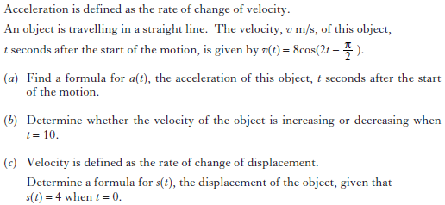

**89. Calculator**

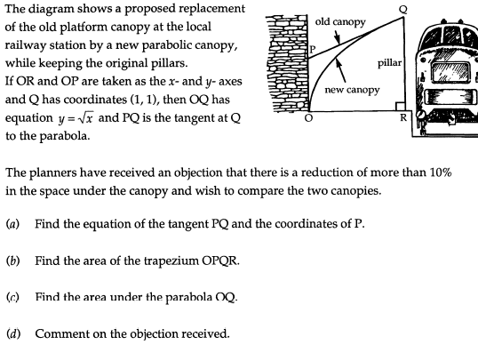

**90. Calculator**

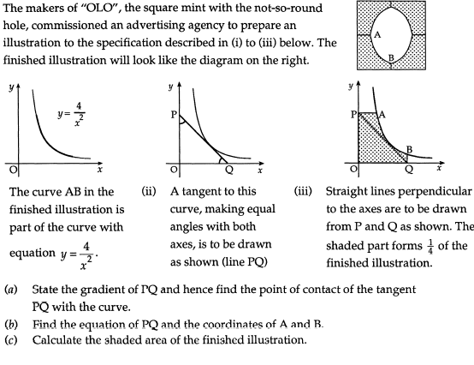

**91. Calculator**

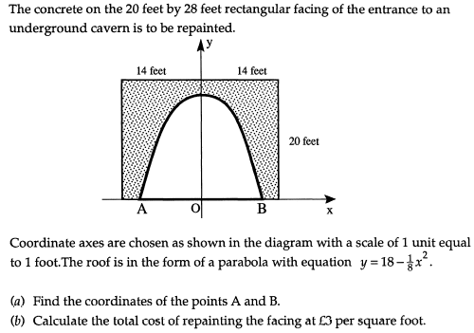

**92. Calculator**

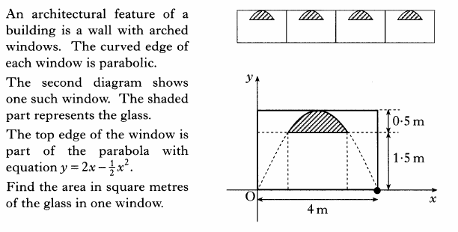

**93. Calculator**

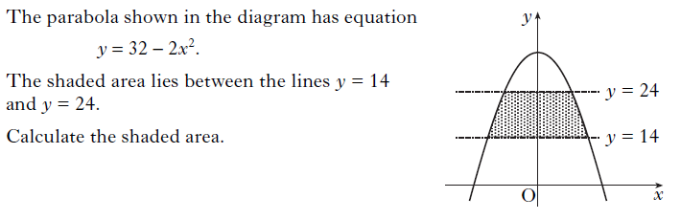

**94. Calculator**

