Higher Mathematics

Pupil Evaluation Document

Name:

Higher Mathematics – The Straight Line

Learning Outcome / Example
Page in hsn Notes
Practice Past Paper Questions
Evaluation

1−2
6, 42(a)

Use the distance formula 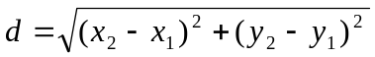 to calculate the distance between two points,
eg calculate the distance between the points A(−2, 4) and
B(3, 1).
1
3

2
Use the midpoint formula M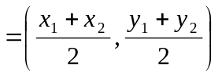 to find the coordinates of the midpoint of a line,
eg find the coordinates of the midpoint of the line joining
the points A(1, −4) and B(7, 8).

4−5
7, 8, 9, 10, 11, 23, 24, 26, 27, 28, 29, 52(c)

6
25, 50

3
Use the formula 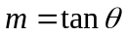 to calculate the gradient of a line or the angle that a line makes with the positive direction of the x-axis,
eg calculate the angle that the line PQ makes with the
positive direction of the x-axis, where P is (−2, −2) and
Q is (1, 7).

4
Use gradients to investigate whether three points are collinear in two dimensions,
eg show that the points P(−6, −1), Q(0, 2) and R(8, 6) are
collinear.
Higher Mathematics – The Straight Line

Learning Outcome / Example
Page in hsn Notes
Practice Past Paper Questions
Evaluation

5
Find the equation of parallel and perpendicular lines,
eg find the equation of line passing through the point
(3, −3) which is perpendicular to the line with equation
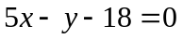.
7−10
1, 2, 3, 5, 12, 13, 14, 15, 16, 17, 18, 19, 21, 30. 45(b)(c), 54(a)

6
Find the equation of a median in a triangle,
eg find the equation of the median from A in triangle
ABC, where A is (4, −9), B is (10, 2) and C is (4, −4).
11
4, 31, 32, 45(a), 53

7
Find the equation of an altitude in a triangle,
eg find the equation of the altitude from A in triangle
ABC, where A is (3, −5), B is (4, 3) and C is (−7, 2).
12
33, 34

8
Find the equation of the perpendicular bisector of a line joining two points,
eg find the equation of the perpendicular bisector of the
line joining the points A(−2, 1) and B(4, 7).
13
35, 36, 52(a)

9
Find the coordinates of the point of intersection of two lines by solving a system of equations,
eg find the coordinates of the point of intersection of the
lines with equations 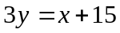 and 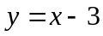.
14−16
20, 22, 37, 38, 39, 40, 41, 42(b), 43. 44, 46, 47, 48, 49, 51, 52(b), 54(b)

Higher Mathematics – Functions & Graphs

Learning Outcome / Example
Page in hsn Notes
Practice Past Paper Questions
Evaluation

10
Determine the maximum possible domain for a function,
eg determine the maximum possible domain for the
function (i) 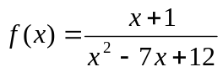 (ii) 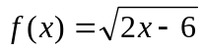
3
3, 4, 5, 16, 18, 19, 23

11
Determine the range of a function given a suitable domain, eg determine the range of the function 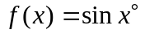,R
4
6, 24

12
Find a formula for a composite function,
eg if 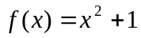 and 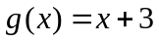, find formulae for the
composite functions 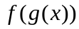 and 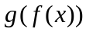.
5
1, 2, 13, 14, 15, 17, 20, 21, 22, 25

13
Find the formula for the inverse function
and know that
and
.
eg if
, find the formula for the inverse
function
.
6−7
26, 27, 28

14
Given the graph of a function 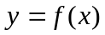, know how to sketch the graph of the inverse function 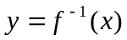 by reflecting the graph of the function in the line with equation 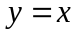. In particular, know the connection between logarithmic and exponential graphs.
8−9
29, 30(a)(b)

Higher Mathematics – Functions & Graphs

Learning Outcome / Example
Page in hsn Notes
Practice Past Paper Questions
Evaluation

15
Given the graph of a function
, know how to sketch the graph of a related function,
eg
;
;
;
;
;
10−15
7, 8, 9, 10, 11, 12, 30(c), 31, 32, 33, 34, 35, 36, 17, 38

Higher Mathematics – Differentiation

Learning Outcome / Example
Page in hsn Notes
Practice Past Paper Questions
Evaluation

16
1, 6, 7, 8, 20, 21, 22, 23, 24, 25, 26, 27, 28, 29, 30, 48

Differentiate functions involving powers, fractions and roots,
eg 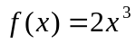; 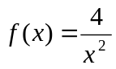; 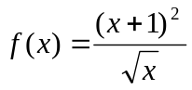

2−6

17
Use differentiation to find the rate of change of a function,
eg if 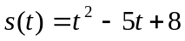, find the rate of change of s with
respect to t when 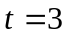.
7
15, 16, 17, 47

18
Find the equation of the tangent to a curve at a given point,
eg find the equation of the tangent to the curve with
equation 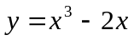 at the point where 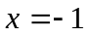.
8−11
2, 3, 4, 5, 49, 50, 51, 52, 53, 54, 55, 56, 57, 58, 59, 60, 61, 62, 63, 64, 65, 66, 67, 68, 69, 70, 71, 72, 73, 74, 75

19
Use the value of the derivative to determine whether a curve is increasing, decreasing or stationary at a given point,
eg determine whether the curve with equation
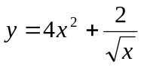 is increasing, decreasing or stationary at
the point where 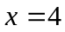.
12−13
18, 19, 46, 88

Higher Mathematics – Differentiation

Learning Outcome / Example
Page in hsn Notes
Practice Past Paper Questions
Evaluation

20
Find the coordinates and nature of the stationary points of a curve,
eg find the coordinates and nature of the stationary points
of the curve with equation 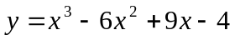.
13−17
76, 77, 78, 79, 84, 85, 86, 87

21

Sketch a curve, showing the points of intersection with the coordinate axes and stationary points.
17−18
22

Differentiate functions involving 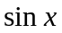 and ,
eg 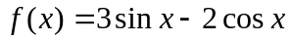
19

80, 81, 82, 83

23
Use the chain rule to differentiate a function of a function,
including in particular 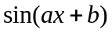 and 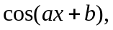
eg 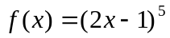; 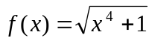; 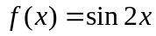;
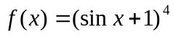; 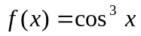
20−22
9, 10, 11, 12, 13, 14, 31, 32, 33, 34, 35, 36, 37, 38, 39, 40, 41, 42, 43, 44, 45

24
Find the maximum and minimum value of a function on a closed interval,
eg find the maximum and minimum values of the function
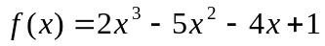 in the interval 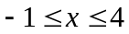.
23−24
89, 90

25
Given the graph of a function , sketch the graph of the derived function 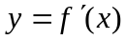.
25−26
91, 92, 93, 94, 95, 96, 97, 98, 99, 100, 101, 102

Higher Mathematics – Differentiation

Learning Outcome / Example
Page in hsn Notes
Practice Past Paper Questions
Evaluation

26
Given a mathematical model, use optimisation to find when the maximum or minimum value occurs,
eg if the surface area of a tray with a square base is given
by the formula 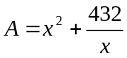, where x cm is the length
of a side of the base, find the value of x which gives the
minimum possible surface area.
26−29
103, 104, 105, 106, 107, 108, 109, 110, 111, 112, 113, 114, 115, 116, 117, 118, 119, 120, 121, 122, 123

Higher Mathematics – Sequences (Recurrence Relations)

Learning Outcome / Example
Page in hsn Notes
Practice Past Paper Questions
Evaluation

1, 2, 3, 4, 5, 6, 29

2−4

27
Write down a linear recurrence relation of the form 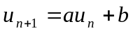 to model a situation and use the recurrence relation with a given starting value to generate values of the sequence,
eg a tyre has pressure 30 units, however a slow puncture
causes the tyre to lose 11% of its pressure every day
and, to compensate for this, every morning 3 units of
pressure are put into the tyre.

28
Know that the sequence generated by a linear recurrence relation of the form will approach a limit if 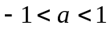 and be able to find the value of the limit using the formula 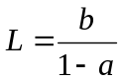 (or otherwise),
eg explain why the sequence generated by the recurrence
relation 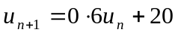 will approach a limit and
find the value of this limit.
4−6
7, 8, 9, 10, 11, 12, 13, 14, 15, 16, 17, 18, 19, 20, 21, 25, 26, 27, 28, 30, 31, 32, 33, 34, 35, 36, 37, 38

29
Know how to find the values of a and b in the linear recurrence relation given the value of three consecutive terms in the sequence,
eg given that 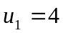, 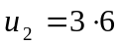 and 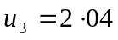, find the
values of a and b.
6
22, 23, 24

Higher Mathematics – Polynomials & Quadratics

Learning Outcome / Example
Page in hsn Notes
Practice Past Paper Questions
Evaluation

30
1, 2, 3, 4, 5, 6, 28, 29, 30

Use the value of the discriminant 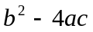 to determine the nature of the roots of a quadratic equation,
eg determine the nature of the roots of 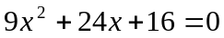.
1−3

31
Use the value of the discriminant to solve problems regarding the nature of the roots of a quadratic equation,
eg find the value of k if the equation 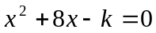 has
equal roots.
3−4
7, 31, 32, 33, 34, 35, 36, 37, 38, 39, 40, 41, 42, 43, 44, 45, 64, 65

32
Write a quadratic expression in the form 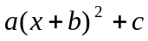 by completing the square,
eg write 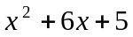 in the form 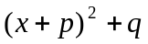;
write 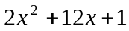 in the form 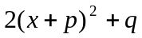.
4−5
8, 9, 10, 11, 12, 46, 49, 53, 54, 59

33
Find the coordinates of turning point of a parabola by completing the square,
eg find the coordinates of the turning point of the parabola
with equation 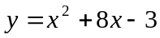 by completing the square.
6−8
47, 48, 50, 51, 52, 55, 56, 57, 58

34
Find the equation of a parabola from its graph by considering the roots.
9−10
21, 22, 105(a), 109(a)

35
Solve quadratic inequalities by considering the graph of the quadratic function,
eg solve 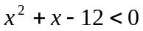 by considering the graph of the
parabola with equation 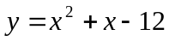.
11−13
13, 14, 15, 16, 17, 66, 67, 68

Higher Mathematics – Polynomials & Quadratics

Learning Outcome / Example
Page in hsn Notes
Practice Past Paper Questions
Evaluation

36
60, 61, 62, 63, 105(b), 109(b)
Find the coordinates of the point(s) of intersection of a line and a parabola and, in particular, show that a line is a tangent to a parabola,
eg show that the line with equation 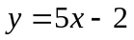 is a tangent
to the parabola with equation 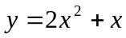 and find the
coordinates of the point of contact.
13−14
37
Use synthetic division to find the quotient and remainder on dividing a polynomial by a linear term of the form 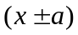,
eg find the quotient and remainder on dividing
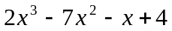 by 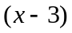.
19
18, 19, 20

38
Use synthetic division to show that a linear term of the form is a factor of a polynomial and then factorise the polynomial fully,
eg show that 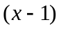 is a factor of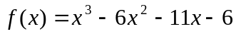
and hence factorise 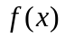 fully.
16−18
69, 70, 71, 72, 73, 74, 75, 76, 92, 94

39
Use synthetic division to find the roots of a polynomial equation,
eg show that 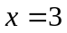 is a root of the equation
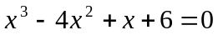 and hence find all the roots of this
equation.
18
77, 79, 80, 81, 82, 83, 84, 85, 87, 88, 89, 90, 93, 104

Higher Mathematics – Polynomials & Quadratics

Learning Outcome / Example
Page in hsn Notes
Practice Past Paper Questions
Evaluation

40
78, 91, 95, 96, 97, 98, 99, 100
Find the value of an unknown coefficient in a polynomial given information about the polynomial,
eg given that is a factor of 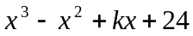, find
the value of k.
19−20
41
Find the coordinates of the points of intersection of two curves by forming and solving a polynomial equation,
eg find the coordinates of the points of intersection of the
curves with equations 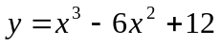 and
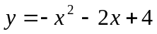.
21−22
101, 102, 103, 106, 107, 108
42
Find the equation of a polynomial function from its graph by considering the roots.

23−24
23, 24, 25, 26, 27, 86

Higher Mathematics – Integration

Learning Outcome / Example
Page in hsn Notes
Practice Past Paper Questions
Evaluation

43
1, 2, 3, 4, 5, 15, 16, 18, 19, 20, 50, 51, 52

Find indefinite integrals of functions involving powers, fractions and roots, eg 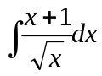

1−5

44
Solve a differential equation to find the equation of a curve,
eg if a curve with 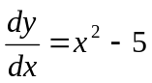 passes through the point
(3, −4), express y in terms of x.
5−6
7, 31, 32, 33, 34, 35, 36, 37, 38, 39, 40, 41, 81, 85
45
Evaluate definite integrals of functions involving powers, fractions and roots, eg 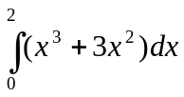

7−8
25, 26, 27, 28, 29

46
Use integration to find the area enclosed between a curve and the x-axis, including areas below the x-axis.

8−12
12, 13, 22, 23, 24, 56, 57, 58, 59, 60, 61, 62, 63, 64, 80, 89, 90, 91

47
Use integration to find the area enclosed between two curves.

13−17
14, 65, 66, 67, 68, 69, 70, 71, 72, 73, 74, 75, 76, 77, 78, 79, 82, 83, 94, 86, 92, 93, 94

Higher Mathematics – Integration

Learning Outcome / Example
Page in hsn Notes
Practice Past Paper Questions
Evaluation

48
Integrate functions involving and ,
eg 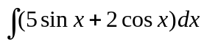; 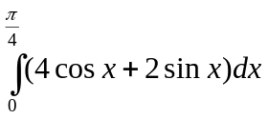
19

49
Use the special integral
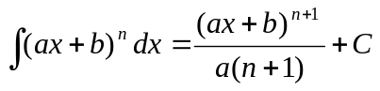, 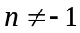
to integrate functions, eg 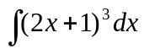; 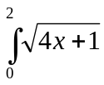
20−22
8, 9, 10, 42, 43, 44, 45, 48, 87

50
Integrate and 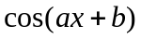 using the following results: 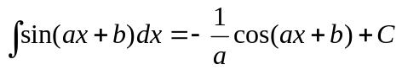
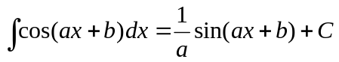
eg 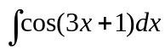; 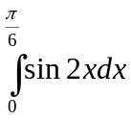
23−24
6, 11, 17, 30, 46, 47, 49, 53, 54, 55, 88

Higher Mathematics – Trigonometry

Learning Outcome / Example
Page in hsn Notes
Practice Past Paper Questions
Evaluation

51
Know how to change between degrees and radians for angles using the conversion factor radians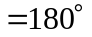,
eg 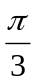radians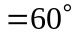; 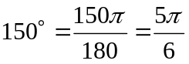radians.
1
2, 3, 4, 5, 6, 26, 27

53
7, 8, 9, 10, 28, 29, 30, 31, 32

Solve simple trigonometric equations involving x in degrees and radians,
eg solve 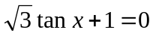 for 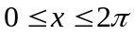
2−3

52
1
Know the exact values of sin, cos and tan for the angles
0, 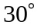, 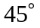, 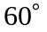, 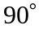,
eg 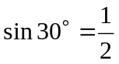; 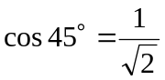; 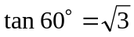,
and know how to use these exact values to find sin, cos and tan of related angles outwith the 1st Quadrant,
eg 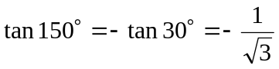

1

54
Solve trigonometric equations involving multiple angles (2x, 3x, etc) in degrees and radians,
eg solve 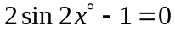 for 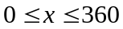
3−5
11, 33, 34, 35, 36, 37, 38, 39, 40, 41, 42

55
Use trigonometry (SOH CAH TOA) in 3 dimensions to calculate angles between lines and planes.
5−7

Higher Mathematics – Trigonometry

Learning Outcome / Example
Page in hsn Notes
Practice Past Paper Questions
Evaluation

56
Use the compound angle formula for 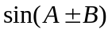 and 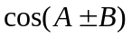,
eg expand and simplify 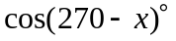;
given acute angles p and q such that 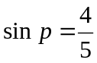 and
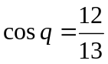, show that 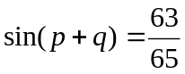;
show that 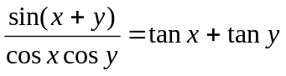
8−10
12, 13, 14, 43, 44, 45, 46, 47, 48, 49, 50, 51, 52, 53

57
Use the double angle formula for 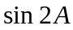 and 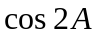,
eg given 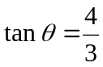, where 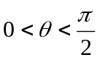, find the exact
values of 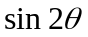 and 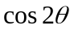.
11
15, 16, 17, 18, 19, 20, 54, 55, 56, 57, 58, 59, 60, 61, 62, 63, 64, 65, 66

58
67, 68, 69, 70, 71, 72, 73, 74, 75, 76, 77, 78, 79, 80, 81, 82, 83, 84, 85, 86, 87

Solve trigonometric equations involving 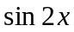 and 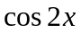 using double angle formulae,
eg solve 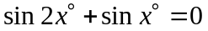 for 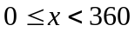;
solve 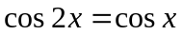 for 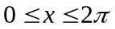.
12−13

59
21, 22, 88

Express 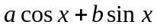 in the form 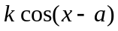,
eg express 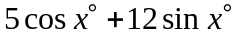 in the form 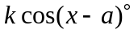,
where 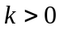 and 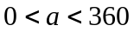.
14−15

Higher Mathematics – Trigonometry

Learning Outcome / Example
Page in hsn Notes
Practice Past Paper Questions
Evaluation

60
Express in another wave form,
ie 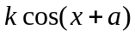, 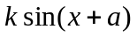 or 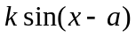
eg express 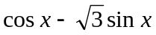 in the form 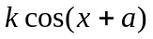,
where and 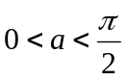;
express 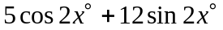 in the form 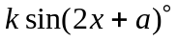,
where and 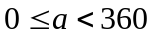.
15−16
89, 90, 91, 111, 112, 113, 114

61
Find the maximum and minimum value of a wave function,
eg express 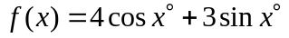 in the form
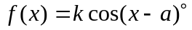 and hence state the maximum and
minimum values of f and the values of x in the interval
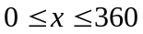 at which they occur.
17
23, 24, 25, 92, 93, 94, 95, 96, 97, 98

62
Solve a trigonometric equation involving a wave function,
eg express 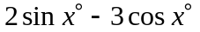 in the form 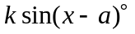 and
hence solve the equation 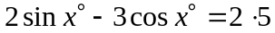 for
.

18−19
99, 100, 101, 102, 103, 104, 105, 106, 107

63
Sketch the graph of 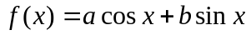 by expressing as a wave function,
eg sketch the graph of 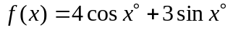 by
expressing in the form .

20−22
108, 109, 110

Higher Mathematics – The Circle

Learning Outcome / Example
Page in hsn Notes
Practice Past Paper Questions
Evaluation

64
1, 9, 10, 11, 12, 13, 14, 16, 17, 18, 24(b), 37(a), 39(a), 40(c), 41(a)(b), 46(d), 47, 48(c), 49(b), 50, 51, 52, 53(c), 55(b), 56, 57(a), 58, 60

Find the equation of a circle with centre (a, b) and radius r using 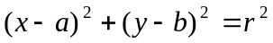,
eg find the equation of the circle with diameter AB, where
A is (−3, 1) and B is (5, 3).
1−2

65
Find the centre and radius of a circle when the equation is given in the expanded form 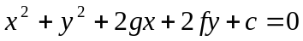,
eg find the centre and radius of the circle with equation
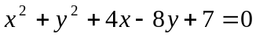.
2−4
2, 8, 15, 19, 20, 21, 22, 23, 48(a), 53(b), 57(b)(c)

66
Find the coordinates of the points of intersection of a line and a circle,
eg find the coordinates of the two points of intersection of
the line with equation 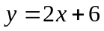 and the circle with
equation 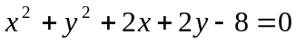.
4−5
3, 24(a), 44(c), 45, 49(a), 53(a)

67
Show that a line is a tangent to a circle and find the coordinates of the point of contact,
eg show that the line with equation 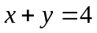 is a tangent
to the circle with equation 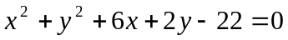
and find the coordinates of the point of contact.
5−6
25, 26, 27, 28, 29, 30, 38(b)(c), 39(b), 48(d), 55(a)

Higher Mathematics – The Circle

Learning Outcome / Example
Page in hsn Notes
Practice Past Paper Questions
Evaluation

68
Find the equation of the tangent to a circle at a given point,
eg find the equation of the tangent to the circle with
equation at the point A(1, 3)
on the circle.
6−7
4, 5, 6, 7, 31, 32, 33, 34, 35, 36, 37(b), 38(a), 40(a)(b), 41(c), 44(b), 56(a)(b)(c), 48(b), 54

69
42, 43, 44(a), 59, 61

Given the equations of two circles, determine how the circles intersect, ie do the circles overlap (2 points of intersection), touch externally (1 point of intersection), touch internally (1 point of intersection) or not intersect at all,
eg show that the circles with equations
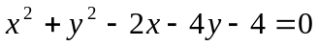 and 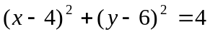
touch externally.
8−9

Higher Mathematics – Vectors

Learning Outcome / Example
Page in hsn Notes
Practice Past Paper Questions
Evaluation

7, 8, 9, 10, 26, 27, 28, 29, 30, 31, 32(b), 47(c), 65(a)(b)

3

70
Find the magnitude (length) of a vector in 3 dimensions and, in particular, know what is meant by a unit vector
eg given the vector 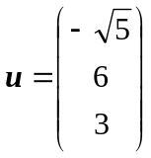, find 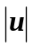;
show that the vector 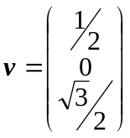 is a unit vector.

71
Know how to add and subtract vectors when the vectors are given in diagrams or in component form.
5−6
24, 25

72
Know how to find a scalar multiple of a vector
(eg
,
) and, in particular, know what is meant by the negative of a vector (ie
).
7−8
1, 2, 3, 4, 5, 6, 33, 47(a)

73
Given the coordinates of two points A and B, know how to find the vector
using the formula
,
eg given the points R(2, −2, 3) and S(4, 6, −1), find the
vector
in component form.
8−9

74
Know how to write vectors in terms of the unit vectors
i, j and k, eg 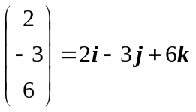
9

Higher Mathematics – Vectors

Learning Outcome / Example
Page in hsn Notes
Practice Past Paper Questions
Evaluation

75
11, 12, 13, 14, 34, 35, 36, 37, 38, 39, 40, 41, 44(c), 68(a), 84(a), 85(a)

Use vectors to prove that three points are collinear in 3 dimensional space,
eg use vectors to prove that the points A(1, −2, 5),
B(8, −5, 9) and C(22, −11, 17) are collinear and state
the ratio in which B divides AC.
10
76
Use the section formula (or equivalent method) to find the coordinates of the point which divides a line in a given ratio,
eg find the coordinates of the point T which divides the
line joining P(−2, 4, −1) and R(8, −1, 19) in the ratio
2 : 3.
11−14
32(a), 42, 43, 44(a)(b), 45, 46

77
Use the formula
to find the scalar product of two vectors a and b given in a diagram.
14−15
19
78
Use the formula
to find the scalar product of two vectors a and b given in component form,
eg given the points A(2, 3, 9),B(1, 4, −2) and C(−1, 3, −6),
find the scalar product
.

16
47(b)

79
Use the formula 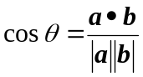 to calculate the angle between two vectors a and b,
eg calculate the angle between the vectors p = 3i + 4j − 2k
and q = 4i + j + 3k.

17−19
48, 49, 50, 51, 52, 53, 54, 55, 56, 57, 58, 59, 60, 61, 62, 63, 64, 65(d), 86, 87

Higher Mathematics – Vectors

Learning Outcome / Example
Page in hsn Notes
Practice Past Paper Questions
Evaluation

80
15, 16, 17, 18, 65(c), 66, 67, 68(b), 69, 70, 71, 72, 73, 74, 84(b), 85(b)

Know that
if a and b are perpendicular vectors and use this fact to solve problems involving perpendicular vectors,
eg show that the vectors a = 4i + 2j − 5k and
b = 2i + j + 2k are perpendicular;
find the value of p if the vectors u
and v
are perpendicular.
20
81
Know the following properties of the scalar product and use these to solve problems involving scalar products:

eg if vectors p and q are such that
,
and
, find the value of
.

21
20, 21, 22, 23, 75, 76, 77, 78, 79, 80, 81, 82, 83, 88, 89, 90, 91

Higher Mathematics – Exponentials & Logarithms

Learning Outcome / Example
Page in hsn Notes
Practice Past Paper Questions
Evaluation

1
1−3

3
2, 11, 12, 18(a)

3−5
3, 13, 14

82
Use formulae to model exponential growth and decay and recognise graphs for exponential growth and decay.

83
Switch between logarithmic and exponential form and, in particular, evaluate logarithms,
eg 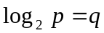 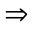 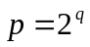;
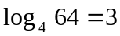 since 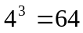

84
Use the three laws of logarithms to simplify expressions involving one or more logarithms,
eg ;
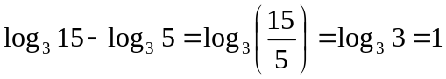;
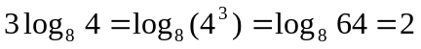

6
15

85
Know that 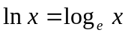 and evaluate logarithms to base e,
eg express 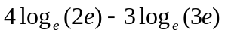 in the form
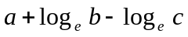 for whole numbers a, b and c.
86
Solve equations involving logarithms and exponentials,
eg solve 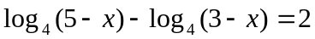 for 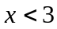;
solve 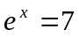; solve 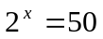
7−9
4, 5, 17, 17, 18(b), 19, 20, 21, 22, 23, 24, 25, 26, 27, 28, 29, 30, 31, 32, 33

Higher Mathematics – Exponentials & Logarithms

Learning Outcome / Example
Page in hsn Notes
Practice Past Paper Questions
Evaluation

34, 35, 36, 37, 38, 39, 40, 41, 42, 43, 44, 45, 46, 47

9−10

87
Solve problems involving exponential growth and decay given a formula of the form 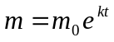 or 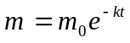,
eg if the mass, m, of a radioactive substance after t years is given by the formula 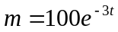, find the initial mass of the substance and then calculate the half-life (the time taken for the mass to decay to half the initial mass).

10−12
6, 8, 48, 49, 50

13
51, 52, 53, 54, 55

88
Given that the graph of 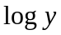 against x is a straight line, show that 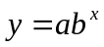, stating the values of a and b,
eg given that the graph of 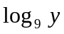 against x is a straight
line passing through the points (0, 2) and (6, 5), show
that 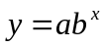 and state the values of a and b.

89
Given that the graph of against 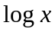 is a straight line, show that 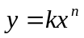, stating the values of k and n,
eg given that the graph of 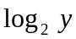 against is s
straight line passing through the points (0, 5) and (4, 7),
show that 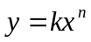 and state the values of k and n.

90
Sketch the graph of a logarithmic or exponential function using knowledge of related graphs,
eg 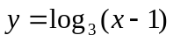; 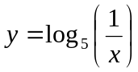; 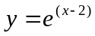

14−15
7, 9, 10, 56, 57, 58, 59, 60, 61, 62, 63, 64, 65, 66, 67

