HIGHER MATHEMATICS

Answers to Exam Questions on Functions & Graphs

1. A 2. D 3. A 4. A

5. C 6. D 7. C 8. D

9. D 10. B 11. A 12. A

13.(a) 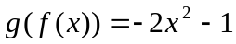 (b) 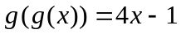

14. 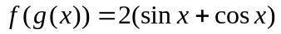; 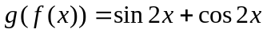

15.(a) 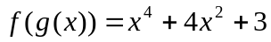 (b) 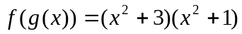

16.(a) 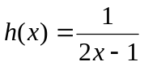 (b) 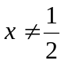

17.(a)(i) 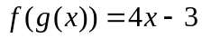 (ii) 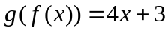 (b) min value = −9

18. 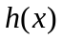 is undefined for 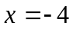 and 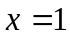

19.(a) 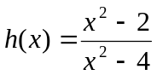 (b) 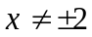

20.(a) 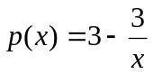 (b) 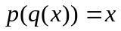

21. 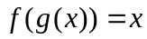 22. 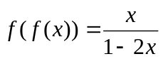

23.(a) 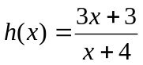 (b) 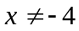

24.(a) 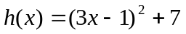 (b)(i) 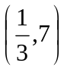 (ii) 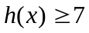

25.(a) 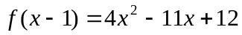; proof (b) 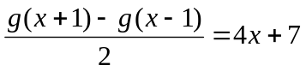
(c) 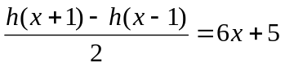

26.(a) 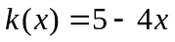 (b) 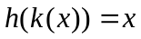
(c) The function k is the inverse of the function h since .

27.(a) 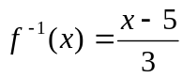 (b) 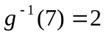

28.(a) 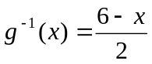 or 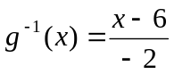 (b) 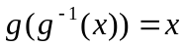

29.
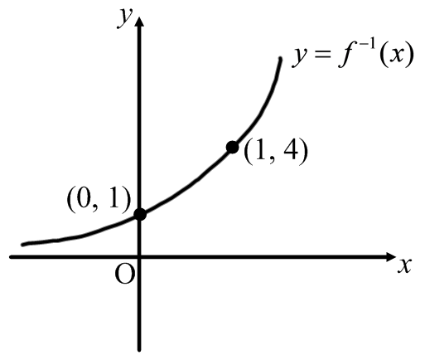

30.(a) 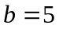
(b)(i) (ii) 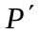(5, 1); 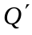(4, 0)
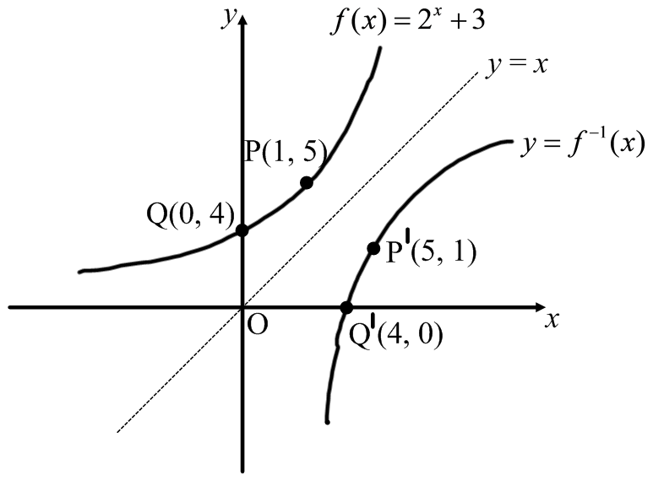
(c) 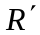(2, −7)

31.(a) (b)
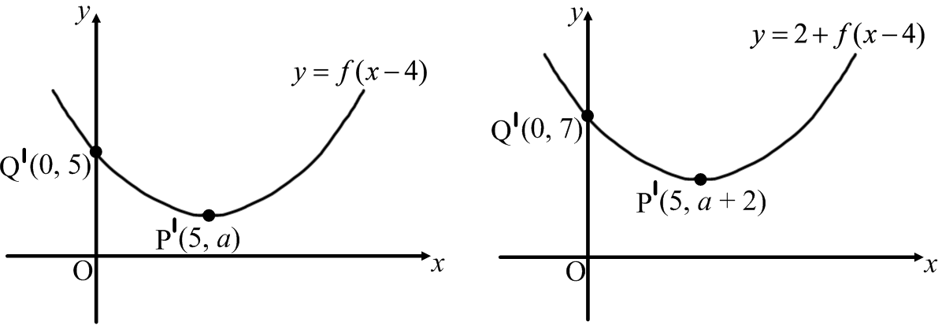

32.(i) (ii)
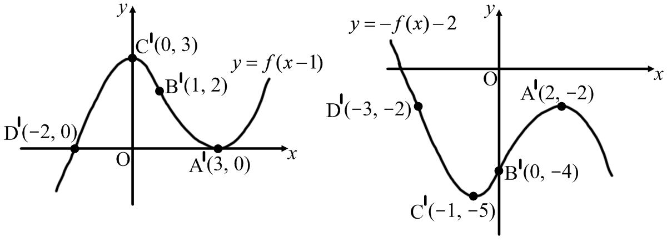

33.(a) (b)
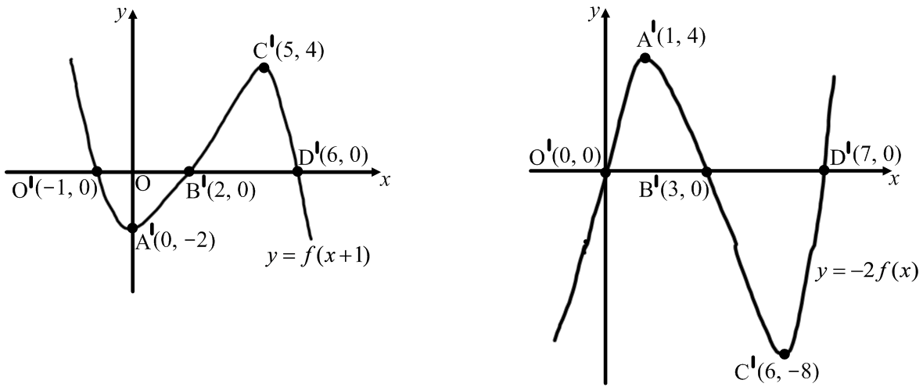

34.(a) (b)
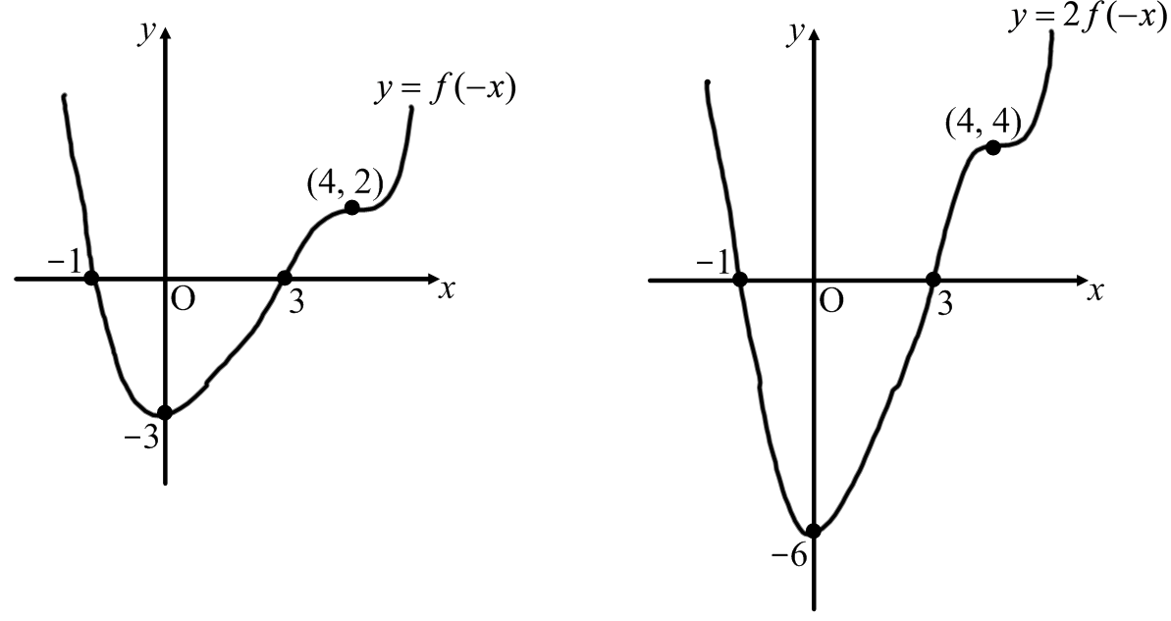

35.
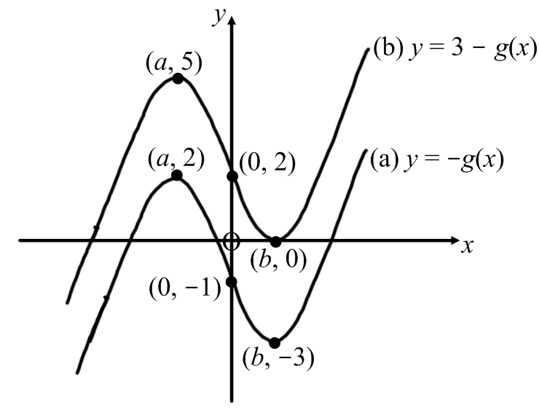
36.
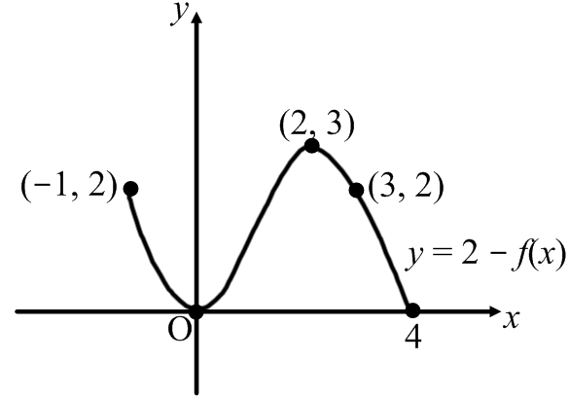

37.(a) (b)
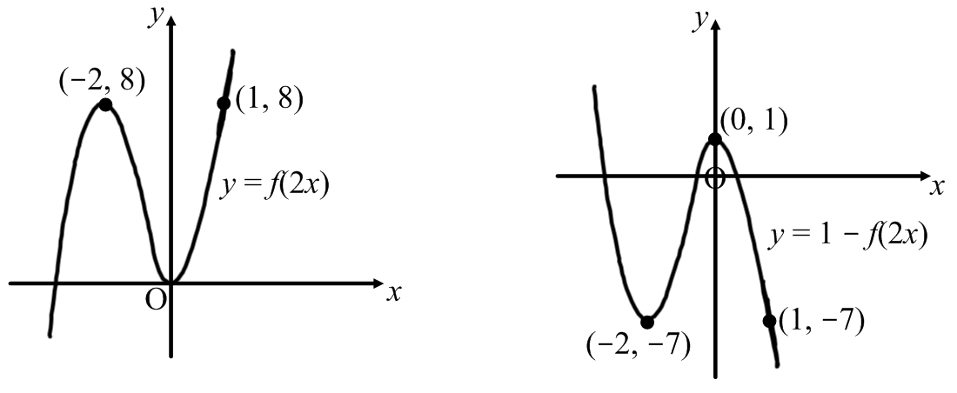
38.(a) (b)


