HIGHER MATHEMATICS

**Exam Questions on Functions & Graphs**

**1. Non-Calculator (Multiple Choice)**

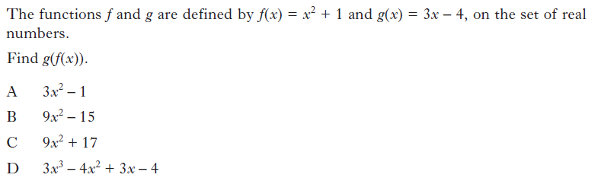

**2. Non-Calculator (Multiple Choice)**

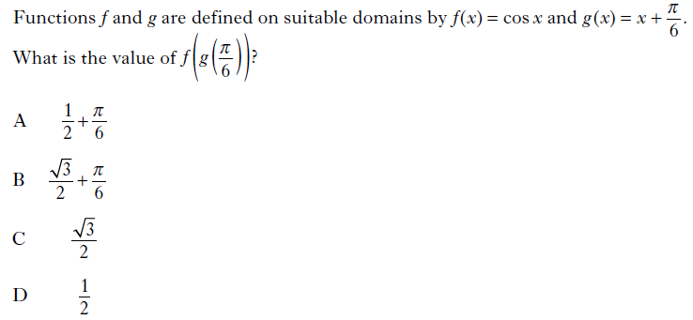

**3. Non-Calculator (Multiple Choice)**

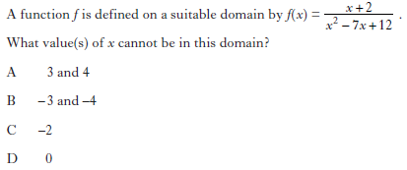

**4. Non-Calculator (Multiple Choice)**

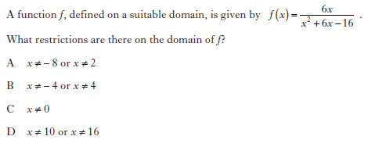

**5. Non-Calculator (Multiple Choice)**

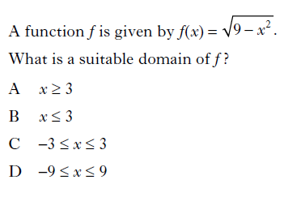

**6. Non-Calculator (Multiple Choice)**

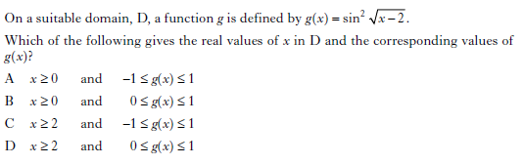

**7. Non-Calculator (Multiple Choice)**

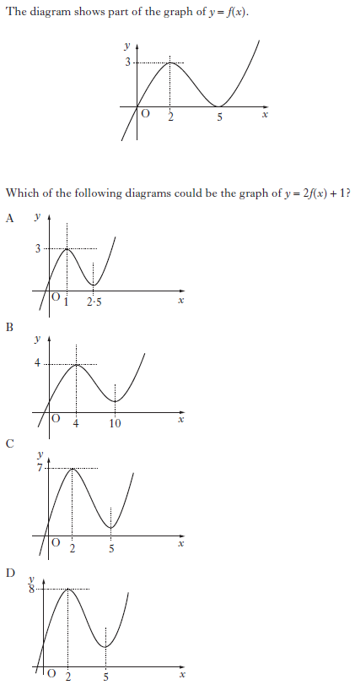

**8. Non-Calculator (Multiple Choice)**

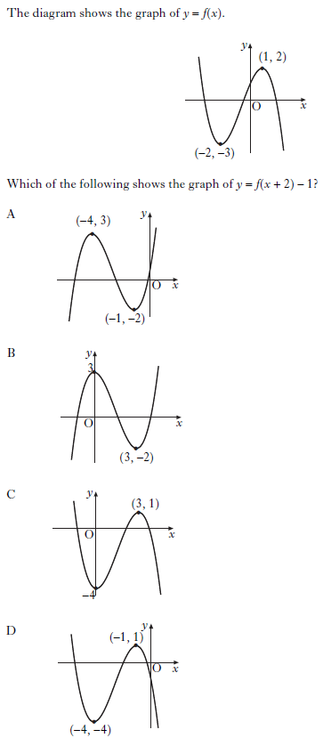

**9. Non-Calculator (Multiple Choice)**

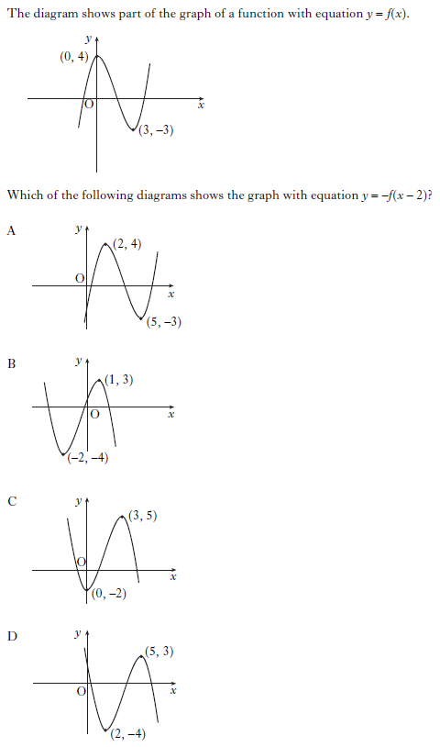

**10. Non-Calculator (Multiple Choice)**

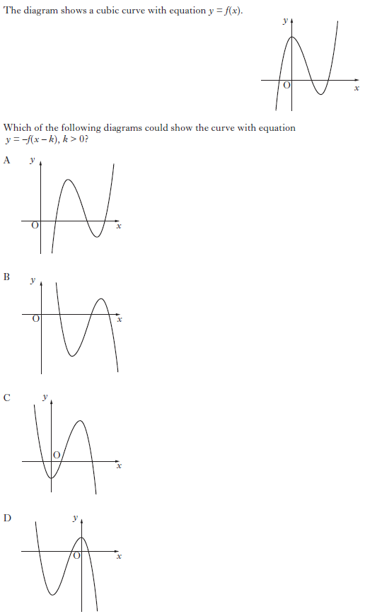

**11. Non-Calculator (Multiple Choice)**

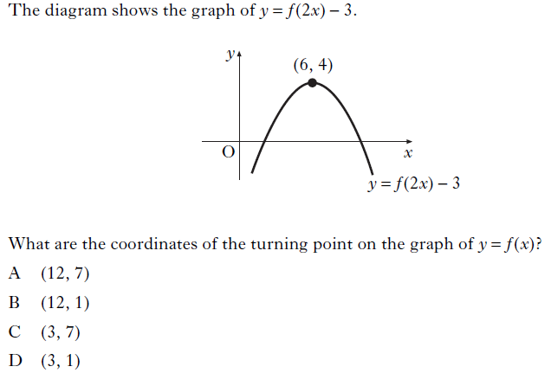

**12. Non-Calculator (Multiple Choice)**

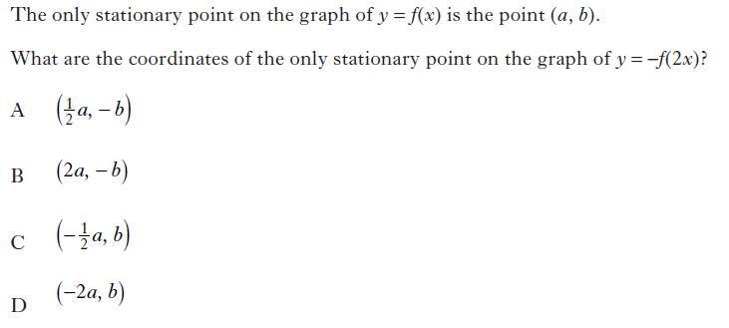

**13. Non-Calculator**

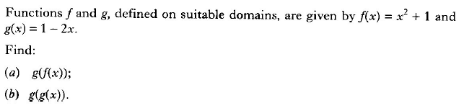

**14. Non-Calculator**

Functions *f* and *g*, defined on suitable domains, are given by  and

.

Find  and .

**15. Non-Calculator**

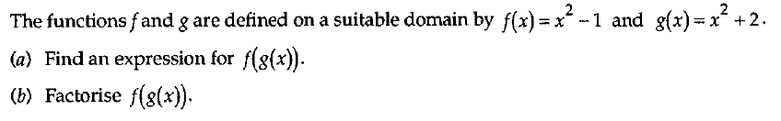

**16. Non-Calculator**

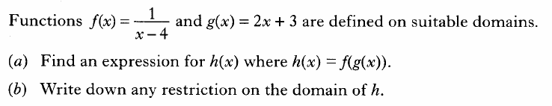

**17. Non-Calculator**

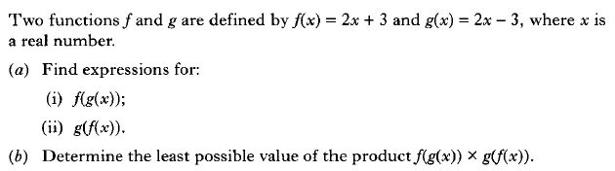

**18. Non-Calculator**

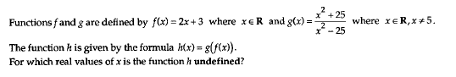

**19. Non-Calculator** 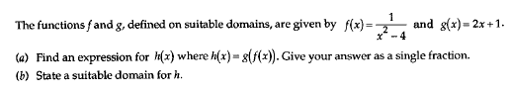

**20. Calculator**

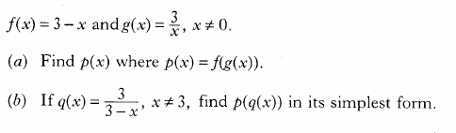

**21. Non-Calculator**

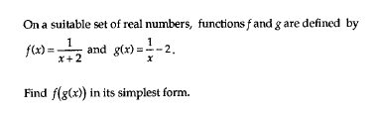

**22. Non-Calculator**

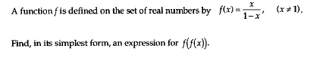

**23. Non-Calculator**

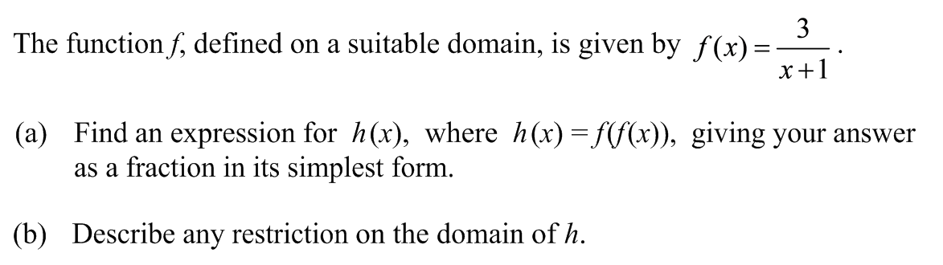

**24. Non-Calculator**

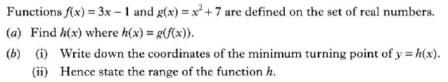

**25. Non-Calculator** 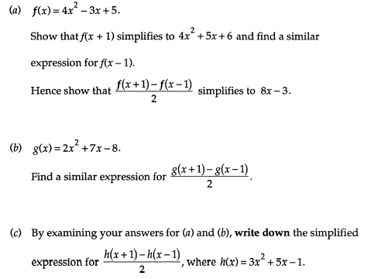

**26. Non-Calculator**

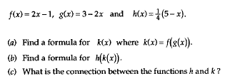

**27. Non-Calculator**

Functions *f* and *g* are defined on the set of real numbers.

The inverse functions  and  both exist.

1. Given , find .
2. If , write down the value of .

**28. Non-Calculator**

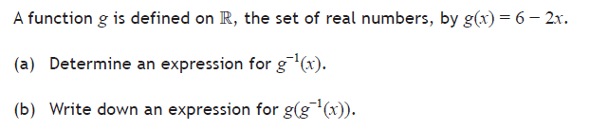

**29. Non-Calculator**

The diagram below shows the graph of the function , where .

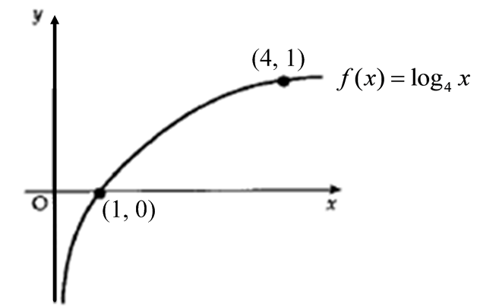

The inverse function, , exists.

Sketch the graph of the inverse function.

**30. Non-Calculator**

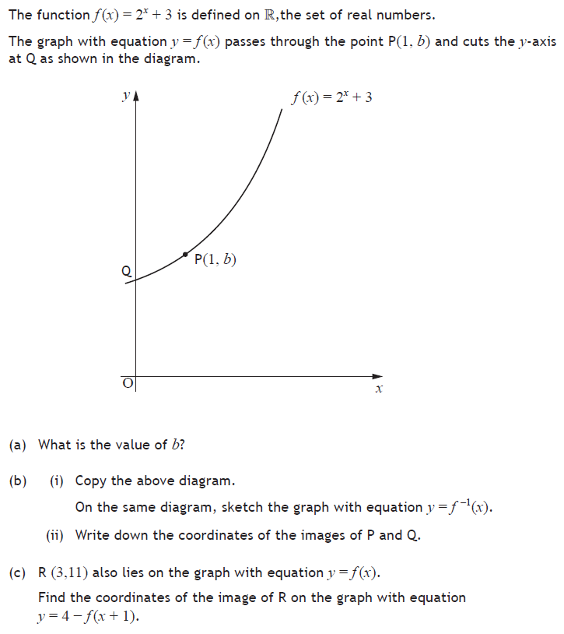

**31. Calculator**

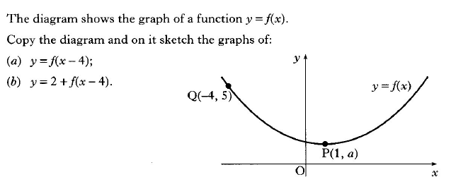

**32. Non-Calculator**

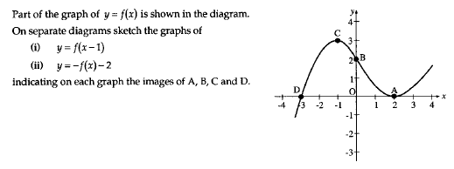

**33. Non-Calculator**

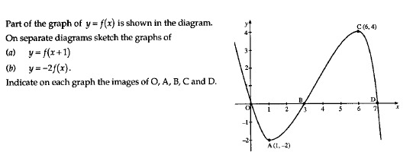

**34. Calculator**

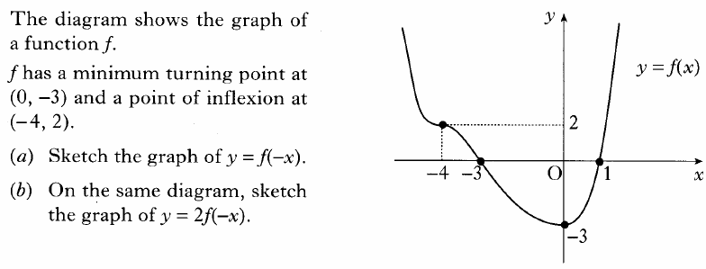

**35. Non-Calculator**

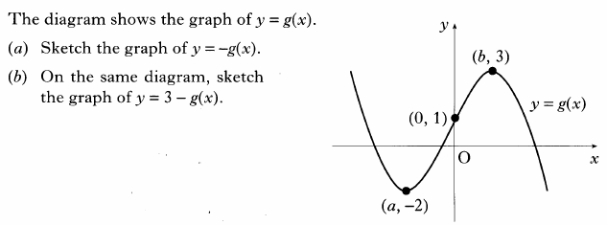

**36. Non-Calculator**

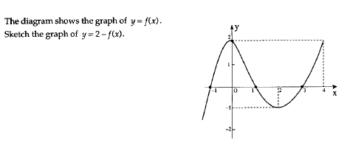

**37. Calculator**

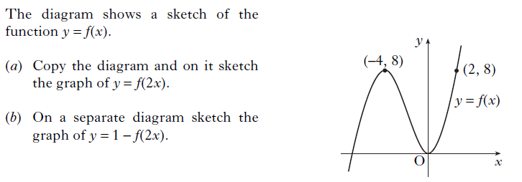

**38. Non-Calculator**

