Tuesday 21st April 2020
Primary 1/2 PE
Hope you have had a lovely Easter
1) We are going to start this term with some fitness. In a space, perhaps in your garden, set up a circuit. Use a timer to do each activity for 45 seconds:
- 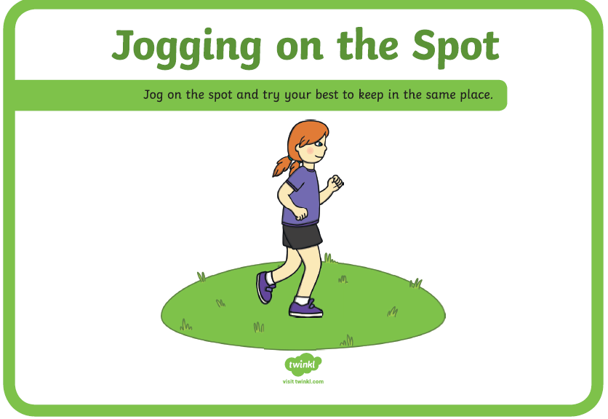 2) 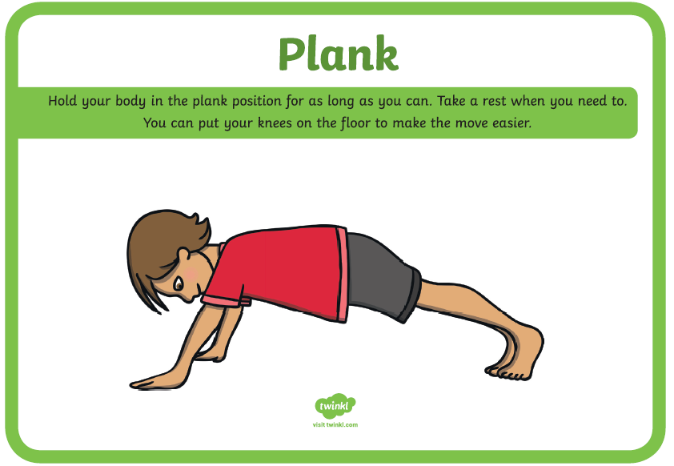
- 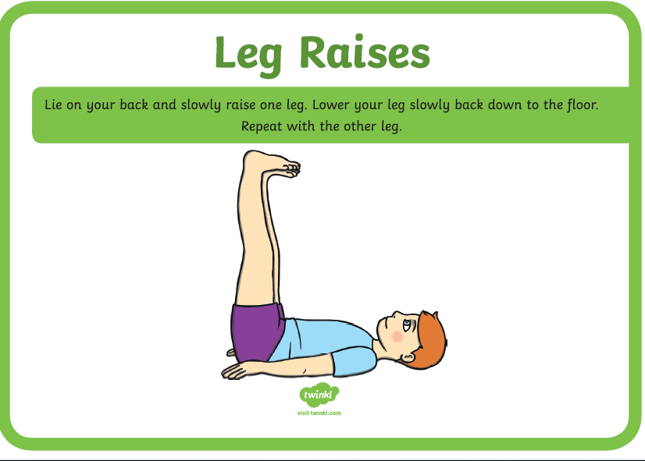 4) 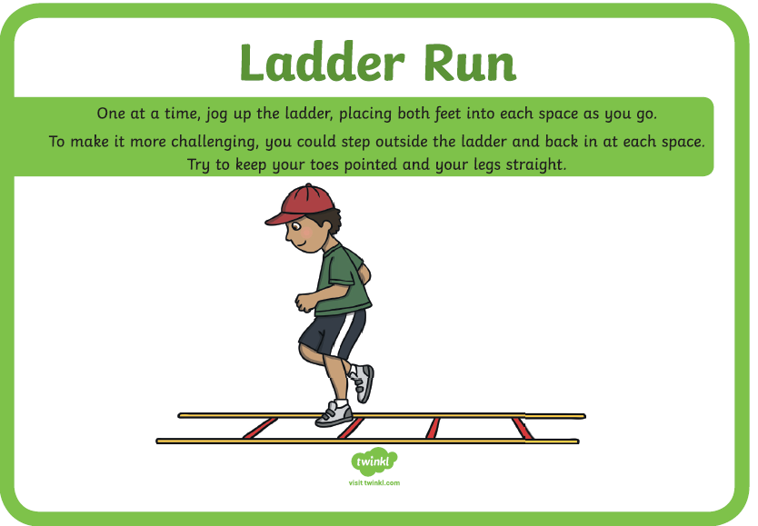
5) 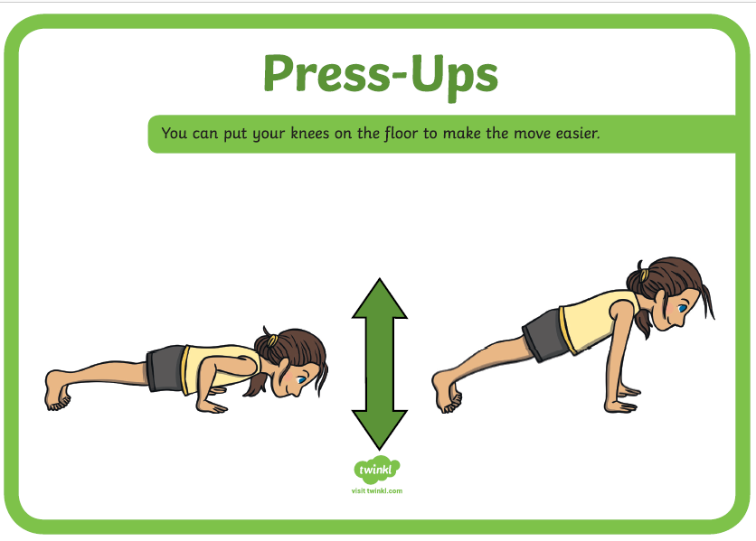 6) 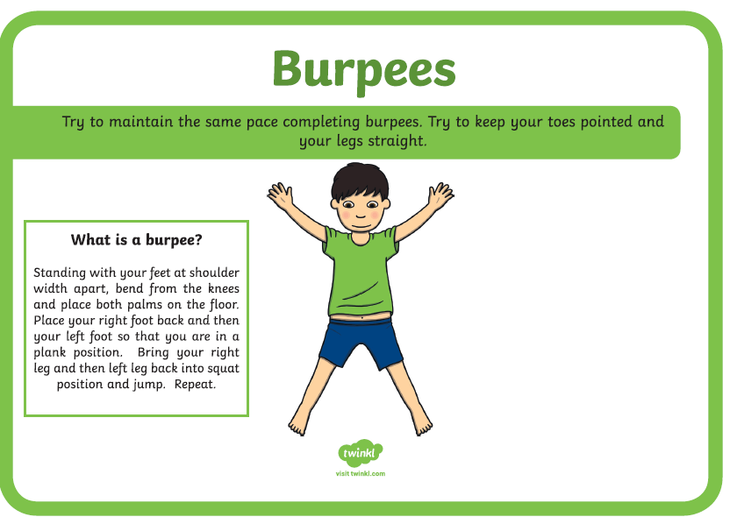
2) Now try each one again and see if you can do more of each Rep.
3) Now for strength stretches have a go at the Harry Potter Cosmic Kids Yoga:
https://www.youtube.com/watch?v=R-BS87NTV5I

