|  |  |  |  |  |
| --- | --- | --- | --- | --- |
| |  | | --- | | **The Torphichen** | | Scoop | | 30th November 2013 |  |  | | --- | | **The Newspaper Produced By P5/6/7, Torphichen Primary School £1** |   [http://t2.gstatic.com/images?q=tbn:ANd9GcSA2uu31LNYmTcWLpgnCjE5wVr7t_nA-xqazuHHn4NHK5hXprkWYvAETSNllw](http://www.google.co.uk/url?q=http://www.theblueberryhill.com/category/knit-hats&sa=U&ei=vdeVUv3UJ4eqhAfAjoGYBg&ved=0CDwQ9QEwCQ&usg=AFQjCNEb4MtEDxaUxouuTCgYbJayYc5yzA) |
| Read Heather’s Fashion  “Dos and Don’ts” on page 3   |  | | --- | | **Perfect Christmas Presents for Pupils in Torphichen** | | **Dear Old Santa is inundated with requests from Torphichen pupils for the latest Gran Turismo 6 console game.** Read more from our chief technology reviewers on page 4.  http://nowgamer.net-genie.co.uk/siteimage/scale/0/0/356752.gif | |

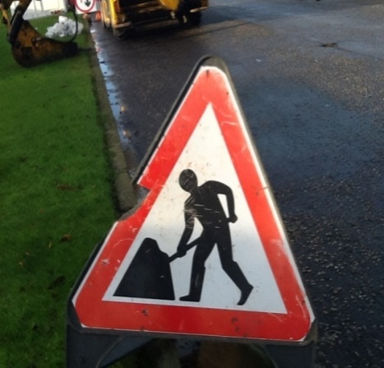

**Torphichen village has been hit with serious road work disruption within their streets which this is set to continue right through the festive season**.

By Jessie Jamieson and Lana Morrison

Scottish Water is replacing the old pipes for new ones to ensure they survive the winter. The work being done on the pipes in the village, has caused inconvenience for the

past few weeks. Pupils are not happy to know that the scheduled date for finishing is the end of February. School children are becoming late, employees have been late total and it has caused a catastrophe for our community. The workmen who are currently on site spoke to The Torphichen Scoop about what they are doing. Cont. on page 2

**Read from our restaurant reviewer, Adam Menzies, on the new café/bar and restaurant 1912.** More on pg 5

**ROAD WORK TURNOVER**