June - Early Level Maths Calendar - ANSWERS
1. If I bought a sweet at 4p, how much change would I get from 10p? 6p | 2. How many? (Without counting the dots!) 8 | 3.Share these dots into 2 equal groups:  4 in each group | 4. What season comes after Spring? Summer | 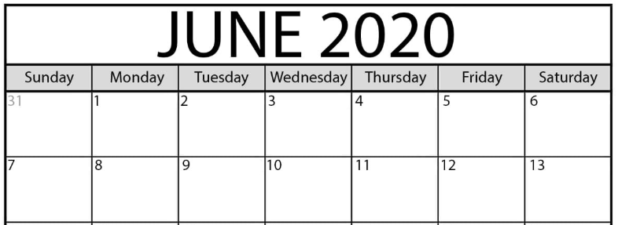  5. What day is 12th June? Friday  6. What is the date of the first Tuesday? 2nd
7. How many edges does a triangle have? 3 | 8. 7 + 6 = 13 | 9. How many fingers? (Without counting in ones.) 7  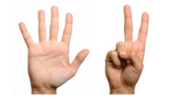 | 10. What is the number before 18? 17 | 11. What number is in between 22 and 24? 23 | 12. What is the value of the missing number?  10 + 4 = 14
13. Measure the width of 2 different sized plates using small objects like Lego or spoons. Which one is the narrowest?  Answers will vary | 14. What time is this? 8 o’clock  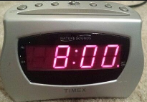 | 15. Which of these glasses is half full? | 16. How many? How many more to make 20?17, 3 more  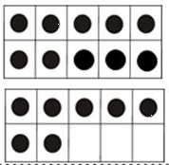 | 17. Which snake is the shortest?  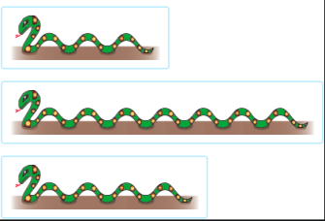 | 18. What number is the minute hand pointing to? 12  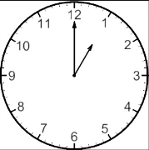
19. What month comes before August? July | 20. How many 2p’s are in 8p? 4 | 21. What are the 3 numbers after 29? 30, 31, 32 | 22. Write eleven as a number. 11 | 23. What is the day after Sunday? Monday | 24. Half of 6? 3
25. Double 10? 20 | 26. What’s the missing number in the sequence?  20, 19, 18, 17, 16. | 27. What colour would be next?  Red | 28. What comes next in the sequence?  2, 4, 6, 8, 10 | 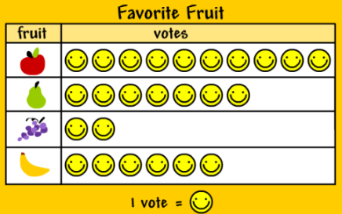 | 29. How many apples? 10  30. How many bananas? 6

